Journal of Information Literacy
ISSN 1750-5968

Volume 17 Issue 2
November 2023

Article
Charles, L. H. 2023. Insights on first-generation students’ development of social capital for the rigours of college-level research. Journal of Information Literacy, 17(2), pp. 85–107.
http://dx.doi.org/10.11645/17.2.9

This work is licensed under a Creative Commons Attribution-ShareAlike 4.0 International License.

Copyright for the article content resides with the authors, and copyright for the publication layout resides with the Chartered Institute of Library and Information Professionals, Information Literacy Group. These Copyright holders have agreed that this article should be available on Open Access and licensed under a Creative Commons Attribution ShareAlike licence.

"By ‘open access’ to this literature, we mean its free availability on the public internet, permitting any users to read, download, copy, distribute, print, search, or link to the full texts of these articles, crawl them for indexing, pass them as data to software, or use them for any other lawful purpose, without financial, legal, or technical barriers other than those inseparable from gaining access to the internet itself. The only constraint on reproduction and distribution, and the only role for copyright in this domain, should be to give authors control over the integrity of their work and the right to be properly acknowledged and cited.”

Chan, L. et al. 2002. Budapest Open Access Initiative. New York: Open Society Institute. Available at: http://www.soros.org/openaccess/read.shtml [Accessed: 18 November 2015]

Insights on first-generation students’ development of social capital for the rigours of college-level research
Leslin H. Charles, Instructional Design Librarian, Rutgers, the State University of New Jersey. Email: leslin.charles@rutgers.edu. ORCID: 0000-0001-6167-6029.
Abstract
As a part of a larger study titled, First Years Meet the Frames, this work explores the perceptions of first-generation students (FGS) on their readiness for college-level research as well as their first-year college experience with libraries and librarians. Although, by definition, these students lack the cultural capital normally derived from parents who went to college in order to readily assimilate into higher education institutions, depending on their high school experiences, they may be able to build social capital. Accordingly, this article investigates such opportunities which lie in high schools with strong library programs that have a full-time certified librarian working in alignment with the national school library standards of the American Association of School Librarians (AASL). It addresses what aspects of this preparation facilitate the development of social capital and follows FGS into the first year of college to see how they continue to build it. It also compares FGS to their continuing generation student (CGS) counterparts from the same high schools. Findings show that FGS can build social capital via these high school library programs and continue to leverage their high school experiences and skill sets in order to create new networks and to tackle college-level research during the first year of college. FGS demonstrate similar preparedness and similar confidence in research abilities as their CGS counterparts.

Keywords
college preparation; first-generation students; information literacy; social capital; United States

1. Introduction
As a part of a larger study that began in September 2019 to explore the value of certified school librarians in preparing students for the rigours of college-level research in the state of New Jersey, US this work focuses on the first-generation students (FGS) compared with continuing generation students (CGS) in the research sample. According to Cataldi et al. (2018), “Although it has become proportionally smaller over time, the group of US undergraduates whose parents had not attended college (First-Generation Student) remains sizeable: one-third of students enrolled in US post-secondary institutions in 2011-12” (p. 2). Using longitudinal data of a cohort of high school sophomores from 2002-2012, several gaps emerged in the high school and postsecondary experiences of FGS and their continuing-generation counterparts: proportionally fewer FGS took high level math courses, fewer had enrolled in postsecondary education by 2012, and three years after enrolling, more FGS had left postsecondary education without attaining a postsecondary degree (Cataldi et al., 2018). With these descriptions in mind, the author sought to investigate perceptions of preparedness of the FGS under study.

Of note, Ward et al. (2012) highlight the difficulty of identifying FGS on college campuses by saying, “Until these students either announce themselves as first-generations students, self-identify on questionnaires and surveys for the purposes of institutional or national level research, or become identified through participation in such campus programs as new student orientation, they may remain hidden” (p. 3). So, the survey instrument used was the ideal tool to capture the data to determine the preparation of this population. Furthermore, since precollege characteristics can help to determine student readiness (Ward et al., 2012), the focus on the student experience in high schools with a certified librarian should provide a composite view of the readiness of FGS in the study.

In focusing on a sample of FGS one must acknowledge that there are differences in conceptual definitions of the term. For example, in the Higher Education Act (1965) First-Generation College Student is defined as, “(A) An individual both of whose parents did not complete a baccalaureate degree; or (B) In the case of any individual who regularly resided with and received support from only one parent, an individual whose only such parent did not complete a baccalaureate degree” (p. 3). However, this definition eliminates the extent of college experience of the parent with an Associate’s degree: a two-year college degree. A student from such a household would be counted as a FGS. Furthermore, Peralta and Klonowski (2017) highlight inconsistencies in members of the household (for example guardians) that are considered. Researchers therefore, need to define FGS in their specific contexts of exploration for these reasons.

Accordingly, this work uses Peralta and Klonowski’s (2017) suggested definition of FGS as “an individual who is pursuing a higher education degree and whose parents or guardians do not have a postsecondary degree. This conceptual definition includes students who may lack key parental relationships and resources that may support them throughout their academic career from enrolment to graduation” (p. 635).

2. Literature Review
2.1 First-Generation college students (FGS)
The literature focuses on the academic preparation and proficiency of FGS (Deng & Yang, 2021; Padgett et al., 2012; Salehi et al., 2020; Terenzini et al., 1996; Warburton et al., 2001) and students’ own perspectives of their preparation and needs (Byrd & MacDonald, 2005; Longwell-Grice & Longwell-Grice, 2021; Murphy & Hicks, 2006; Reid & Moore, 2008; Ricks & Warren, 2021). Common characteristics of FGS are that, compared to their CGS counterparts, they tend to come from low-income families, underrepresented groups, and lag in reading, math, and critical thinking skills (Terenzini et al., 1996). Padgett et al. (2012) find that, “Compared to students with highly educated parents, first-generation students are already at a disadvantage in terms of their experiences, values, and resources before they even step foot on a college campus” (p. 246). In a study focused on STEM courses, FGS student performance lagged that of non-FGS with the main reason being gaps in student preparation before college. Furthermore, students’ ability to persist in college is positively associated with the parents’ level of education (Salehi et al., 2020). Longwell-Grice and Longwell-Grice (2021) provide a comprehensive overview of the characteristics of FGS, including the intersections of their identities. Of note, Warburton et al. (2001) find that FGS who take rigorous coursework in high school do not differ significantly from non-FGS in terms of GPA scores and remedial course enrolment during their first year of college. In looking at FGS performance in online learning environments during the COVID-19 pandemic, Deng and Yang (2021) find that the FGS did not perform as well as CGS. However, both generations demonstrated that individual psychological well-being was impacted by digital proficiency. They recommend strategies to support the digital proficiencies of FGS.

Byrd and MacDonald (2005) seek community college FGS perspectives on college readiness regarding how they can be seen to have strengths and not merely deficits. Among the themes emerging from the interviews were, “background factors and life experiences that contribute to college readiness” (p. 26). Notably, all the participants expressed the need for more guidance and support from both family members and high school.

Murphy and Hicks (2006) look at academic expectations among FGS and CGS at a doctoral granting institution. Both groups were similar in that all students were optimistic about achieving the degree under pursuit and all lacked confidence in their mathematical abilities. Reid and Moore (2008) look at the perceptions of FGS from the same urban high school regarding college preparation in terms of what supported college success and what was deficient. Taking Advanced Placement (AP) courses is aligned with college success. Students drew support from high school counsellors, teachers, and administrators. Furthermore, students felt they lacked academic skills in some college-level coursework. Ricks and Warren (2021) focus on FGS’ transition to college experience. Four themes emerged that included confusion during the first year of college. They recommend that student service offices work collaboratively with high school counsellors to “promote cultural and social capital and other assets necessary for FGCS (First-Generation College Students) to successfully transition to college” (p.11).

Some works focus on ways that the university and faculty can adequately support FGS. Asset-based pedagogical strategies that leverage students’ lived experiences or social capital are recommended. They advocate for a funds of knowledge approach for these students (Delima, 2019; Folk, 2021; Folk, 2018; Ilett, 2019b; Morrison, 2017; Verdín et al., 2021). Folk (2018) highlights that, “first-generation students, including first-generation students with extra-minoritised identities, have strengths that they bring to college by virtue of their identities, lived experiences and interests” (p. 53). Delima (2019) notes that by adopting this approach, “Faculty can then teach in a way that invites the diverse and unique contexts of students to enter into the learning of subject matter” (p. 207). Additionally, Folk (2021) explains that with a funds of knowledge approach in the classroom that goes beyond merely acknowledging differences but integrates such, students from traditionally underserved and marginalised populations can be assisted in learning via their own lived experiences. Ilett (2019b) uses this approach with FGS by focusing on their applications of information literacy (IL) in everyday life. Findings demonstrate that students bring “a wealth of funds of knowledge related to IL that they have gained in their lives with them to college” (p. 86). Morrison (2017) focuses on the cultural assets of community college students that can be leveraged in the IL classroom and says, “Our students are giving us their assets to revitalize our curricula - for them, for us, and for those who follow” (p. 211). Verdín et al. (2021) focus on FGS engineering students. They state, “engineering educators and other university staff have a unique role to play in making the funds of knowledge of first-generation college students visible and valued inside of university settings, and more importantly inside the curriculum” (p. 691). Hao (2011) puts forward critical compassionate pedagogy to influence FGS success because “realistically and practically speaking, many teachers do not consider the pedagogical needs of underserved student populations that often could negatively affect the students’ likelihood to succeed in the academy” (p. 92).

2.2 Libraries and first-generation students
The library and information science (LIS) literature covers FGS’ perceptions of libraries and librarians (Borrelli et al., 2018; Brinkman et al., 2013; Couture et al., 2021; LeMire et al., 2021a; Long, 2011; Pickard & Logan, 2013) as well as acquisition and assessment of their IL skills (Graves et al., 2021; LeMire et al., 2021b; Quiñonez & Olivas, 2020). Borrelli et al. (2018) look at changes in FGS perceptions of library personnel over time. Findings show that compared to CGS, FGS have a “deficit of library-related cultural capital” (p. 32). They had low awareness of available library services and limited interactions with library personnel. Through a sample of undergraduate Latino FGS fluent in English, Long (2011) finds that all used the library late in their academic career. In exploring sub-populations among first-year students and their library perceptions, LeMire et al. (2021a) find that FGS expressed the lowest confidence levels for academic research and were among those most likely to have little experience with research assignments. They recommend that, “librarians should consider implementing pre-assessments in order to target library instruction to meet the specific needs of the students in the session” (p. 8).

Furthermore, Pickard and Logan (2013) seek out expectations that FGS freshmen and seniors have of academic libraries before they develop research habits at their institution. Seniors demonstrated knowledge of who had specific expertise. They approached instructors for content and assignments and librarians for help in searching for information. The differences in responses among seniors and freshmen is due to an increase in college experience. Brinkman et al. (2013) also seek out FGS’ perceptions of their general life information seeking skills to determine if this impacts their academic seeking skills. They further look at the libraries as a hindrance or facilitator in information seeking for these students. They say, “…in general, the students sought both academic and non-academic information from non-academic sources” (p. 647). University systems, including the libraries, proved to be more difficult to navigate compared with their high school experiences. Students perceived themselves as information-poor compared to CGS, which impacted their academic information seeking. Library layouts and jargon in signage and multiple libraries on campus also led to frustration and consequently, lack of library use (Brinkman et al. 2013). Couture et al. (2021) also find that FGS seek research help from outside the libraries including “professors, advisers, and other students” (p. 135). Tsai (2012) looks at course-related information behaviour of FGS and notes that, while the library lands on their information horizon in general, some students only turn to library resources when it is a class requirement.

In a sample of first-year students Graves et al. (2021) seek differences in IL skills among FGS. Although the study shows that most of the students in this course performed below a proficient score for IL, the FGS showed the most gains over the semester in selecting tools/resources to address a research need. So, targeted IL instruction and interventions for FGS are effective. LeMire et al. (2021b) compare the IL skills of FGS and CGS. They outline shared strengths and weaknesses: both groups had at least a moderate level of IL preparedness and neither group scored above the research ready threshold for the ACRL Frames, “Authority is Constructed and Contextual" and “Information Creation as a Process”. However, between these two groups there were significant IL gaps in other areas. They recommend specific IL instruction for FGS particularly if institutions have learning communities or courses that target this demographic.

In a critical review of the LIS literature from the 1970s onward, Ilett (2019a) finds four major themes: “first-generation students as outsiders, as a problem, as reluctant library users, and as capable students’’ (p. 178). They recommend that, “Rather than acting as obstacles to success in college, the knowledge, skills, and dispositions that students gain from their families, communities, work experiences, and previous education can form the basis on which to expand their learning, including the area of information literacy” (p. 181). Thus, a funds of knowledge approach to FGS in libraries is underscored. Couture et al. (2021), in looking at FGS experience of academic libraries at 3 institutions, state that, “It is not FGS who are deficient and in need of intervention, but rather libraries and library employees that must strive to reduce barriers and improve access” (p. 142). Furthermore, Quiñonez and Olivas (2020) recommend validation theory as a means to engage Latinx FGS in the IL classroom to develop student scholar identity.

2.3 Value of high school librarians
The literature agrees that school library programs impact students positively (Farmer & Phamle, 2021; Lance & Kachel, 2018; Saunders et al., 2017; Valenza et al., 2022a). Reporting on state-wide school library impact studies across the US, Lance and Kachel (2018) highlight that strong school library programs with a certified school librarian correlated with student achievement. They state that, “students tend to thrive academically where library programs provide ready access to free and subscription-based online resources alongside more traditional collections of books, periodicals, and audio-visual resources” (p.18). Regarding the more vulnerable learners they find that the impact of good library programs is most noteworthy. These include “students of color, low-income students, and students with disabilities” (p.17).

Regarding the transition from high school to college, the literature focuses on academic success in general (Farmer & Phamle, 2021; Saunders et al., 2017; Valenza et al., 2022a). Farmer and Phamle (2021) focus on five years of data covering first semester GPA scores of first-year students. They state that, “Students earned significantly higher GPAs if they graduated from schools with a school librarian employed at least half-time; that correlation was even stronger if the cut-off point was set at full-time librarian employment” (p. 3). Saunders et al. (2017) examine librarian perspectives on student preparation for college level IL competencies in a national sample of high school and academic librarians in the US. Findings show that, while both groups agreed on which skills were most important, the high school librarians tended to give more weight to how important they were. Valenza et al. (2022a) surveyed certified high school librarians in the state of New Jersey to determine their instructional practices as they relate to the ACRL Framework for Information Literacy for Higher Education. They also focus on first-year students who have had interactions with a librarian or librarian created/curated materials to determine their perception of preparedness to undertake college-level research. Students with prior interactions with a certified high school librarian felt better prepared. Certified high school librarians identified aspects of the Framework as important although this is not required at the high school level. Furthermore, inequities in opportunities for students in high schools without a certified librarian resulting in less college preparation are highlighted.

2.4 Social capital
The concepts of social and cultural capital stem from Bourdieu in the 1980’s (Richardson, 1986) who sees social interactions and relationships as akin to the exchange of economic capital. These are implicit factors that can influence student success in higher education settings. Stanton-Salazar (1997) describes social capital as “accumulative, possess(ing) the capacity to produce profits or benefits in the social world, convertible into tangible resources or other forms of capital and possess(ing) the capacity to reproduce itself in identical or in expanded form” (p. 8). According to Ward et al. (2012), “First-generation students lack much of the capital that their non-first-generation counterparts enjoy because their parents do not possess the information, familiarity, jargon, cultural understanding, experience, and emotional bearings that the students need to effectively tackle the challenges of the college environment” (p. 7). Lin (2001) explains that social capital is a social resource that is accessible via one’s social connections. They say that it:

contains resources of other individual actors to whom an individual actor can gain access through direct or indirect social ties. They are resources embedded in the ties of one’s networks. Like personal resources, social resources may include material goods…and symbolic goods such as education… (p. 43).

Furthermore, Stanton-Salazar (1997) looks to institutional agents as conduits to institutional resources and opportunities. These include teachers and librarians. So, one can gain social capital through high school experiences and education.

Some studies seek to determine the relationship between social capital and college student success (Almeida et al., 2021; McCallen & Johnson, 2020; Nichols & Ángel Islas, 2016). Nichols and Ángel Islas (2016) explore ways that inequality in college can be reproduced by the availability and acquisition of social capital through parents. They also look at how students utilise their social capital as first-year college students through the three main elements of social capital: “resources embedded in social structures, accessibility to those resources, and the use of such resources” (p. 63). CGS had large amounts of social capital and were able to utilise it toward their success while FGS lacked in this area. McCallen and Johnson (2020) find that FGS build social capital on campus by naming teaching faculty, academic advisors, and student services as sources of support. Almeida et al. (2021) find that social capital is more important than grit (passion and perseverance) for college success among FGS.
The literature highlights high schools as sources of social capital among FGS and points to their ability to continue to build it while at college. Whereas there have been studies of FGS in college, few have followed them from high school into college, nor have they investigated the rigour of their high school preparation in terms of IL, which directly aligns with their proficiency for higher education research. This work fills these gaps and opens a new conversation by looking at high school library skills preparation among FGS as a means of gathering social capital to face the rigours of college-level research. Specifically, it examines:

- In what ways do high schools with certified librarians and strong library programs prepare FGS for college-level research?
- What aspects of this preparation facilitate the development of social capital?
- How do FGS and CGS alumni from the same high schools perceive their high school preparation for college-level research?
- In what areas are FGS able to build social capital through librarian/library interactions in their first year of college?

In this work social capital is seen through the lens of Stanton-Salazar (1997) looking at institutional agents as a link to resources and opportunities.

3. Methods & participants
The larger study, Valenza et al. (2022a) and Valenza et al. (2022b) focused on the level of preparedness of first-year students to undertake the rigours of college-level research. The team of LIS faculty, high school, and academic librarians from six institutions including two community colleges, a large research public institution, two state colleges/universities, and an independent four-year university received Institutional Review Board approval and conducted two phases of data collection. Phase 1 began in Fall 2019 with the recruitment of high school librarian participants via a 22-question instrument. These questions were based on the AASL’s (2018a) definition of effectiveness and asked about their “certification, resources, and professional practice” (Valenza et al., 2022a, p. 3). Eleven of the 16 respondents met the AASL criteria such as supporting student college readiness via instruction that involved inquiry learning and the provision of digital and print materials. All were employed full time and had ALA-accredited master’s degrees. These 11 vetted participants were then surveyed regarding their instruction practice via a 44-question Qualtrics survey called the High School Librarians Survey. These librarians also made an email recruitment form available to their graduating seniors in Spring 2020 so that the research team could contact them in Spring 2021 at the conclusion of their first year in college (Valenza et al., 2022a; Valenza et al., 2022b).

In Phase 2, a 64-question Qualtrics survey was distributed to students at the six New Jersey institutions and to a wider sample of first-year college students around the country. The latter group formed alumni who had graduated from the high schools that were studied in Phase 1. Accordingly, this survey is called the First Years/Alumni Check-in Survey (Valenza et al., 2022a; Valenza et al., 2022b). The first group of questions focused on their high school library experience and college preparation while the second group focused on their first year of college experience related to library use and exposure to librarians and IL instruction. It had been informed by earlier studies on IL (Head & Eisenberg, 2010; Head, 2013; Julien et al., 2018; Purcell et al., 2012) as well as the ACRL Framework. It was intended for first-year college students straight out of high school who were over 18 years old. FGS were then identified by the demographic description: “I am a first-generation college student. (None of my parents/guardians attended college)”. Thus, the potential for capturing participants whose parents have any college education was eliminated.

3.1 First years/alumni check-in survey data analysis
In the larger study the terms novice and non-novice were used to:

compare those students who had instruction in research strategies and access to research resources in high school with those who did not. Participants were considered part of the non-novice category if they had interactions with high school librarians, made use of librarian-curated digital materials and/or experienced librarian-driven instruction. Non-novices were differentiated from novices based on their frequency of use of said materials (Valenza et al., 2022a, p. 4).

Furthermore, those respondents whose high school had formed a part of Phase 1, were called alumni non-novices.

For the current work the sub-population of FGS alumni non-novices was examined since, according to the literature, they might have been afforded opportunities to develop social capital outside of the family, namely in high school (Lin, 2001; Stanton-Salazar, 1997). FGS alumni non-novices were compared to those CGS who all had access to certified librarians/librarian curated materials in the high schools that were vetted in Phase 1. The 11 high schools in the research study with certified librarians would provide the backdrop of “resources embedded in social structures” which these students could access and utilize (Nichols & Ángel Islas, 2016, p. 6). In this paper, FGS alumni non-novices are also referred to as (FGS alumni or FGS) and CGS alumni non-novices are also referred to as (CGS alumni or CGS).

3.2 First years/alumni check-in survey qualitative analysis
NVivo software was used for the open-ended questions: “What gaps exist between the information skills you learned in high school and what was expected of you for college-level research?” and “What are the three most important things that you learned in high school that you use in college?” Term frequency analysis was performed on the responses. These were then visualized in a word cloud respectively.

4. Results
Valenza et al. (2022a) explored the instructional priorities of the 11 vetted high school librarians via the High School Librarians Survey in the larger study. This revealed that ten of these librarians “regularly updated library websites where they pointed to digital resources and offered instruction. Nine of the 11 librarians reported commitment to either “often” or “very often” incorporating the AASL National Standards (AASL, 2018b) in instructional planning” (p. 5). Regarding their consideration of the Framework in instructional planning, six never considered it so, “the ACRL Framework was at least ‘on the radar’ of 5 of the 11 school librarians” (p. 5). Furthermore, “when asked about their teaching priorities, their thematically coded responses aligned with the Frames” (p. 5). Moreover, among their grouped instructional priorities, “librarians ranked concepts included in Authority is Constructed and Contextual, Searching as Strategic Exploration, and Research as Inquiry as highest most frequently” (p. 5). This establishes the alignment of high school IL preparation and college-level research expectations specifically related to the Framework (in part) among this group of certified high school librarians.

The First Years/Alumni Check-in Survey was limited to students who had just graduated high school and so their ages were mostly 18-20. Although 614 students started the survey 425 responses qualified for the analysis. One hundred and thirty-nine students identified as FGS (32.8%).

4.1 Alumni Non-Novices in the Study
There were 53 alumni non-novices coming from the studied high schools. Eighteen were enrolled in institutions outside the ones of the team members undertaking the research. They were enrolled as follows: Institution A: 32.08% (n=17); Institution B: 9.43% (n=5); Institution C: 3.77% (n=2); Institution D: 3.77% (n=2); Institution E: 3.77% (n=2); Institution F: 15.09% (n=8) and Other: 32.08% (n=17). Fifteen FGS (six males and nine females) came from the studied high schools in Phase 1. Although 15 FGS started the survey (giving demographic information), only ten of them completed it so, while this is made available for interest (Table 1); only those ten responses were analysed. Of note, among the alumni non-novices, none came from one of the high schools under study. The FGS alumni attended 7 of the studied high schools. All were 18-20 years old. Nine were born in the US. The 38 CGS alumni (8 male, 29 female, one non-binary) attended nine of the studied high schools. All but one identified as 18-20 years old. Thirty-one CGS were born in the US.

Table 1: Alumni non-novice enrolment in high schools with certified librarians
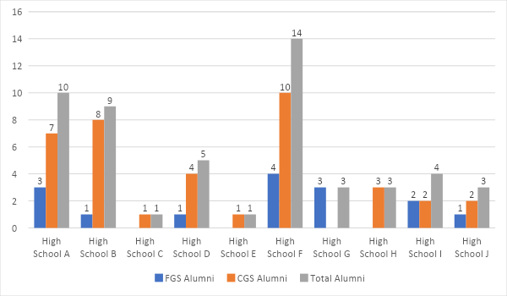

4.2 High school preparation
Of 38 respondents (ten FGS/28 CGS) regarding their frequency in visiting their high school library, three FGS and ten CGS visited daily or once a week. Prior to the COVID-19 shutdown, FGS and CGS alumni interacted with libraries/librarians for reasons ranging from acquiring books and other materials to using media or technology. Only one FGS compared with ten CGS had little or no contact with their high-school librarian as seen in Table 2.

Table 2: Interaction with high school library/librarian (select all that apply)
Library/Librarian Interaction
 | FGS | CGS
To get books and other materials | 5 | 7
To do research | 3 | 10
To ask for help with projects | 2 | 2
To attend a program outside of class | 2 | 4
To use media or technology | 2 | 15
To hang out | 4 | 10
Had classes taught by librarians with teachers | 3 | 18
Had classes taught by librarians independent of teachers | 3 | 2
Had librarians who advised in extracurricular club/activity | 1 | 1
Had librarians who collaborated with teachers to present extracurricular activities | 1 | 4
Little or No Librarian Interaction
 | FGS | CGS
 | 1 | 10

Six out of ten (60%) FGS and 11 out of 28 (39%) CGS visited the high school library website daily or once a month. One CGS stated that their high school library did not have a website.

In Table 3, all students had opportunities to acquire research skills outside the library context. They indicated which classroom teachers (other than a librarian) taught them research skills like evaluating information, crediting sources, and developing questions. Of interest, three FGS compared with zero CGS selected “English as a Second Language (ESL)” teachers.

Table 3: Classroom Teachers Who Taught Research Skills (Select all that apply)
Classroom Teachers Who Taught Research Skills | FGS Alumni | CGS Alumni
Art, Drama, Music, Visual & Performing Arts | 2 | 3
Industrial Arts | 1 | 0
English/Language Arts | 9 | 24
English as a Second Language (ESL) | 3 | 0
Mathematics | 3 | 2
Science/STEM | 6 | 17
Social Studies | 7 | 18
World Language | 1 | 6
Special Education | 2 | 0
Health/Physical Education | 1 | 2

Students were asked to select subject areas in which they took Honours courses and Advanced Preparation (AP) courses. Both generations were enrolled in all the Honours courses listed. Both FGS and CGS alumni groups were enrolled in AP courses except for the following, in which only CGS were enrolled: Art History (one), European History (one), German Language and Culture (one), US Government & Politics (three), Electricity and Magnetism (one), and Mechanics (one). Two FGS and five CGS did not take any AP courses. One FGS never enrolled in an AP course but did take the test. See Table 4.

Table 4: Enrolment in Honours and AP Courses (Select all that apply)
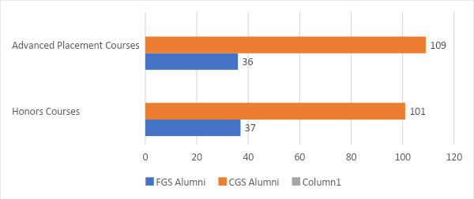

Respondents indicated that they learned a wide range of research related terminologies in high school. This aligns with the finding that the high school librarians in Phase 1 regularly provided and pointed to digital research resources; and they also did instruction relating to IL and the Framework. See Table 5.

Table 5: Terms Learned in High School
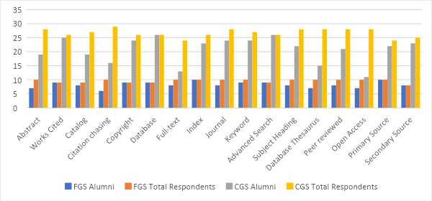

4.3 First-Year college experience
Two of ten (20%) FGS and nine of 26 (34%) CGS enrolled in Honours courses during the first year of college. Eighty percent (n=8) FGS did research projects in their first year at college while 100% (n=25) of CGS respondents did. However, comparatively small numbers of these alumni had a librarian help with these projects: one FGS and six CGS. Even so, seven of ten (70%) FGS felt comfortable or extremely comfortable navigating the quantity of information and services available through their college library. Nineteen of 25 (76%) CGS felt comfortable or extremely comfortable. Three FGS and six CGS felt overwhelmed when navigating resources and services of their college library.

Due to the COVID-19 pandemic many college libraries were not physically open during the first year of the students under study. In fact, 17/36 indicated that their libraries were closed and so they could not physically visit. Three FGS and five CGS chose not to physically visit their libraries while two FGS and nine CGS visited in person. Eighty percent (n=8) FGS and 88% (n=23) CGS used their college library website during their first year. The two FGS and three CGS that didn’t use the website indicated that they didn’t know that there was one. Sixty percent (n=6) FGS and 57% (n=15) CGS were moderately or extremely comfortable navigating the college library website. None of the alumni visited the library’s website/research guides, services, and tools daily. An equal number of FGS and CGS (n=7) representing 87% and 30% respectively visited about once per month. However, one FGS and five CGS visited once a week.

Regarding librarians, 20% of FGS (n=2) and 34% of CGS (n=9) knew the name or face of at least one college librarian. This aligns with the fact that few alumni indicated that they had received help from a librarian for their research projects. Table 6 shows how the alumni groups connected with a librarian during their first year.

Table 6: Ways of Connecting with a College Librarian in the First Year (Select all that apply)
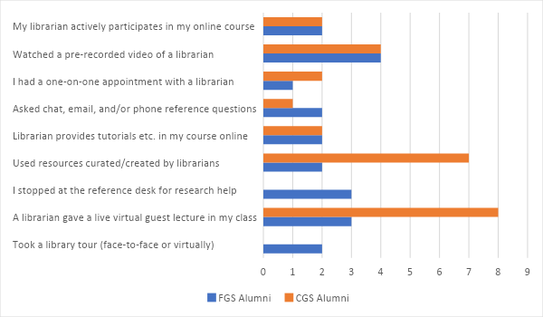

Furthermore, as shown in Tables 7 and 8, in rating the level of confidence felt in executing activities related to first-year college research projects, very few of this group of alumni non-novices selected “not confident”. For example, only one FGS indicated no confidence in “identifying/selecting best sources” after a search and only one FGS had no confidence in “selecting a database relevant to my research”.

Table 7: FGS Alumni Confidence in Research Activities

Table 8: CGS Alumni Confidence in Research Activities

Aligned with the continued acquisition of social capital in college, alumni were asked, “Who was the most helpful to you in terms of your research in your first year of college?” As is seen in Table 9, FGS were utilising all the avenues of support including a counsellor/advisor. One FGS stated that lab assistants were helpful during the research process. While six CGS stated that they figured things out on their own, only one FGS responded the same. Of note, CGS alumni seemed more comfortable with approaching instructors for support. For example, 3/12 (25%) FGS and 9/12 (75%) CGS found English Composition instructors most helpful. Also, 4/17 (23%) FGS vs 13/17 (73%) CGS found instructors/professors most helpful. While zero CGS selected tutors, two FGS found tutors most helpful. One FGS selected “counsellor/advisor” while zero CGS selected this option.

Table 9: Most Helpful for Your Research in First Year of College (Select all that apply)
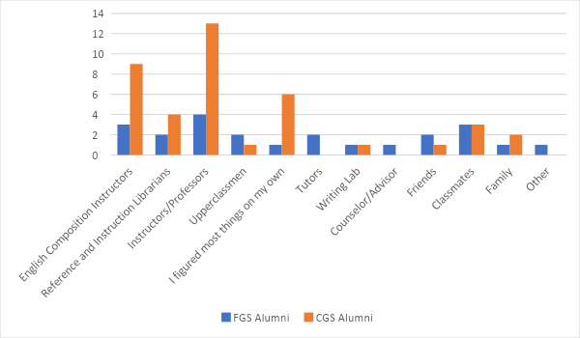

4.4 Comparing high school and first-year experience
Table 10 shows how 27 (8 FGS and 19 CGS) alumni rated their level of high school preparation for college-level research. Notably none of the FGS indicated a lack of preparedness. Comparatively, two CGS said they felt unprepared.

Table 10: Rating of High School Preparation for College-Level Research
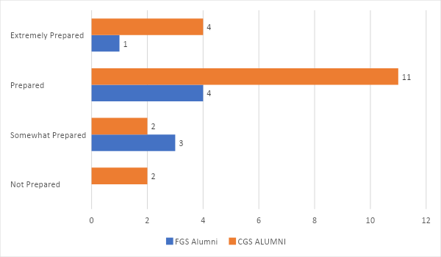

When asked specifically about their level of comfort in ability to credit/cite research sources when they began their college experience, both groups tended to be comfortable. While two CGS alumni expressed extreme discomfort with their ability, zero FGS expressed this level of discomfort. The same number of FGS (three) and CGS (three) selected “slightly uncomfortable”. See Table 11.

Table 11: Comfort in Ability to credit/cite research sources
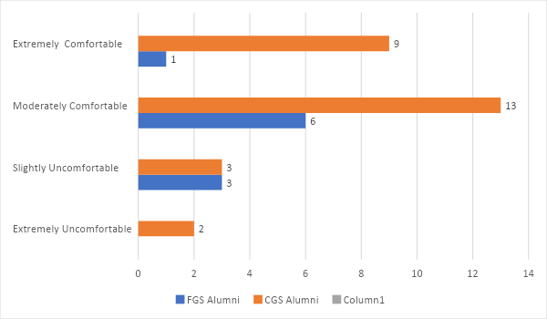

Alumni in general identified IL skill gaps related to academic sources like peer-reviewed journals and the specifics of citations that were expected in college. Notably, they named the APA expectations in college as an area that they were not prepared for. This is in contrast with the comfort that they felt coming into college in using a different citation style. One FGS alumni identified credibility of sources as a gap that they faced. Figure 1 also shows scholarly articles, peer-reviewed articles, and research as gaps.

Figure 1: Perceived IL Skill Gaps from High School to College Expectations
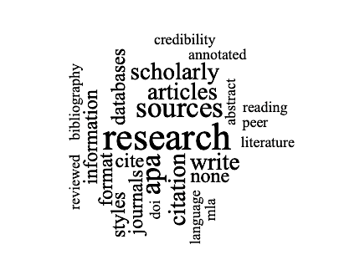
Three FGS and 16 CGS responded to the open-ended question,” What are the three most important things that you learned in your high school that you use in college?” One FGS stated, “What makes a source credible, how to search online for those sources, and how to cite MLA”. Responses are visualised in Figure 2.

Figure 2: Three Most Important Skills Learned in High School and Using in College
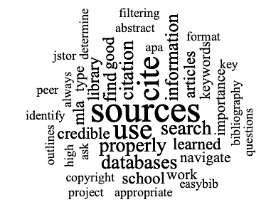
Regarding familiarity with research concepts aligned with the Framework, student responses aligned with the priorities of the certified librarians in their high schools. For example, as shown in Table 12, three FGS and 16 CGS were familiar with “Authority is Constructed and Contextual” concepts; four FGS and 19 CGS were familiar with “Research as Inquiry” concepts; and three FGS and 17 CGS were familiar with “Searching as Strategic Exploration” concepts.

During their first year of college, these students had acquired familiarity with research concepts aligned with additional Frames: seven FGS and 17 CGS selected “Information Creation as a Process”, three FGS and 17 CGS selected “Information has Value”, and three FGS and 19 CGS selected “Scholarship as Conversation”. One FGS and two CGS were not familiar with any of the concepts.

Table 12: Familiarity with Research Concepts Aligned with the Framework
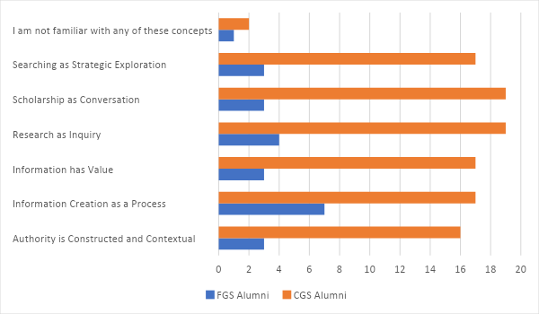

5. Discussion
5.1 Building social capital through high school preparation
According to Stanton-Salazar (1997), “…the power invested in school-based agents is understood not only in terms of moral support, but also in terms of their capacity to initiate and foster the development of the proper dispositions and motivational dynamics” (p. 3).
In the larger study Valenza et al. (2022a) and Valenza et al. (2022b) established the value of full-time certified high school librarians in college preparation specifically in IL. The current study highlights that these librarians functioned as conduits to social capital by making available what Nichols and Ángel Islas (2016) call “resources embedded in social structures” (p. 63). They provided inquiry instruction in the library and in classrooms with teachers and curated and provided digital resources. Sixty percent of FGS visited the school library website daily or once a month. Three FGS were exposed to library instruction taught by a librarian independent of a teacher and three FGS were exposed to library instruction by a librarian in collaboration with a teacher. These high school librarians also participated in extra-curricular activities as seen in Table 2. So, beyond the acquisition of skills for college-level research, FGS had further opportunities to create social networks with librarians in the library, in the classroom, and outside of the classroom. Notably, only one FGS had little or no interaction with their library/librarian.

In addition to instruction from high school librarians FGS had curriculum-specific opportunities to learn research skills in classes ranging from Art to ESL. Furthermore, both FGS and CGS students were enrolled in all the Honours courses listed in the survey. Only two (20%) FGS did not take any AP courses. So, despite the potential for their parents not understanding the value of taking such courses in college preparation (Warburton, et al, 2001) FGS had access to and enrolled in courses with the same rigour as their CGS peers.

Findings in this study align with that of LeMire et al. (2021b) who state, “most students come to college with at least a moderate level of information literacy preparedness, regardless of first-generation or continuing generation status” (p. 742). Students in this study had a high level of IL preparedness. They learned key terminologies (Table 6) and research related skills that made them feel confident to tackle college-level research (Tables 8 & 9). Very few of the total alumni non-novices expressed a low level of confidence in specific research activities. They indicated that they learned research related activities aligned with the same ACRL Frames that the high school librarians focused on. Generation did not matter.

At the beginning of their college experience, none of the FGS felt unprepared for college-level research. This attests to their high school experience with certified librarians in strong library programs. Regarding citing sources, FGS and CGS were equally “slightly uncomfortable”. This could be because they were starting to be exposed to other citation styles in college. As one FGS stated, it “…used to be all MLA now we use APA or Chicago too”. Of note, both generations named different citation styles as something they did not expect in college.

Both generations focused on credibility of sources, finding sources, and citing as the most important skills learned in high school that they were using in college during their first year. Interestingly, they also listed citations and finding scholarly and peer-reviewed sources as an IL research gap. Perhaps indicating more rigour in determining credibility of sources as one FGS indicated.

As aforementioned, Stanton-Salazar (1997) looks to institutional agents as conduits to institutional resources and opportunities. These include teachers and librarians. So, FGS and CGS from the same high schools with access to rigorous courses like Honours and AP and strong library programs with a full-time certified librarian have similar confidence in their preparation for college level-research. In fact, 20% FGS and 34% CGS enrolled in Honours courses at college. As Warburton et al. (2001) find, the generations did not differ in college with GPA and remedial college enrolment. Furthermore, they also showed familiarity with aspects of three ACRL Frames. So, FGS can build social capital with librarians in various settings and with some teachers outside the classroom.

5.2 Building social capital first year of college
FGS in this study were able to continue to build their social capital during the first year of college. They expanded their social networks for finding information by using agents across their institution. This tendency to make connections beyond the classroom and the library is demonstrated in Table 10. Students were asked, “Who was the most helpful to you in terms of your research in your first year of college?” FGS included lab assistants, counsellor/advisor, and tutors. Of note, none of the CGS selected these agents. This FGS leaning aligns with Brinkman et al. (2013) and Couture et al. (2021) who find that they tend to look outside the libraries for research help. Brinkman et al. (2013) state that they turn to “working-class university staff such as bus drivers, custodians, and cafeteria servers as another source of information and support” (p. 647). In this case, although they did not consult “working-class” agents, they did go outside the classroom and the library for research help.

Interestingly, only 25% FGS and 23% FGS found English Composition instructors and professors most helpful respectively. So, it seems that they are taking a longer time to feel comfortable with college professors than their CGS peers. Instructors should therefore use asset-based instructional strategies to ensure that these students can see themselves in the curriculum and feel more connected to the instructors (Delima, 2019; Folk, 2021; Folk, 2018; Ilett, 2019b; Morrison, 2017; Quiñonez & Olivas, 2020; Verdín et al., 2021).

Aligned with Borelli et al. (2018), FGS demonstrated that they continued to build library-related capital in college. Students became “increasingly proactive as they learned to capitalize on available resources and acknowledged the libraries’ contributions to their academic and personal needs and experiences” (p. 32). Eighty percent FGS used the library website and 60% were comfortable navigating it. Seventy percent were comfortable with the amount of information and services from their college library. This is despite only one FGS getting direct help from a librarian with a research project. It should be noted that FGS were still able to interact with an academic librarian/librarian curated tools in various instructional ways as seen in Table 7 to the extent that two FGS knew the name or face of at least one librarian. So, FGS continued to build social networks (capital) via the libraries.

Additionally, both generations continued to build on their knowledge of research concepts associated with the Framework. Whereas the high school librarians had focused on “Authority is Constructed and Contextual”, “Research as Inquiry” and “Search as Strategic Exploration”, by the end of their first year of college most students had added aspects of the other 3 Frames to their knowledge base. For example, one FGS demonstrated “Authority is Constructed and Contextual”, “Searching as Strategic Exploration”, “Research as Inquiry”, and “Scholarship as Conversation” knowledge practices by saying:

I have started looking at scholarly sources instead of surface-level articles and webpages. My research has benefited from both my understanding of complex studies and experiments and my inclusion of various facts and statistics. Also, I ‘shop around’ for my sources now. I don’t settle on the first one I find. Much of the time, the first few resources I find bring my attention to something I never realized, which will steer my search toward a different direction. Finally, I make use of articles’ bibliographies now. I look to see which sources the author has cited and if those particular sources will suit my needs best.

It seems that during this first year, FGS were on par with CGS in general. This aligns with Pickard and Logan (2013) who state that, “regardless of the disadvantages with which (FGS) students arrive at college, at some point before they graduate, college appears to provide them with the tools they need to compete with their peers. In particular, the library has a role to play in this process” (p. 412). Only in this case, the students were making strides during their first year.

5.3 Implications for academic librarians
Although few FGS worked with a college librarian for their research assignments during their first year, and despite the gaps they identified in their preparation, they emerged as capable students for college-level research. This begs for academic librarians to employ asset-based instructional approaches to IL instruction (Delima, 2019; Folk, 2021; Folk, 2018; Ilett, 2019b; Morrison, 2017; Quiñonez & Olivas, 2020; Verdín et al., 2021). Ilett (2019b) encourages valuing “the skills and knowledge that students bring with them to college as the foundation for further, collaborative learning” (p.189). Furthermore, the ACRL Framework (2016) encourages understanding of “how and why some individuals or groups of individuals may be underrepresented or systematically marginalized within the systems that produce and disseminate information”. Accordingly, Ilett (2019b) recommends, “Librarians can engage with first-generation students in exploring the ways in which information itself reflects and reproduces power and social inequalities'' (p.180). Thus, FGS could see themselves in the curriculum.

Moreover, as Graves et al. (2021) and LeMire et al. (2021a) suggest, librarians can target demographic groups in courses, learning communities, and academic programs that aim to support FGS in developing IL skills as early as possible. Pickard and Logan (2013) confirm this as FGS (seniors) speak with more specificity about databases and library resources. They find that the library plays a part in providing FGS with tools to compete with their peers despite the disadvantages with which they may start college.

This study shows FGS already feeling on par or ahead of CGS. This is opposite to Brinkman et al. (2013) who found FGS feeling information-poor compared to CGS regarding academic information seeking. In response to the open-ended question about a positive experience or discovery related to research in college, one FGS stated, “I was happy that for the most part, I was ahead of my peers because I knew how to find good sources and easily weave multiple together in support of my argument”. This student’s comment is key in librarian approaches to instruction. LeMire et al. (2021a) encourage librarians to avoid the assumption that all FGS have limited experience or are not confident and to utilise pre-assessments to meet student needs effectively.

5.4 Issues of inequity
Valenza et al. (2022a) raise the issue of inequity for all high school students without access to a certified librarian and a strong library program. Stanton-Salazar (1997) makes the point, “The possession of social capital does not imply the utilization of support, but rather the potential for such utilization” (p. 10). Lin emphasises the impact of lack of social capital: “(it) depends on the size of one’s connections and on the volume or amount of capital in these connections’ possession” (p. 22). This is compounded for FGS who come from high schools without such support to aid them in honing inquiry and research skills including coming to college with relevant terminology for college-level research. As Long (2011) finds of the fully Latino FGS sample, “All described their secondary schools as inadequate and unable to offer the opportunities they believe their peers from more affluent communities had” (p. 507). It is incumbent upon institutions to “situate youth within resource-rich networks by actively manipulating the social and institutional forces that determine who shall ‘make it’ and who shall not” (Stanton-Salazar, 1997, p. 11). This is critical at the high school level in college preparation for academic research. This responsibility extends to colleges. Until high schools address the gaps in preparation via creation of adequately staffed, strong library programs, colleges and universities need to identify underprepared FGS early to avoid a “…continuation of the status quo. Even when hard-working students from less privileged backgrounds pave their way to higher education, their performance and prospects of success are hampered due to systemic educational structures of universities that favor their better prepared peers” (Ward et al., 2012, p. 12).

5.5 Limitations
This study was conducted entirely online. Therefore, those who were more comfortable with online technology would be more prone to participate. Additionally, not all questions were required to be answered by participants and those who did not have a research assignment in their first year of college were able to skip the questions asking about their research experience. Therefore, sample sizes vary per answered question (Valenza et al., 2022a). Furthermore, the demographic portion of the survey did not ask for race/ethnicity which would have been useful in providing more context on the backgrounds of the FGS students.

6. Conclusion
Through high schools with certified librarians and strong library partnerships, FGS are afforded opportunities to develop social capital in the area of research skills. They are exposed to many research terminologies, making them confident in their research abilities when they start college. In these cases, generation did not matter. FGS and CGS had similar feelings of levels of preparedness and IL gaps perceived in college. Even when they did not work with a college librarian in their first year, they felt confident in doing research. In their first year, FGS had begun to extend their social networks beyond the library and classroom to include other agents on campus. FGS students taking more rigorous courses such as AP and Honours in high school can close the college preparation gap and help them perceive that they are on par with their CGS counterparts when they get to college. FGS and CGS coming from the same effective high schools are similarly competent for the rigours of college-level research during their first year of college.

This work underscores the need for institutions to address issues of inequities where FGS do not have access to strong high school library programs. High schools and communities should agitate to hire certified high school librarians. Colleges should identify such students early in order to take appropriate steps to facilitate their success. Faculty need to implement appropriate pedagogies. Academic librarians need to diversify instructional approaches to include these student experiences. Otherwise, FGS will continue to lag behind CGS as they enter college.

7. References
Almeida, D. J., Byrne, A. M., Smith, R. M., & Ruiz, S. (2021). How relevant is grit? The importance of social capital in first-generation college students’ academic success. Journal of College Student Retention: Research, Theory & Practice, 23(3), 539–559.

American Association of School Librarians (AASL). (2018a). Definitions of an effective school library.

American Association of School Librarians (AASL). (2018b). National school library standards for learners, school librarians, and school libraries. American Library Association.

Association of College & Research Libraries (ACRL). (2016). Framework for Information Literacy for Higher Education. American Library Association.

Borrelli, S., Su, C., Selden, S., & Munip, L. (2018). Investigating first-generation students’ perceptions of library personnel: A case study from the Penn State University Libraries. Performance Measurement and Metrics, 20(1), 27–36.

Brinkman, S., Gibson, K., & Presnell, J. (2013). When the helicopters are silent: The information seeking strategies of first-generation college students. ACRL 2023 Conference Proceedings, American Library Association, April 10–13, 2013.

Byrd, K. L., & MacDonald, G. (2005). Defining college readiness from the inside out: First-generation college student perspectives. Community College Review, 33(1), 22–37.

Cataldi, E. F., Bennett, C. T., & Chen, X. (2018). First-generation students: College access, persistence, and post bachelor’s outcomes. Stats in brief. NCES 2018-421. National Center for Education Statistics.

Couture, J., Bretón, J., Dommermuth, E., Floersch, N., Ilett, D., Nowak, K., Roberts, L., & Watson, R. (2021). “We’re gonna figure this out”: First-generation students and academic libraries. portal: Libraries and the Academy, 21(1), 127–147.

Delima, D. G. (2019). Making a case for a funds of knowledge approach to teaching and learning for first-generation college students. College Teaching, 67(4), 205–209.

Deng, X. (Nancy), & Yang, Z. (2021). Digital proficiency and psychological well-being in online learning: Experiences of first-generation college students and their peers. Social Sciences (Basel), 10(6), 192.

Farmer, L. S. J., & Phamle, S. (2021). Transitioning to college: Impact of high school librarians. The Journal of Academic Librarianship, 47(1).

Folk, A. (2021). Exploring the development of undergraduate students’ information literacy through their experiences with research assignments. College & Research Libraries, 82(7), 1035.

Folk, A. (2018). Drawing on students’ funds of knowledge: Using identity and lived experience to join the conversation in research assignments. Journal of Information Literacy, 12(2), 44-59.

Graves, S. J., LeMire, S., & Anders, K. C. (2021). Uncovering the information literacy skills of first-generation and provisionally admitted students. The Journal of Academic Librarianship, 47(1), 102260.

Hao, R. N. (2011). Critical compassionate pedagogy and the teacher's role in first-generation student success. New Directions for Teaching and Learning, 2011(127), 91–98.

Head, A. (2013). Learning the ropes: How freshmen conduct course research once they enter college.

Head, A., & Eisenberg, M. (2010). Truth be told: How college students evaluate and use information in the digital age.

Higher Education Act of 1965, 1998 Higher Education Act Amendments Subpart 2—Federal Early Outreach and Student Services Programs.

Ilett, D. (2019a). A critical review of LIS literature on first-generation students. Portal: Libraries and the Academy, 19(1), 177–196.

Ilett, D. (2019b). First-generation students’ information literacy in everyday contexts. Journal of Information Literacy, 13(2), 73.

Julien, H., Gross, M., & Latham, D. (2018). Survey of information literacy instructional practices in US academic libraries. College & Research Libraries, 79(2), 179–199.

Lance, K. C., & Kachel, D. E. (2018). Why school librarians matter: What years of research tell us. Phi Delta Kappan, 99(7), 15–20.

LeMire, S., Graves, S. J., Bankston, S., & Wilhelm, J. (2021a). Similarly different: Finding the nuances in first year students' library perceptions. The Journal of Academic Librarianship, 47(4), 102352.

LeMire, S., Xu, Z., Hahn, D., Balester, V., & Dorsey, L. G. (2021b). Assessing the information literacy skills of first-generation college students. College & Research Libraries, 82(5), 730.

Lin, N. (2001). Social capital: A theory of social structure and action. Cambridge University Press.

Long, D. (2011). Latino students’ perceptions of the academic library. The Journal of Academic Librarianship, 37(6), 504–511.

Longwell-Grice, R., & Longwell-Grice, H. (Eds.). (2021). At the intersection: Understanding and supporting first-generation students. Taylor & Francis Group.

McCallen, L. S., & Johnson, H. L. (2020). The role of institutional agents in promoting higher education success among first-generation college students at a public urban university. Journal of Diversity in Higher Education, 13(4), 320–332.

Morrison, K. L. (2017). Informed asset-based pedagogy: Coming correct, counter-stories from an information literacy classroom. Library Trends, 66(2), 176–218.

Murphy, C. G., & Hicks, T. (2006). Academic characteristics among first-generation and non-first-generation college students. College Quarterly, 9(2).

Nichols, L., & Ángel Islas. (2016). Pushing and pulling emerging adults through college. Journal of Adolescent Research, 31(1), 59–95.

Padgett, R. D., Johnson, M. P., & Pascarella, E. T. (2012). First-generation undergraduate students and the impacts of the first year of college: Additional evidence. Journal of College Student Development, 53(2), 243–266.

Peralta, K. J., & Klonowski, M. (2017). Examining conceptual and operational definitions of "first-generation college student" in research on retention. Journal of College Student Development, 58(4), 630–636.

Pickard, E., & Logan, F. (2013). The research process and the library: First-generation college seniors vs. freshmen. College & Research Libraries, 74(4), 399–415.

Purcell, K., Rainie, L., Heaps, A., Buchanan, J., Friedrich, L., Jacklin, A., Chen, C., & Zickuhr, K. (2012). How teens do research in the digital world. Pew Internet & American Life Project.

Quiñonez, T. & Olivas, A. (2020). Validation theory and culturally relevant curriculum in the information literacy classroom. Urban Library Journal, 26(1), 1–17.

Reid, M. J., & Moore, J. L. (2008). College readiness and academic preparation for postsecondary education: Oral histories of first-generation urban college students. Urban Education, 43(2), 240–261.

Richardson, J. G. (1986). Handbook of theory and research for the sociology of education. Greenwood Press.

Ricks, J. R., & Warren, J. M. (2021). Transitioning to college: Experiences of successful first-generation college students. Journal of Educational Research and Practice, 11(1).

Salehi, S., Cotner, S., & Ballen, C. J. (2020). Variation in incoming academic preparation: Consequences for minority and first-generation students. Frontiers in Education, 5. 552364.

Saunders, L., Severyn, J., & Caron, J. (2017). Don't they teach that in high school? Examining the high school to college information literacy gap. Library & Information Science Research, 39(4), 276–283.

Stanton-Salazar, R. (1997). A social capital framework for understanding the socialization of racial minority children and youths. Harvard Educational Review, 67(1), 1–40.

Terenzini, P. T., Springer, L., Yaeger, P. M., Pascarella, E. T., & Nora, A. (1996). First-generation college students: Characteristics, experiences, and cognitive development. Research in Higher Education, 37(1), 1–22.

Tsai, T. -I. (2012). Coursework-related information horizons of first-generation college students. Information Research, 17(4).

Valenza, J. K., Dalal, H., Mohamed, G., Boyer, B., Berg, C., Charles, L. H., Dempsey, M., Bushby, R., Dalrymple, J. & Dziedzic-Elliott, E. (2022a). First Years’ information literacy backpacks: What’s already packed or not packed? Journal of Academic Librarianship, 48.

Valenza, J., Berg, C., Boyer, B., Bushby, R., Charles L. H., Dalal, H. A., Dalrymple, J., Dempsey, M., Dziedzic-Elliott, E., & Mohamed, G. (2022b). First Years meet the Frames.

Verdín, D., Smith, J. M., & Lucena, J. C. (2021). Recognizing the funds of knowledge of first‐generation college students in engineering: An instrument development. Journal of Engineering Education, 110(3), 671–699.

Warburton, E. C., Bugarin, R., & Nunez, A. (2001). Bridging the gap: Academic preparation and postsecondary success of first-generation students. Statistical analysis report. postsecondary education descriptive analysis reports.

Ward, L., Siegel, M. J., Davenport, Z., Ward, W., Siegel, h. J., & Davenport, u. (2012). First-generation college students: Understanding and improving the experience from recruitment to commencement. John Wiley & Sons, Incorporated.

8. Declarations
8.1 Ethics Approval
The study received Institutional Review Board approval (Study ID: Pro2019001581)

8.2 Funding
The First Years Meet the Frames study was supported by a Rutgers University, School of Communication and Information Science Grant for Individual Faculty Research.

8.3 Acknowledgements
The author gratefully acknowledges the librarians who participated in the larger study from which this work subsequently came.

