Article

Information and digital literacy at school: A BRIDGE between critical thinking and equality values

http://dx.doi.org/10.11645/20.1.836

Dora Sales
Professor, Universitat Jaume I (Castellón-Spain). Email: dsales@trad.uji.es. ORCID: 0000-0002-6290-2013.

Konstantina Martzoukou
Associate Professor, Robert Gordon University (Aberdeen, Scotland-United Kingdom). Email: k.martzoukou@rgu.ac.uk. ORCID: 0000-0003-3435-6606.

Sarah Pavey
Education Consultant, SP4IL (Epsom-United Kingdom). Email: sarahjpavey@gmail.com. ORCID: 0009-0005-1235-6420.

Stéphane Goldstein
Executive Director, InformAll CIC (London-United Kingdom). Email: sg@informall.org.uk.

Noora Hirvonen
Professor, University of Oulu (Oulu-Finland). Email: noora.hirvonen@oulu.fi. ORCID: 0000-0001-7577-3057.

Heidi Enwald
University Lecturer, University of Oulu (Oulu-Finland). Email: heidi.enwald@oulu.fi. ORCID: 0000-0003-1953-2157.

Serap Kurbanoğlu
Professor, Hacettepe University (Ankara-Türkiye). Email: serap@hacettepe.edu.tr. ORCID: 0000-0002-9561-9978.

İpek Şencan
Assistant Professor, Hacettepe University (Ankara-Türkiye). Email: ipeksencan@hacettepe.edu.tr. ORCID: 0000-0002-3318-8981.

Anna Antoniazzi
Associate Professor, University of Genoa (Genoa-Italy). Email: anna.antoniazzi@unige.it. ORCID: 0000-0003-2955-3840.

Mara Morelli
Senior Lecturer, University of Genoa (Genoa-Italy). Email: mara.morelli@unige.it.
ORCID: 0000-0002-3036-1486.

Christina Banou
Professor, Ionian University (Corfu-Greece). Email: cbanou@ionio.gr.

Petros Kostagiolas
Professor, Ionian University (Corfu-Greece). Email: pkostagiolas@ionio.gr. ORCID: 0000-0001-8974-1128.

Abstract
The BRIDGE project (Information and Digital Literacy at School: A Bridge to Support Critical Thinking and Equality Values for Primary Education Using Children’s Literature and Transmedia) addresses the urgent need for structured information and digital literacy education in primary schools. In an era of increasing dis/misinformation, polarisation, and threats to democratic values, young learners are particularly vulnerable to manipulative online content, hate speech and algorithm-driven bias. Despite the recognised importance of critical literacy skills, primary education curricula across Europe exhibit significant gaps in embedding information, digital, and media literacy in a way that is pedagogically sound and transferable across diverse educational contexts. Since the COVID-19 pandemic these challenges have been further exacerbated, accelerating digitalisation while exposing the digital divide.

In response, the BRIDGE project (developed through a transnational Erasmus+ KA2 partnership across six countries: Spain, Turkey, Italy, Finland, Greece, and the United Kingdom) proposes an innovative framework to embed information and digital literacy within the primary education curriculum through children’s literature and transmedia, and dialogic reading strategies. This article presents the project’s conceptual framework and the diagnosis on the
strategies developed in the project countries in order to promote information and digital literacy in primary education, together with the project’s practical outcomes (open access portal and training suggestions), emphasising its relevance for primary educators, school librarians, and policymakers.

The BRIDGE project intends to contribute to both academic discourse and practical education reform, offering evidence-based recommendations for integrating information and digital literacy into primary education. For school librarians, the project provides tools to reposition libraries as active learning spaces, encouraging ethical information use and digital resilience in young learners. BRIDGE may serve as a model for addressing contemporary socio-political challenges, helping future citizens navigate and critically engage with an increasingly complex information landscape.

Keywords: critical information literacy; democracy; digital literacy; disinformation; diversity; equality; ethics; information literacy; information sources; media literacy; misinformation; school libraries

- Introduction
In an era marked by rising polarisation in society, the proliferation of hate speech, and growing threats to democratic values (Regehr et al. 2024; Skipper, 2025), the role of education in nurturing critical thinking and equality has never been more crucial. Information literacy (IL) is fundamental for people of all ages to enable participation in contemporary society and is therefore specifically a key competence to be developed starting from early childhood (Baji et al., 2018; Batool & Webber, 2019; Chu et al., 2011; Gardner et al., 2020). The global information landscape is increasingly shaped by dis/misinformation, algorithm-driven filter bubbles and echo chambers, and a declining public trust in institutions. Children, as digital citizens, are especially vulnerable to these paradigms, yet current primary education curricula often lack robust frameworks for developing information and digital literacy skills that enable young learners to navigate these complexities.

In some countries, for the primary education stage, the socio-educational need to promote IL has produced an institutional response with the inclusion of information and digital competences in the school curriculum and in current legislation. But the reality is that there is no sound educational approach, no updated and transferable curricular design, and no substantial support for school libraries. Indeed, the results of both the PISA Programme (Programme for International, 2018) and recent academic research (Martínez-Piñeiro et al., 2019) regarding IL of primary school students show huge gaps that urgently need to be addressed.

The BRIDGE project (Information and Digital Literacy at School: A Bridge to Support Critical Thinking and Equality Values for Primary Education Using Children’s Literature and Transmedia) addresses this gap by providing a comprehensive, transnational strategy for integrating information and digital literacy into primary education. The proposal is aimed at children in the approximate middle primary school stage (aged eight-11 years, age range chosen to cover as far as possible an intermediate stage of primary education in all countries participating in the project) because BRIDGE seeks to emphasise the importance of promoting information and digital literacy before adolescence and at this intermediate stage of primary school children already have autonomous and reflective reading skills. (BRIDGE, 2026a).

The urgency of this initiative has been further underpinned by the legacy of the COVID-19 pandemic, which accelerated the digitalisation of education while exposing deep inequalities in access to information and digital literacy. As classrooms moved online, disparities in digital access, digital literacy, and critical thinking skills became even more pronounced, amplifying vulnerabilities to dis/misinformation and extremist narratives. This period demonstrated that information and digital literacy is not merely (and has never been) a technical skillset but a fundamental pillar of democratic participation, equity, and social cohesion. Schools and school librarians are now on the frontlines of an educational challenge learning how to equip their students not only to access and use information but also to analyse, evaluate, and create content responsibly in an increasingly complex digital world.

Against this backdrop, the BRIDGE project, developed through an Erasmus+ KA2 European partnership of eight institutions across six countries (Universitat Jaume I, Spain; Hacettepe Universitesi and Cankaya Universitesi Vakfi, Turkey; Università degli Studi di Genova, Italy; University of Oulu, Finland; Ionian University, Greece; InformAll and SP4IL, United Kingdom), proposes an innovative approach to embedding information and digital literacy within the primary school curriculum. By using children’s literature and transmedia storytelling, BRIDGE provides educators with suggestions and practical tools to teach young learners how to critically assess information, challenge stereotypes, and engage in constructive dialogue. The project is aligned with UNESCO’s Media and Information Literacy (MIL) framework and the European Commission’s Digital Education Action Plan, advocating for the integration of IL as a cornerstone of democratic education. BRIDGE has presented its results at the last two editions of ECIL (European Conference on Information Literacy) (Sales et al., 2023, 2025).

Table 1: Main project results (BRIDGE, 2026a).
Project Results | Content
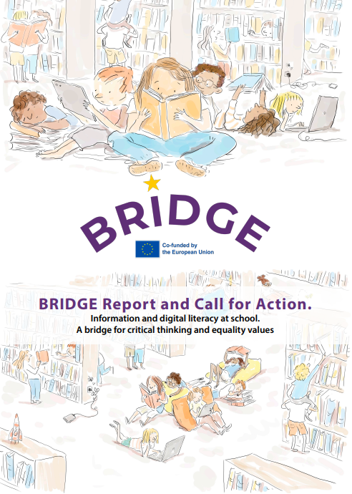 | 1. A report presenting the conceptual framework of the project and a diagnosis on the strategies in each of the six participating countries to promote information and digital literacy in the school curriculum.
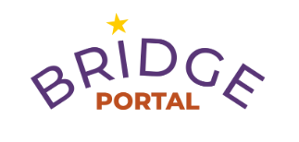  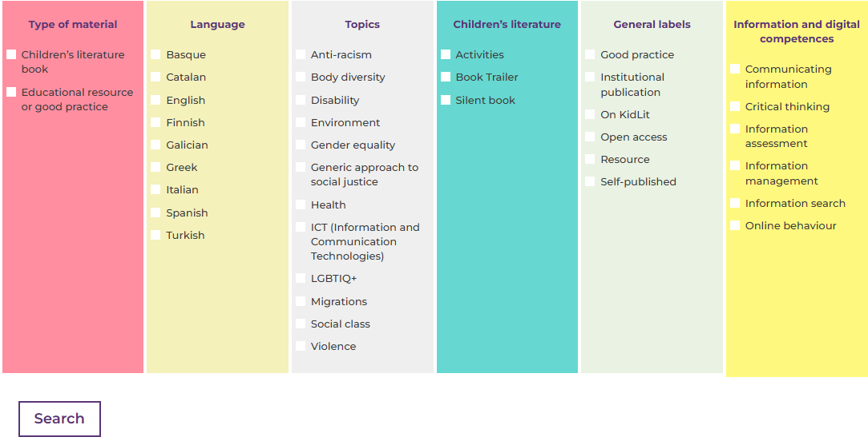 | 2. An open access portal with selected resources and curated children’s literature (picture books) to promote information and digital literacy in primary education, to support teachers and school librarians in developing critical thinking and equality values in young learners.
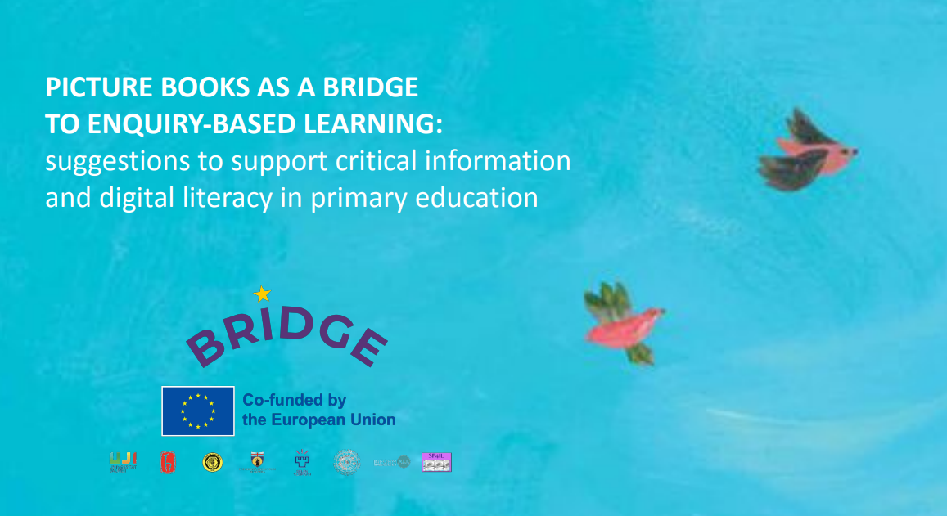 | 3. A booklet that features a pedagogical model with training suggestions for dialogic reading, equipping teachers and school librarians with structured questioning techniques to help children identify bias, assess credibility and engage in inquiry-led learning, making use of children’s literature (in particular picture books) and transmedia narratives to develop information and digital literacy activities.
The BRIDGE project’s outcomes are designed to be immediately applicable in primary education settings, offering a series of tools, methodologies, and pedagogical frameworks that may empower both teachers and school librarians to engage children with information and digital literacy. The project builds upon the premise that primary school education plays a foundational role in shaping children's attitudes toward knowledge, critical inquiry, and democratic participation.

The BRIDGE project has developed a multilingual, open-access platform that serves as a hub for best practices, resources, and interactive learning materials (BRIDGE, 2026b). Educators and librarians are able to access children’s book recommendations and websites to promote engagement with IL from an early age. One of the key contributions of BRIDGE is its framework for dialogic reading, which uses structured questioning techniques and discussion prompts to help children interrogate information, identify bias, and explore multiple perspectives in texts. This approach is particularly relevant for school librarians, who play a critical role in curating materials and guiding students toward informed, reflective reading practices.

Beyond traditional IL, BRIDGE emphasises the ethical and civic dimensions of digital literacy. The project’s materials include guidelines for using children’s literature and transmedia narratives to introduce complex social issues such as gender equality, social justice, dis/misinformation, and online safety in age-appropriate ways. This enables teachers and librarians to engage children in meaningful discussions about the role of information in shaping their understanding of the world. In recognition of how students engage with information in the digital age, BRIDGE integrates transmedia storytelling techniques to enhance critical engagement with digital content. These strategies encourage children to not just consume stories but actively analyse and create their own narratives, reinforcing both digital, IL and creative expression.

The project has documented practical training session videos that help teachers and school librarians build confidence and expertise in digital and IL instruction. These resources focus on bridging the gap between formal curriculum requirements and real-world classroom/library applications, ensuring that information and digital literacy is embedded across subjects rather than treated as an isolated skillset.

By advancing a transnational, collaborative and evidence-based approach, the BRIDGE project offers a scalable model for countering digital dis/misinformation, promoting equality, and strengthening democratic engagement from an early age. For academics studying IL, education policy, and library sciences, BRIDGE provides an in-depth dataset on the current state of digital and IL in primary education across six European countries, highlighting best practices, challenges, and pedagogical innovations.

For school librarians, BRIDGE represents a practical toolkit that acknowledges their evolving role as information facilitators and digital literacy educators. It reinforces the library’s role as an active space for inquiry-led learning, where children can develop information-seeking behaviours, critical appraisal skills, and ethical digital citizenship in a structured yet exploratory environment.

For primary school teachers, the project offers a clear roadmap for embedding digital and IL within existing curricula, ensuring that students not only learn how to search for information but also how to evaluate, interpret, and ethically use it. As dis/misinformation and digital manipulation become more sophisticated, equipping children with early-stage critical literacy skills is essential in preventing future susceptibility to online radicalisation, hate speech, and conspiracy theories.

This article presents the framework and diagnosis of strategies to promote equality-based information and digital literacy in primary education, as well as the tools developed through the BRIDGE project. The project serves as a call to action for academics, teachers, school librarians and policymakers to recognise information and digital literacy not just as an educational skill but as a fundamental right and necessary competency for the 21st century.

- BRIDGE Framework
The BRIDGE project has sought to address information and digital literacy specifically in relation to critical thinking and equality values in primary education using children’s literature and transmedia narratives. BRIDGE aligns with the idea that children’s literature “enhances children’s literary awareness and information literacy, and has the potential to encourage readerly empathy” (Mallan, 2017). Transmedia relates to “different story forms that flow across multiple media channels” (Jenkins, 2003), such as book-trailers and animations (Martzoukou, 2022; Martzoukou et al., 2023). Storytelling using transmedia represents “a process where integral elements of a fiction get dispersed systematically across multiple delivery channels for the purposes of creating a unified and coordinated entertainment experience” (Jenkins, 2003).

In the project, equality values are understood as the values of a democratic and ethical culture based on respect for human rights, regardless of gender, culture, religion, sexual orientation or any other aspect of identity, to be dealt with in an informed and non-stereotypical way in line with critical IL (Drabinski & Tewell, 2019). Central to this project is also the use of children’s literature, emphasising its importance in education as a primary tool for socialisation. Zohar Shavit (1986) explained that children’s literature is doubly attached to both the literary and educational systems. Moreover, “(...) children’s literature, much more so than adult literature, is the product of constraints imposed on it by several cultural systems, such as the educational, the ideological, and so on” (Shavit, 1986, p. x). Therefore, narratives (both textual and visual, such as in picture books) based on values of equality can contribute precisely to an egalitarian education (Kanwal, 2024; Nikolajeva, 2013; Simpson & Cremin, 2022).

The changing nature of the information landscape, particularly with the rapid evolution of teaching and learning since the COVID-19 pandemic has signified an era of information and digital education at all levels via new possibilities offered by digital technology and has further reinforced the importance of ensuring that everyone has equal access to education in which the use of digital technologies and media has increased, even in face-to-face educational settings. There is now a growing awareness of the importance of educating young people at all levels, including early years and primary education, to equip them with the information and digital skills to help them become future citizens, along with renewed directions around the establishment of relevant standards. For example, the Digital Education Action Plan (2021-2027) provides the European Union (EU) with a policy initiative that designates a shared EU vision and direction, focusing on providing “high-quality, inclusive and accessible digital education in Europe'', “greater cooperation” in the digital education environment and the enhancement of “digital skills and competences'' that can be achieved by means of creating “common guidelines for teachers and educators to foster digital literacy and tackle disinformation through education and training” (European Commission, 2023).

However, the concept of information and digital literacy has diverse and sometimes conflicting conceptualisations or definitions that make standardising research findings and practice quite difficult (Bawden, 2001). For example, some definitions place emphasis on functional digital skills such as the ability to use digital tools and technologies, others focus on computational thinking and coding with an emphasis on employability and the economy, while others stress higher level transferable IL skills, such as critical evaluation, problem solving and the ability for lifelong learning, with a focus on changing online behaviours and expectations (Hague & Payton, 2010; Jenkins, 2007; Belshaw, 2014). The BRIDGE project focuses on key directions that are underpinned by core equality values that emphasise the importance and impact of information and digital literacy skills for critical thinking, participation, and lifelong learning.

Conceptually, BRIDGE aligns with the following definitions of IL: “the ability to think critically and make balanced judgements about any information we find and use.. addressing the challenges of the modern information society” and “…at all stages of education, from school to higher education” (CILIP, 2018). IL is “about people's ability to operate effectively in an information society” (Bruce, 1999) and it is “inextricably associated with information practices and critical thinking in the information and communication technology environment” (Bruce, 2004). IL also encompasses understanding of the wider context of a learner’s information experiences, the development of an “adaptive, transferable and ongoing” IL mindset (Martzoukou & Sayyad, 2017), coinciding with the notion that IL is not just functional information skills but “ways of knowing” (Lloyd, 2010, p. 26). In other words, IL is not just about acquiring the skills to use tools and to find resources but it includes lifelong learning and professional development, and the ability to interact with others in the information society (Kirton & Barham, 2005). This concept of IL as an enabler for participation in the information society and as an essential component of continuous learning has also been embraced by the United Nations Educational, Scientific and Cultural Organisation (UNESCO): “Information Literacy…is a prerequisite for participating effectively in the Information Society, and is part of the basic human right of lifelong learning” (UNESCO, 2003) and within a digital world, promoting social inclusion of all nations” (Horton, 2008, p.63).

More recently, UNESCO has put emphasis on a composite concept of MIL, which is perceived as “an important prerequisite for fostering equitable access to information and knowledge and promoting free, independent and pluralistic media and information systems’, a means of empowerment of people. MIL “recognizes the primary role of information and media in our everyday lives”. Similarly within the UK, the work of CILIP since 2021 has moved on from a single focus on IL to contribute to the establishment in 2021 of the Media and Information Literacy Alliance (MILA), “help[ing] people lead happier, healthier, safer and more productive lives”.

Focusing on the concept of digital competences, in the European context in which the BRIDGE project is located the Digital Education Vision for the European Schools is that “Every pupil and student develops…digital competence to foster confident, critical, responsible and creative use of, and engagement with, digital technologies for learning, at work, and for participation in society” (Schola Europaea, 2019). That encompasses not only what people can effectively do, but also what behaviour and attitudes they should be developing towards technology and online connectivity, with responsibility as online citizens and with confidence as creators of content. Digital competence is also included as one of the eight key competences in Key Competences for Lifelong Learning in the European Schools (Schola Europaea, 2018) with initiatives to support both functional (e.g., online accessibility, use of technology) and behavioural/attitudinal aspects (online safety, media literacy and cyber security and resilience), using self-assessment tools, such as SELFIE (European Commission, 2022). The Digital Competence Framework (DCF) (Schola Europaea, 2020), which is based on the European Digital Competence Framework for Citizens (also known as DigComp), similarly describes digital competence as a necessary transversal key competence on the basis of lifelong learning and participation in the information society on different levels (education, work and everyday life) (Carretero et al., 2017).

The DCF offers the foundations required for the development of key skills at different levels, with learners supported to develop them from an early age to primary and then secondary education, with increasing autonomy. Structured in five areas — information and data literacy, communication and collaboration, digital content creation, safety and problem solving — it addresses finding, understanding, evaluating, creating, communicating, and safely using digital information, with a dedicated area on problem solving, which emphasises innovation, lifelong learning, and continuous development. Of particular interest to this work is the first area of the DCF, ‘Information and Data Literacy’ which aligns with the concept of IL.

Within the primary school context, although it is assumed that information and digital literacy (or competencies) should be developed at an early age (Aesaert et al., 2013; Ilomäki et al., 2016) it is not yet clear how this vision can be enabled. Although young people are exposed to and interact with the online digital environment and the surrounding information overload both online and offline, there still a fundamental lack of research focusing on younger learners and particularly within the context of primary education to explore both the challenges and the opportunities created in the fast-growing digital information environment.

An earlier study by Aesaert and van Braak (2015) found that by the time children finish primary school they already experience challenges with online information evaluation, the creation of digital content, and advanced search strategies. More recent research by Desimpelaere, Hudders, and Van de Sompel (2020) with children (eight-eleven years) identified concerns around young people’s ability (and their parents’) to safeguard their personal information from commercial online services. This is also reflected in another study with adolescents (Shin & Kang, 2016). This study offers evidence of the necessity for awareness from an early school level to empower young people to understand not only how personal data are made available online, but also how to make informed and critical choices about what personal information to share openly with others and how to protect one’s own personal data as well as that of others following online safety and security behaviours while using commercial online tools, in order to make ethical online choices. This notion of critical and informed choices has also been highlighted by Kumar et al. (2018) providing everyday scenarios of data shared — such as an app which controls the security of a house — highlighting the value of critical conversation and decision-making when it comes to online privacy concerns as well as the value of educational resources. Martzoukou (2022) and Martzoukou et al. (2023) similarly emphasise the value of opening a dialogue with children around issues of online connectivity and safety through creative and interactive educational activities that relate to their own everyday life experiences.

In a systematic review of digital competences in primary school Goadaert et al. (2022) found that there have been few empirical investigations of primary school students’ addressing the key thematic directions of the DCF. Certain areas such as safe and responsible use and problem solving appear to have a lesser research focus, while most attention has been given to the measurements of skills as opposed to knowledge, attitudes, and behaviours. Additional research is therefore required on how young people behave online and how to ensure that their online safety and privacy is safeguarded without compromising the positives of online connectivity, participation, and creativity (Council of Europe, 2023). The EU Kids Online project, which surveyed 25,101 children aged 9-16 from 19 European countries, identified a significant increase in screen time children spend online which had almost doubled in some European countries (such as Spain and Norway) (Livingstone et al. 2011). However, beyond these concerns there is also a call for researchers (and policy makers) to “shift the focus from a count of hours to a more contextual assessment of the quality and nature of children’s engagement with digital media” (Livingstone, 2022).

This brief discussion demonstrates that policy directions highlight the positive outcomes of information and digital literacy in terms of societal inclusion, active civic participation, and engagement. All in all, building on this background, BRIDGE has sought to bring these ideas into practice through two specific resources useful for teachers and school library staff involved in primary education (presented in sections 4 and 5 of this paper): 1) an open-access portal with a selection of best practices and resources for information and digital literacy in primary education, including a selection of children’s literature (picture books) and transmedia resources, and 2) a proposal of recommendations and teaching suggestions on how to integrate information and digital literacy into the primary school curriculum using children’s literature and transmedia materials, inspired by critical literacy and critical IL pedagogies as well as process models of dialogic reading and IL.

- Diagnosing Strategies to Promote Information and Digital Literacy in Primary Education
For the report on the situation of information and digital literacy in primary education in the project countries, the BRIDGE project has adopted a mixed-methods approach that combines qualitative and quantitative methodologies to study and evaluate its strategies both overall and within each participating country. Through country-specific and cross-country analyses, it aspires to develop and exhibit pathways on how primary education can foster information and digital literacy grounded in equality and inclusion, highlighting the key importance of school libraries for the implementation and sustainability of any IL initiative, and the urgent need for support for school libraries in all the countries of the project, as evidenced by the BRIDGE report (Abbatecola et al., 2024).
The qualitative component involved the development of a SWOT analysis (e.g. Papaioannou et al., 2025; Upreti et al., 2024) for each of the participating countries exploring the strengths, weaknesses, opportunities, and threats to assess how national primary education systems and curriculums can promote information and digital literacy based on equality and inclusion. Complementing this, a quantitative, cross-national survey has gathered comparable data from teachers and librarians across participating countries (Abbatecola et al., 2024). In that framework, these approaches enabled BRIDGE to integrate national educational policies with empirical evidence, pointing out informed strategies that promote inclusivity, critical thinking, and digital empowerment in primary education. The analysis and discussion of the survey outcome is beyond the scope of this analysis here which aims to present the overall strategies of BRIDGE to promote critical inquiry, combat dis/misinformation, and foster ethical citizenship in primary education.

The diagnostic analysis of the BRIDGE project is explained through the following three interrelated dimensions:
- Integration and representation of information and digital literacy within national legislation and primary education curricula.

The legislative and curricular frameworks within Europe and more particularly among the participating countries demonstrate varying degrees of integration of information and digital literacy within primary education. While some countries embed these competencies within broader digital or ethical frameworks, others emphasise their functional, critical, or civic dimensions, reflecting shared European priorities in fostering informed, responsible, and digitally competent citizens. Therefore, across the BRIDGE partner countries, information and digital literacy are approached in diverse yet complementary ways through national legislation and curricula in primary education. In Spain, IL is embedded within the broader framework of digital competence, recognised as a key element of the national curriculum and closely linked to media literacy (Royal Decree 157/2022). Greece integrates IL within its national digital strategy, aiming to cultivate a digital learning culture where these skills are developed across all levels of formal education (Government Gazette 303B/13-03-2003; Gazette 304B /13-03-2003). In England, information and media literacy have gained recent policy attention, particularly through the Online Safety Act (UK Parliament, 2023), which addresses online harm and media literacy. However, explicit recognition of IL in education policy remains limited; thus, most initiatives are being developed outside the formal school system. The Basic Education Act (628/1998) in Finland promotes holistic growth, ethical responsibility, and equality, with information and digital literacy implicitly supporting these overarching aims. In Türkiye (State Planning Organisation, 2006), the curriculum explicitly incorporates IL to develop practical problem-solving and critical information-handling skills for everyday life. Finally, Italy’s Primary School Curriculum (MPI, 2007) emphasises the use of digital technologies to enhance communication, collaboration, and social interaction while promoting critical and evaluative thinking.
- Connections between information and digital literacy and the promotion of critical thinking and equality values within the national curriculum.

Across the BRIDGE partner countries, the connection between information and digital literacy, critical thinking, and equality values varies in emphasis and implementation. In Spain, the focus remains largely instrumental, exhibiting the technical use of technologies rather than their critical application; however, certain regional regulations explicitly link information, digital, and media literacy with promoting critical thinking and equality (i.e. Galicia, La Rioja, Canarias, see Abbatecola et al., 2024, p. 22-23). Greece’s 2023 curriculum (Institute of Educational Policy, 2023) reform integrates individual information and digital skills across multiple subjects—such as history, visual arts, and literature—encouraging study, analysis, evaluation, and collaboration, though IL is not formally recognised as a unified concept. In England (UK), the National Curriculum (Department for Education, 2013, last updated 2015) prioritises core competences, with limited systematic teaching of IL or critical thinking. While policies promoting equality, diversity, and inclusion exist, their implementation is inconsistent and largely dependent on individual teachers, and school libraries often lack resources and qualified staff. Finland’s national curriculum offers a more holistic approach, embedding transversal competences—such as multiliteracy, ICT competence, and cultural interaction—directly related to critical thinking, participation, and sustainability (Finnish National Agency for Education, 2021). In Türkiye, the Century of Türkiye Education Model is aligned with the Turkish Qualifications Framework and integrates competencies such as critical thinking, human rights, and democratic sensitivity, reflecting a comprehensive approach to civic and ethical education (Türk et al., 2025). Finally, Italy (MPI, 2007) emphasises the progressive acquisition of digital and information skills that enable pupils to generate, interpret, and share ideas effectively, encouraging independent and critical engagement with information.
- The situation of school libraries and lessons learned from COVID-19 pandemic on information and digital literacy in primary education, viewed as a bridge for fostering critical thinking and promoting equality values.

The situation of school libraries and the impact of the COVID-19 pandemic (e.g. Ludewig et al., 2025; Avcı & Yıldız Durak, 2024) across the BRIDGE partner countries reveal both systemic weaknesses and opportunities for strengthening information and digital literacy in primary education. In Spain, although school libraries are legally mandated, they often lack stability, funding, and qualified staff; the pandemic further disrupted their operation, leading to closures or restricted use. Greece experienced similar challenges, yet the pandemic acted as a catalyst for digital preparedness and adaptability, emphasising the need for well-resourced libraries and trained educators to sustain flexible learning environments. In England, school libraries are not statutory, and pandemic-related school closures deepened educational inequalities, shifting focus toward core competences at the expense of broader literacy and critical thinking skills. Finland, despite having few formal school libraries, benefits from strong collaboration between schools and public libraries under the national Library Act (Library Act 1492/2016), though teachers remain overburdened despite their high qualifications. In Türkiye, approximately 75% of schools have libraries, but many are insufficiently equipped or underutilised, thus their educational impact is limited. Italy faces uneven development across regions; although significant funding has been allocated for school libraries, the pandemic exposed persistent implementation gaps, leaving many libraries inactive or ineffective. Infodemics and the pandemic underscored the vital role of school libraries as key enablers of information and digital literacy, critical thinking, and equality in primary education. Strengthening their infrastructure, staffing, and integration into teaching practices remains crucial for fostering information and digital literacies among students in primary education, promoting critical thinking, inquiry-based learning, and ethical citizenship.

For a concise summary of each project country’s highlights on the three dimensions outlined above, see Table 2:

Table 2: Summary of project highlights

Country | Information and Digital Literacy in Primary Education Legislation | Links with Critical Thinking and Equality | School Libraries and Pandemic Impact
Spain | Linked to digital competence; addressed together with media literacy. | Mainly instrumental technological use; some regional curricula connect information/digital/media literacy to critical thinking and equality. | Libraries compulsory but under-resourced; pandemic worsened access and usability.
Greece | Embedded within digital literacy in national strategy; developed across formal education. | 2023 curriculum includes skills for analysing, critically evaluating, presenting information; information literacy not named explicitly. | Libraries underfunded and understaffed; pandemic highlighted digital resources and need for flexible education.
UK (England) | Mainly through media literacy policies linked to online safety; limited focus in education policy. | Curriculum prioritises core competences; information literacy not systematically taught; equality policies exist but uneven implementation. | Libraries not statutory; pandemic disrupted learning, worsened inequalities; focus remains on core competences.
Finland | Broad educational goals focused on life skills, ethics, equality, social participation. | Strong transversal competences: thinking skills, multiliteracy, ICT competence, participation, sustainability. | Small/no school libraries; schools collaborate with public libraries; teachers well-educated but overburdened.
Türkiye | Included in curriculum to develop searching, analysing, evaluating, managing info skills. | Curriculum aligned with Turkish Qualifications Framework (TQF), integrating critical thinking, human rights, democratic competences. | ~75% of schools have libraries (2021 statistics), but many not fully equipped or effective.
Italy | Emphasis on using ICT (Information and Communications Technology) to enhance interaction and develop critical/evaluative skills. | ICT used to develop ideas, manage information critically, support communication and reuse of information. | Library situation uneven; pandemic worsened effectiveness despite funding efforts.
The BRIDGE project advances a strategic framework that positions and underlines information and digital literacy as essential foundations for fostering inclusive, ethical, and critically engaged citizenship within Europe’s evolving digital ecosystem. Recognising that primary education plays a formative role in shaping future citizens, BRIDGE emphasises the urgent need to embed information and digital literacy across school curricula as core competencies supporting learning how to learn, reflection, and active participation in society. Its strategies aim to cultivate young learners’ abilities to access, interpret, evaluate, and ethically use information from multiple media and digital sources, while understanding how these processes relate to equality, empathy, and respect for human rights. Central to BRIDGE’s approach is the empowerment of teachers, school librarians, and educational practitioners through resources, training, and collaborative networks that enable the effective integration of information and digital literacy into classroom practice. School and public libraries are identified as pivotal infrastructures for ensuring sustainability, offering access to digital resources, curated materials, and pedagogical programs that strengthen students’ critical thinking and ethical digital engagement. BRIDGE’s overarching strategy is to bridge the gap between policy recognition and practical implementation by creating coherent, cross-national models that promote literacy, equality, and digital responsibility from an early age. The BRIDGE project diagnosis advocates for information and digital literacy not merely as technical skills but as transformative educational competences that underpin democratic participation and social cohesion, preparing young learners to navigate and contribute thoughtfully to an increasingly complex information society.

Thus, the BRIDGE report shows the situation and advocates for the urgent need to promote information and digital literacy in primary schools, as a key pillar for the education of a democratic citizenship based on critical thinking and values of equality. It may serve as background reading for institutions and stakeholders in the project countries and, indeed, it aims to be a call for action.

In a transnational project such as BRIDGE, taking into account the diversity of education systems and legislation in each country, the situation revealed by the report made us understand that it was important to produce outputs of practical and applied utility which, beyond the differences or similarities detected in the project countries, could be helpful as we believe is the case with the portal and the proposal for training suggestions, described in what follows.

4. BRIDGE Portal
In order to promote information and digital literacy in primary education, it is essential to have adequate training resources, as well as examples of good practices that can stimulate and provide suggestions to teachers and other agents involved, such as school librarians. BRIDGE also aims to make visible the educational potential of children’s literature (especially picture books) and transmedia (i.e. book trailers) to embed education for equality, diversity and inclusion, and global citizenship in information and digital literacy activities that help to foster curiosity, informed and inquiry-led learning, and critical thinking. Therefore, the project has developed an open access portal of resources (BRIDGE, 2026b), selected for children in the approximate stage of middle primary education (between eight and eleven years old).
The portal is multilingual, including the languages of the project countries (Spanish, English, Italian, Turkish, Finnish, and Greek). It includes two types of materials: educational resources with best practices to support information and digital literacy in primary education and a selection of children’s literature references (picture books) and transmedia resources especially interesting for fostering IL competencies in conjunction with themes that can help education in values of equality.

To work on the selection for the portal and prepare the information it contains, the BRIDGE team agreed that each country would select ten to twenty resources of best educational practices, and 20 to 40 picture books of children’s literature in the countries’ respective languages dealing with topics that address the equality values of the project (such as gender equality, anti-racism, migrations, social justice, health, among others). It was also decided that among the picture books we would also look for books without words in which the whole story is told through the illustrations, so that they could be used in any country.

Taking into account the age group of the target children, the following criteria were established for the selection of the material:
- Resources and best practices: addressing or promoting information and/or digital literacy in primary education, highlighting when possible the reflective part of IL that connects with the equality values promoted by the project. They should be open access materials, with a Creative Commons licence or reliable and verified links.
- Children’s literature: we considered the importance of being very careful with the illustrations, that is, they should not contradict the social values of the project. For the selection, we would carefully revise the illustrations to avoid problematic nuances in the visual elements (for example, in a picture book, it was found that despite the fact that the text defended equality, some illustrations were stereotyped or could generate doubts and confusion in this regard).

To facilitate the work of preparing the information sheets for the portal for each selected material, two working templates were prepared, one for resources and best practices and another for children’s literature. Each team prepared the worksheets in their own language and in English, so that all the material would be on the portal in bilingual form (in English and in Spanish, Italian, Turkish, Finnish or Greek; also in Basque, Catalan and Galician for some of the selected material from Spain), except for the material from the UK.

A checkbox was also created with the keywords to be used to tag each item, indicating what type of material it is (good practice, resource or children’s literature), the languages in which the material is available (sometimes we found resources in more than one language and children’s books have translations), the topics covered, or what information and digital competences they deal with or they may be useful for, among other details. In both cases, if the resource or picture book was freely available in digital format, the link was included. This checkbox served as the basis for the final search engine of the portal, which is shown in Figure 1:

Figure 1: BRIDGE Portal search engine

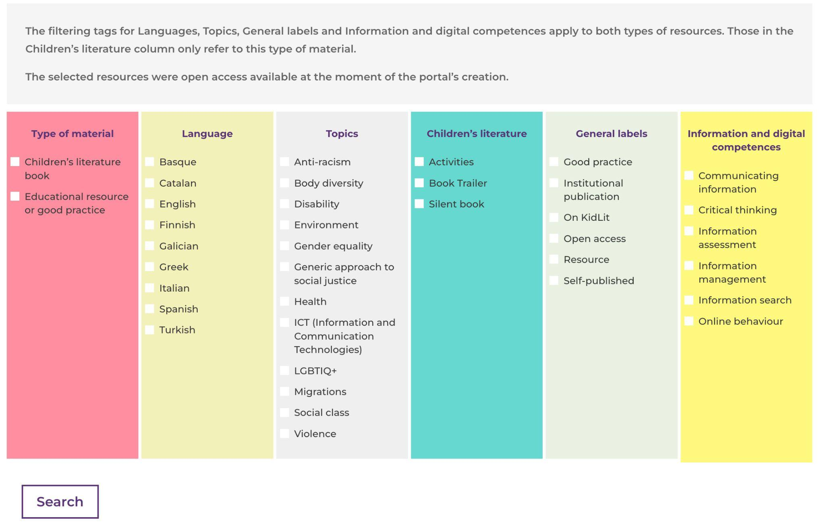

Following the search and selection process, the BRIDGE portal contains a total of 307 information records (for 97 resources and 210 children’s literature), all available in English and in the language of the selecting country.

The selection criteria for best practices and picture books were extremely rigorous and involved a variety of aspects. With regard to resources and best practices, the criteria focused on:
- ensuring consistency with the ethical goals of the BRIDGE project;
- verifying the effective reproducibility of the initiative in other contexts;
- encouraging the possible proliferation of ethical behaviours from those reported; and
- checking the immediacy and clarity of communication.
The selection of picture books was rigorous, since the target audience was directly children. It was then necessary to build a selection strategy that could ensure that each selected book was consistent with the joint project: the international partners were invited not to choose the most aesthetically pleasing or best-packaged picture books, but the most effective publications from the perspective of inclusion, respect for others, and the development of critical thinking.
The selection includes picture books of different types - fiction, nonfiction, concept, wordless/silent, etc. - that also highlight the different publishing methods that Finland, Greece, Italy, Spain, Türkiye and the UK have on shared and common topics. The portal also makes it possible to compare local approaches, styles, and sensibilities to make international exchange increasingly more effective and to foster a common feel through children's literature.

The selection of picture books includes some challenging ones for the BRIDGE project's target, such as War. What if it were here? by Janne Teller and Helle Vibeke Jensen or Erika’s Story by Ruth Vander Zee. These texts can allow children to perceive reality from an alternative viewpoint to that of the media and to confront realities in which the most basic rights of children are violated, anywhere in the world. War. What if it were here? allows readers to empathise with the experience of refugees and war refugees, while Erika’s Story is a memorial book on the Holocaust.

BRIDGE portal, therefore, gives the possibility to:
- approach information and digital literacy through both children’s literature and a selection of best practices;
- have opportunities to deepen knowledge and comparison between lived experiences;
- learn about selected projects in an international context,
- access an annotated bibliography to be used not only in teaching and educational contexts, but also directly by children in non-formalised contexts.
In addition, the portal represents an opportunity for knowledge and in-depth study for university teaching. At the University of Genoa (Italy), for example, students earning a Children's Literature degree in primary education have created book trailers and podcasts for an in-depth analysis of the picture books in the Italian selection of the BRIDGE project. These materials, soon to be available online, constitute the first nucleus of a bibliography, complete with trailers and podcasts, aimed at all those who want to use children’s literature as an opportunity to experiment with critical thinking. BRIDGE portal can, therefore, also be an opportunity for spin-off projects capable of promoting and enhancing both children's literature and information and digital literacy with its best practices.

5. BRIDGE Training Suggestions
The project also developed training for primary school teachers, school librarians, and other professionals working with children. For this purpose, BRIDGE has produced training material in the form of a booklet with guidelines and practical flexible suggestions on how to integrate information and digital literacy for primary school curricula using picture books: Picture books as a bridge to enquiry-based learning: suggestions to support critical information and digital literacy in primary education. It is available in open access on the project website, in the languages of the project (Spanish, Catalan, Turkish, Italian, Finnish, Greek, and English) (BRIDGE, 2026c).
The planning of the training material was based on the observation that IL pedagogies tend to focus on the processes of information seeking and evaluation, and do not support reflection of ideologies and values embedded in and attached to information (Jones, 2016). Critical IL frameworks address these dimensions, but they are often theoretical, and related pedagogies are not directed to children.

We have sought to address this shortage by developing a pedagogical praxis that combines the starting point of supporting critical IL with elements of IL process models and the pedagogies of dialogic reading and critical literacy. By this pedagogical combination, the focus is placed on the deeper understanding of book content (both textual and visual) and on learning thinking skills. Based on this praxis, we have developed materials to be used in pedagogical experimentation with dialogic reading of a picture book. The proposal aims to ensure that information and digital literacy is integrated across subjects in primary education curricula and not treated as an isolated competency.

Critical IL teaching, like IL teaching more generally, has tended to focus on factual texts rather than fiction (McNicol, 2016). Children’s literature offers an opportunity to examine who has power in the text, from whose point of view things are viewed and what the author seems to want the reader to think (McLaughlin & DeVoogd, 2004; McNicol, 2016). In addition, children’s literature allows us to explore different perspectives and socio-political problems with very young children (Pesonen, 2019) who are just learning skills related to IL.

In the booklet produced by BRIDGE, a silent book is used as an example of a picture book: Meidän piti lähteä [We Had to Leave] by the Finnish author Sanna Pelliccioni (2018). This allows the use of the same book in several countries. The silent book focuses on refugees in a very intense, but imaginative way. The material helps the teacher, librarian, or other professional to deal with more demanding topics with young people by offering ideas on how to approach the topic through the book with open questions to support children to think about the topic independently or in groups. The questions encourage children to reflect on and question the illustrations of the book and the story it tells. The dialogic reading is divided into questions to ask at the beginning, during, and after reading. The three stages are approached through wondering, exploring, communicating and reflecting, with wondering and exploring emphasised in the beginning reading stage. During and after reading, communication and reflection are also part of the reading process. This way children's books serve as a starting point for a thematic exploration of a challenging and thought-provoking topic. The booklet offers ways to continue reflecting on the topic after reading, for example, through information seeking or by creating art. In each partner country, the training materials were translated, and the training was localised to align with their respective school curricula. As an example of the proposed approach, Figure 2 shows some suggested prompts for the reading phase.

Figure 2: Example of prompts from the BRIDGE booklet with training suggestions. 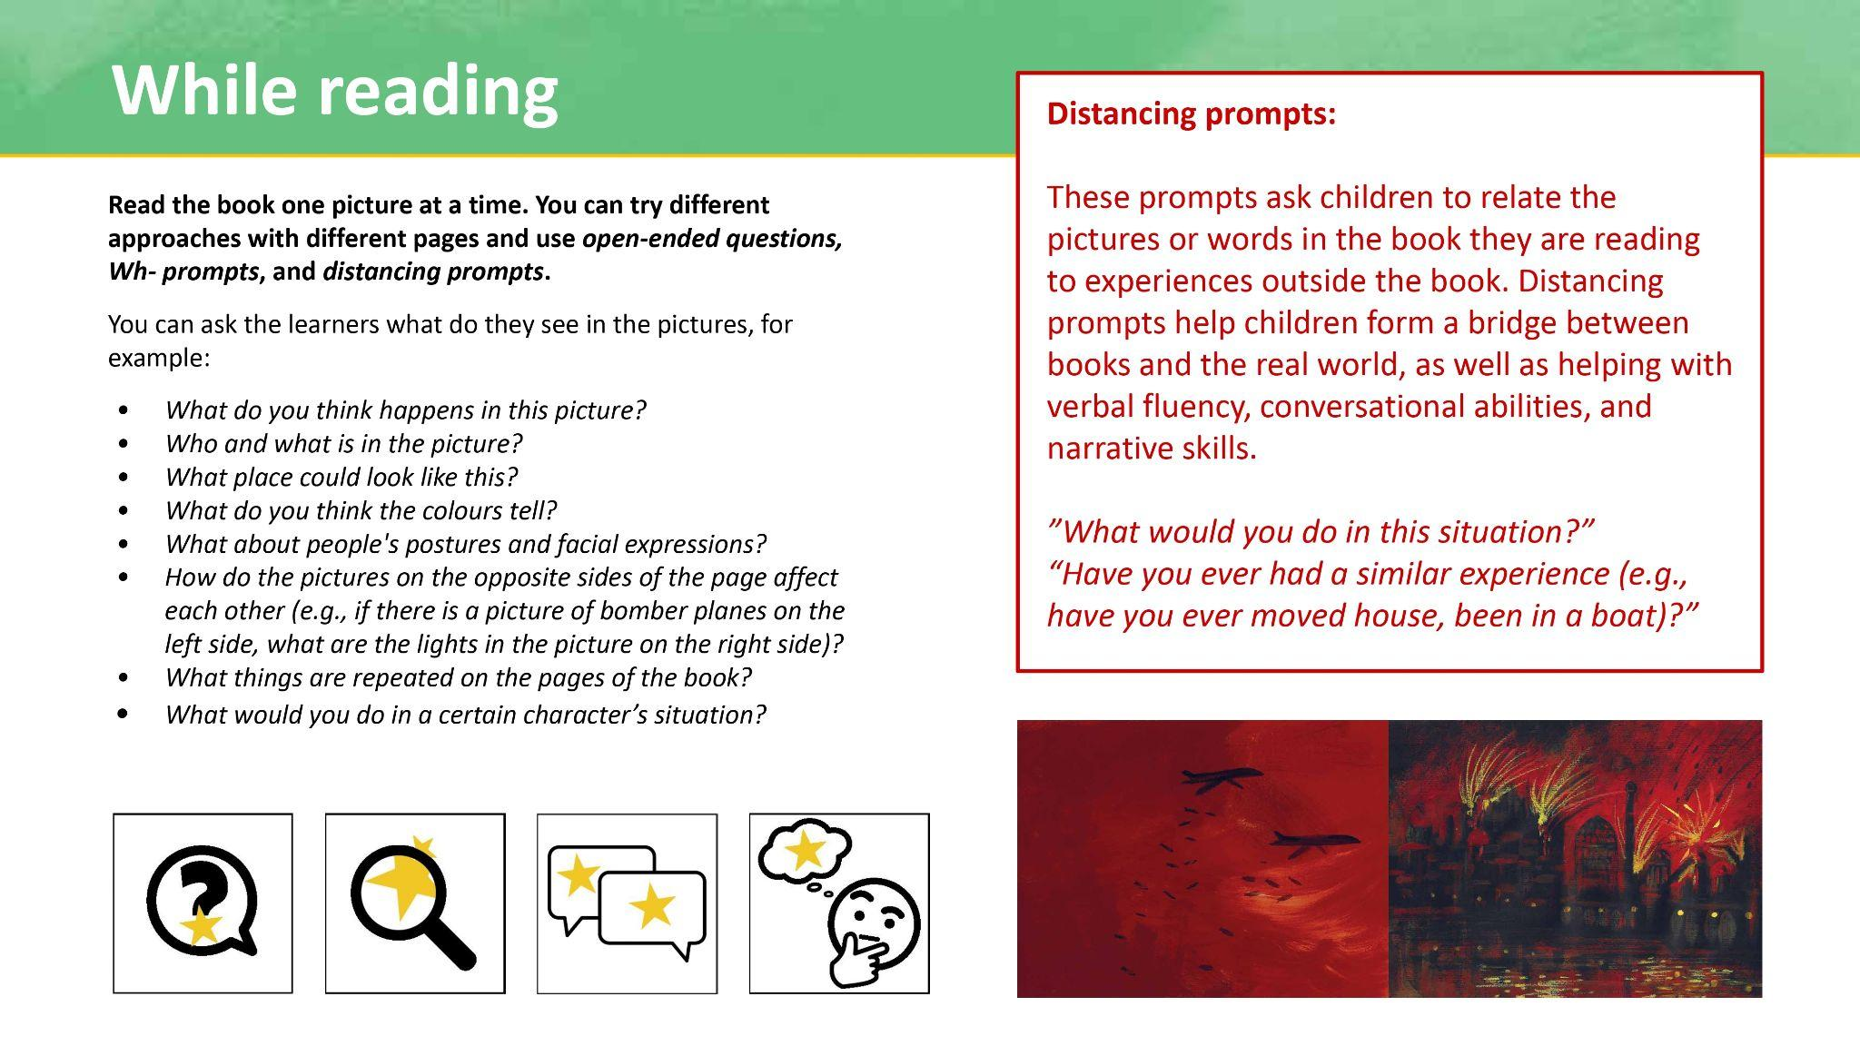
6. Conclusion
IL, as being a transversal competence, is not only important for people of all ages but also useful in a wide variety of contexts, including educational, professional, and everyday life. Furthermore, it is a fundamental pillar of democratic participation, equity, and social cohesion. Therefore, it needs to be developed starting from early childhood.
However, today, while proliferation of dis/misinformation and rising polarisation make children particularly vulnerable to manipulative and biased content, primary education curricula across Europe often lack robust frameworks for developing students’ IL skills and exhibit significant gaps in embedding these skills in a pedagogically sound and transferable way across diverse educational contexts.

The role of education in nurturing IL skills and equality values has never been more crucial. While teachers and school librarians are on the frontlines of this educational challenge, the transnational cooperation network of the BRIDGE project attempts to address this gap by proposing an innovative framework to embed critical and digital literacies along with IL within the primary education curriculum through children’s literature, dialogic reading strategies, and transmedia storytelling. The project’s outcomes include a series of tools, methodologies, and pedagogical frameworks that empower both teachers and school librarians to engage children with IL and are applicable in primary education settings.

The BRIDGE project is also meant to facilitate the exchange of best practices and resources. However, it is a single attempt limited within the practices and resources from its project countries, therefore further initiatives and endeavours, in terms of research and practice, are required to bridge the current skills gaps in children. Moreover, widespread collaboration across Europe seems essential towards establishing common frameworks and processes for the development of these crucial skills in primary education.

All in all, more research is required to bridge the current information and digital literacy gaps in young people and more collaborative work is required towards establishing common frameworks and processes for the development of these skills in young people’s education. In this vein, the BRIDGE project addresses the development of an information and digital literacy framework for promoting critical thinking and equality values in primary education by means of a practical methodology that offers an embedded and transversal way to develop information and digital literacy skills in the school curriculum. This approach involves creating lesson plans based on open access and multilingual resources and best practices shared from all over Europe for the promotion of values of equality, inclusion, and diversity.

Given the important role school libraries play in the BRIDGE model, a useful next step might be to develop and test a training module focused on building strong librarian‑teacher partnerships. This would contribute to the creation of partnerships between academia and libraries, which are key to implementing any educational proposal related to information and digital literacy. On the other hand, although the BRIDGE project focuses on primary education, the approach of using dialogic reading training suggestions as a basis for developing activities that promote information and digital literacy can be transferred to other stages of education (secondary and university). Another next step could be to further explore this transfer.

Declarations
Ethical approval
Ethical review was not considered necessary in alignment with the BRIDGE project guidance on the conduct of ethical research.

Funding
This paper is part of the Erasmus+ project BRIDGE, «Information and Digital Literacy at School. A Bridge to Support Critical Thinking and Equality Values for Primary Education Using Children’s Literature and Transmedia» (Project number: 2021-1-ES01-KA220-SCH-000032527).

AI-generated content
AI tools have been used only for checking grammar at some points.

Acknowledgements
The authors would like to express their gratitude to all the teachers and librarians who responded to the questionnaires in each country, as well as to all those who attended the multiplier events organised to disseminate the project.

References
Abbatecola, E., Akkoyunlu, B., Amigo-Ventureira, A. M., Antoniazzi, A., Banou, C., Caffarena, F., Enwald, H., Goldstein, S., Hirvonen, N., Huttunen, A., Kostagiolas, P., Kurbanoğlu, S., Martzoukou, K., Morelli, M., Multas, A. M., Nygård, T., Pavey, S., Sales, D., Saran, M., & Şencan, İ. (2024). BRIDGE report and call for action: Information and digital literacy at school. A bridge for critical thinking and equality values.

Aesaert, K., Vanderlinde, R., Tondeur, J., & van Braak, J. (2013). The content of educational technology curricula: A cross-curricular state of the art. Educational Technology Research and Development, 61(1), 131–151.

Aesaert, K., & van Braak, J. (2015). Gender and socioeconomic related differences in performance based ICT competences. Computers & Education, 84, 8–25.

Avcı, Ü., & Yıldız Durak, H. (2024). Examination of digital citizenship, online information searching strategy and information literacy depending on changing state of experience in using digital technologies during COVID-19 pandemic. Journal of Information Science, 50(5), 1098–1111.

Baji, F., Bigdeli, Z., Parsa, A., & Haeusler, C. (2018). Developing information literacy skills of the 6th grade students using the Big 6 model. Malaysian Journal of Library & Information Science, 23(1), 1–15.

Basic Education Act (628/1998). Finland.

Batool, S. H., & Webber, S. (2019). Mapping the state of information literacy education in primary schools: The case of Pakistan. Library and Information Science Research, 41(2), 123–131.

Bawden, D. (2001). Information and digital literacies: A review of concepts. Journal of Documentation, 57(2), 218–259.

Belshaw, D. (2014). The essential elements of digital literacies.

BRIDGE. (2026a). About us.

BRIDGE. (2026b). Portal.

BRIDGE. (2026c). Training.

Bruce, C. S. (1999). Workplace experiences of information literacy. International Journal of Information Management, 19, 33–47.

Bruce, C. S. (2004). Information literacy as a catalyst for educational change. A background paper. In P. A. Danaher (Eds), Proceedings lifelong learning: Whose responsibility and what is your contribution?, the 3rd International Lifelong Learning Conference, (pp. 8–19). Yeppoon, Queensland.

Carretero, S., Vuorikari, R., & Punie, Y. (2017). DigComp 2.1: The digital competence framework for citizens with eight proficiency levels and examples of use.

Chu, S. K. W., Tse, S. K., & Chow, K. (2011). Using collaborative teaching and inquiry project-based learning to help primary school students develop information literacy and information skills. Library & Information Science Research, 33(2), 132–143.

CILIP The Library and Information Association (2018). CILIP definition of information literacy 2018. Information Literacy Group.

Council of Europe. (2023). The digital environment.

Department for Education (2013, last updated 2015). National Curriculum in England: primary curriculum.

Desimpelaere, L., Hudders, L., & Van de Sompel, D. (2020). Children’s and parents’ perceptions of online commercial data practices: A qualitative study. Media and Communication, 8(4), 163–174.

Drabinski, E. & Tewell, E. (2019). Critical information literacy. In R. Hobbs & P. Mihailidis (Eds.), The international encyclopedia of media literacy. Wiley-Blackwell.

European Commission. (2023). Digital education action plan – action 7. European Education Area.

European Commission. (2022). SELFIE. A tool to support learning in the digital age.

Finnish National Agency for Education (2021). Kansallinen lukutaitostrategia 2030: Suomi maailman lukutaitoisin maa [The national literacy strategy 2030: Finland, the most literate country in the world].

Gardner, G., Goldstein, S., Pavey, S., & Secker, J. (2020). Information literacy for education.

Goadaert, E., Aesaert, K., Voogt, J., & van Braak, J. (2022). Assessment of students’ digital competences in primary school: A systematic review. Education and Information Technologies, 27(4), 9953–10011.

Government Gazette / ΦΕΚ-FEK 303Β/13-03-2003. ΕΦΗΜΕΡΙΣ ΤΗΣ ΚΥΒΕΡΝΗΣΕΩΣ ΤΗΣ ΕΛΛΗΝΙΚΗΣ ΔΗΜΟΚΡΑΤΙΑΣ. Ε.Τ. 2003. Greece.

Hague, C., & Payton, S. (2010). Digital literacy across the curriculum: A Futurelab handbook. Futurelab innovation in education, 1–63.

Horton, F. W. (2008). Understanding information literacy: A primer. UNESCO.
Ilomäki, L., Paavola, S., Lakkala, M., & Kantosalo, A. (2016). Digital competence – An emergent boundary concept for policy and educational research. Education and Information Technologies, 21(3), 655–679.

Institute of Educational Policy / Ινστιτούτο Εκπαιδευτικής Πολιτικής (Ι.Ε.Π.) (2023). Curriculum / Πρόγραμμα Σπουδών. Greece.

Jenkins, H. (2003). Transmedia storytelling: Moving characters from books to films to video games can make them stronger and more compelling. MIT Technology Review.

Jenkins, H. (2007). Confronting the challenges of participatory culture: Media education for the 21st century (part one). Nordic Journal of Digital Literacy, 2(1), 23–33.

Jones, R. (2016). Curricular and extra-curricular opportunities to engage school students in critical literacy in England. In: S. McNicol (ed.) Critical literacy for information professionals (s. 105–114). Facet.

Kanwal, R. (2024). Children’s literature as a tool for social change: Teaching values and social awareness. The Scientific Temper, 15(spl-2), 40–46.

Kirton, J., & Barham, L. (2005) Information literacy in the workplace. The Australian Library Journal, 54(4), 365–376.

Kumar, P., Vitak, J., Chetty, M., Clegg, T. L., Yang, J., McNally, B., & Bonsignore, E. (2018). Co-designing online privacy-related games and stories with children. Proceedings of the 17th ACM Conference on Interaction Design and Children, 67–79.

Library Act 1492/2016. Finland.

Livingstone, S. (2022). More online risks to children, but not necessarily more harm: EU Kids Online 2020 survey. London School of Economics.

Livingstone, S., Haddon, L., Görzig, A., & Ólafsson, K. (2011). Risks and safety on the internet: The perspective of European children: Full findings and policy implications from the EU Kids Online survey of 9-16 year olds and their parents in 25 countries. EU Kids Online, London, UK.

Lloyd, A. M. (2010). Information literacy landscapes: Information literacy in education, workplace and everyday contexts. Cambridge: Chandos Publishing.

Ludewig, U., Strietholt, R., & McElvany, N. (2025). Reading literacy decline in Europe: Disentangling school closures and out-of-school learning conditions during the COVID-19 pandemic. Learning and Instruction, 98, 102150.

Mallan, K. (2017). Children’s literature in Education. Oxford Research Encyclopedia of Education. New York: Oxford University Press.
Martínez-Piñeiro, E., Gewerc, A., & Rodríguez-Groba, A. (2019). Nivel de competencia digital del alumnado de educación primaria en Galicia. La influencia sociofamiliar [Digital competence of primary school students in Galicia.The socio-family influence]. Revista de Educación a Distancia, 19(61).

Martzoukou, K. (2022). ‘Maddie is online’: An educational video cartoon series on digital literacy and resilience for children. Journal of Research in Innovative Teaching & Learning, 15(1), 64–82.

Martzoukou, K., Panayiotakis, I., Herbert, N., Grey, E., & MacDonald, N. (2023). ‘Maddie is online’: A creative learning path to digital literacy for young people. Computers in the Schools, 1–30.

Martzoukou, K., & Sayyad, E. (2017). Towards an everyday life information literacy mind-set: A review of literature. Journal of Documentation, 73(4), 634–665.

McLaughlin, M., & DeVoogd, G. (2004). Critical literacy: Enhancing students’ comprehension of text. Scholastic.

McNicol, S. (2016). Renegotiating the place of fiction in libraries through critical literacy. In: S. McNicol (ed.) Critical literacy for information professionals (s. 3–17). Facet.

MPI (2007). Indicazioni per il curricolo per la scuola dell’infanzia e per il primo ciclo d’istruzione.

Nikolajeva, M. (2013). Picturebooks and emotional literacy. The Reading Teacher, 67(4), 249–254.

Papaioannou, M., Brinia, V., Michail, P., Kasiola, E., Georgogala, S., & Marinopoulou, S. (2025). Investigation of the environment of primary education school organisations using SWOT-analysis. International Journal of Innovation in Education, 9(2), 136–158.

Pelliccioni, S. (2018). Meidän piti lähteä [We Had to Leave]. Kustantamo S&S.

Pesonen, J. (2019). Children’s stories supporting the development of critical literacy and intercultural understanding. In: K. J. Kerry-Moran & J. A. Aerila (eds.) Story in children’s lives: Contributions of the narrative mode to early childhood development, literacy, and learning. Educating the young child, vol 16. Springer.

Programme for International Student Assessment (PISA). (2018). PISA 2018 results.

Regehr, K., Shaughnessy, C., Zhao, M., & Shaughnessy, N. (2024, February 2). Safer scrolling: How algorithms popularise and gamify online hate and misogyny for young people. UCL IOE, University of Kent.

Royal Decree 157/2022, of 1 March 2022, establishing the organisation and minimum teaching requirements for primary education. Spain.
Sales, D., Martzoukou, K., Goldstein, S., Pavey, S., Hirvonen, N., Saran, M. & Şencan, I. (2023, October 9-12). Information and digital literacy for primary education. Diagnosis of needs and challenges [Panel presentation]. The Eight European Conference on Information Literacy (ECIL) 2023, Jagiellonian University, Krakow, Poland.

Sales, D., Kurbanoglu, S., Şencan, I., Pavey, S., Goldstein, S., Martzoukou, K. & Enwald, H. (2025, September 22-25). An innovative approach using picture books to empower critical information and digital literacy in primary school education [Workshop]. The Ninth European Conference on Information Literacy (ECIL) 2025, University of Bamberg, Bamberg, Germany.

Schola Europaea. (2018). Key competences for lifelong learning in the European schools.

Schola Europaea / Office of the Secretary General. (2019). Digital education vision for the European schools system (DEVES).

Schola Europaea. (2020). Digital competence framework.

Shavit, Z. (1986). Poetics of Children’s Literature. Athens/London: The University of Georgia Press.

Shin, W., & Kang, H. (2016). Adolescents' privacy concerns and information disclosure online: The role of parents and the Internet. Computers in Human Behavior, 54, 114–123.

Simpson, A., & Cremin, T. M. (2022). Responsible reading: Children’s literature and social justice. Education Sciences, 12(4), 264.

Skipper, Y. (2025). ‘I’d probably scroll by’: An exploration of young people’s views on spotting and stopping misinformation. Children & Society, 39(2), 215–231.

State Planning Organization (2006). Ninth Development Plan 2007-2013. Ninth Development Plan 2007-2013. Türkiye.

Türk, E., Canbolat, Y., Dilek, M. C., Özdemir, E. ve Yıldırım, N. (Ed.). (2025). Turkish education system: Key elements, policies and reforms. Republic of Türkiye Ministry of National Education, Directorate of Strategy Development.

UK Parliament. (2023). Online SafetyAct 2023.

UNESCO. (2003). The Prague Declaration “Towards an Information Literate Society”.

Upreti, K., Kushwah, V. S., Vats, P., Alam, M. S., Singhai, R., Jain, D., & Tiwari, A. (2024). A SWOT analysis of integrating cognitive and non‐cognitive learning strategies in education. European Journal of Education, 59(2), e12614.

