Article

Disinformation and gender issues: A study with young people from Salvador and Porto Alegre (Brazil)
http://dx.doi.org/10.11645/20.1.816

Daniela Silva
Postdoctoral researcher, Federal University of Rio Grande do Sul. Email: dsilva.jor@gmail.com. ORCID: 0000-0003-4436-6955.

Ana Cristina Prates
Masters student in Information Science, Federal University of Rio Grande do Sul. Email: cristina.prates@ufrgs.br. ORCID: 0000-0002-6196-8299. X: @AnaCristin28182.

Josiene da Silva Niesciur
Masters student in Information Science, Federal University of Rio Grande do Sul. Email: nenesn@hotmail.com. ORCID: 0009-0000-2871-6180.

Abstract
Disinformation, amplified on digital platforms, disproportionately impacts young people and those oppressed by their gender identity, who end up being more vulnerable to the phenomenon. Given this context and based on the perceptions of young people living in Salvador (Bahia) and Porto Alegre (Rio Grande do Sul), two Brazilian capitals, this article aims to investigate the relationship between disinformation and gender. This is a basic study with a qualitative approach and exploratory intent. A bibliographical study was conducted covering the period 2016 to 2025 in the main database of Information Science in Brazil (BRAPCI), and empirical research data collected from young people from both cities was analysed. The results highlight hate speech as the most cited problem among young people, with a higher prevalence among girls and non-binary individuals. There is also variation in the intensity of self-reported impacts, with boys reporting milder impacts, followed by girls and, finally, non-binary people, who report more severe impacts. The findings reinforce the importance of promoting information literacy (IL) and media education in Brazil.

Keywords
Brazil; children; disinformation; gender disparities; hate speech; information literacy; LGBTQ+; media literacy

1. Introduction
The rise of disinformation as a global phenomenon has had profound impacts across various social spheres, and its consequences are not evenly distributed. Young people are among the most affected groups (United Nations, 2023), as are people with oppressed gender identities (Butler, 2000; Papadamou et al., 2021). Global studies (United Nations Women Brazil, 2024) indicate that between 16-58 percent of women experience technology-mediated gender-based violence. This gendered cyberviolence includes digital platforms, such as social media, where harassment, abuse, stalking, and non-consensual image sharing, for example, disproportionately affect women, especially younger women.

False content intended to undermine, oppress, or limit the actions of individuals based on their gender identity can have devastating effects, especially on young people. Acquolini and Sousa (2022) discussed gender disinformation, a type of violence against women, which manifests itself in disputes over radical narratives as a way of maintaining oppression. UNESCO (2021) expanded the discussion by highlighting that, in addition to women, LGBTQIA+ people suffer intense attacks in digital environments through the articulation of hate speech, with the aim of eroding their rights. Therefore, in addition to paying attention to the unique characteristics of young people, studying misinformation from the perspective of its impact on people with oppressed gender identities (such as women and non-binary people) is fundamental because it affects both the individual and collective spheres, as well as society (Papadamou et al., 2021).

This phenomenon is fuelled by false content and misleading narratives constructed and disseminated with the purpose of reinforcing stereotypes, perpetuating prejudices, and undermining progress toward gender equality. This complexity, therefore, calls for public policies on media literacy as one of the priority fronts for confronting and preventing gender disinformation. In this sense, the Brazil Ministry of Education (2025b) recognises that media literacy is essential to prepare individuals for critical use and participation in digital environments.

Given this context, this article begins with the following research question: What gender-related challenges do young people face when impacted by disinformation? Based on the perceptions of young people living in Salvador, Bahia, and Porto Alegre, Rio Grande do Sul, two Brazilian capitals, this article aims to investigate the relationship between disinformation and gender. Thus, this study analyses young people's perceptions of disinformation and its impact on themselves and their peers, providing insights into the particularities between the perceptions of boys, girls, and non-binary individuals. The participants in the empirical research are between the ages of 18 and 29. Research with this demographic has proven crucial in highlighting the importance of developing information literacy (IL) and media education strategies in Brazil to ensure resilience in the face of disinformation and, above all, hate speech involving gender issues.

Following this introduction, the article is organised into three main sections, plus a conclusion. The first section will contextualise the phenomenon of disinformation and its impacts by social markers, with an emphasis on gender. The paper will also discuss the role of media literacy as a strategy for promoting equity, human rights, and combating disinformation in Brazil. The second section will address the methodology of this research and the third will present and analyse the results, sharing the experiences of young people in Salvador and Porto Alegre.

2. Theoretical discussion
Recent critical approaches have highlighted that disinformation cannot be understood merely as a technical or communicational problem, but rather as a historically situated phenomenon, traversed by a structural field defined by power relations and social inequalities. Kuo and Marwick (2021) argued that disinformation narratives are constructed from pre-existing ideologies and operate as political strategies, reinforcing hierarchies of race, gender, and class, disproportionately affecting socially marginalised groups. By criticising approaches that treat disinformation as a virus within a “healthy” informational ecosystem, the authors emphasised that this framing obscures central questions such as who produces disinformation, who benefits from its circulation, and which populations are most vulnerable to its effects. Thus, understanding disinformation from a critical perspective implies shifting the focus from the individual to institutional and economic structures.

These reflections can help analyse the current context, in which at least two contemporary movements have provoked significant concerns as examples of misogynistic discourse in the digital environment: involuntary celibates (incels) and the Red Pill movement. Incels constitute a digital subculture that promotes narratives of male victimisation, blaming women for the romantic and sexual frustration of young men (Papadamou et al., 2021). As documented by Griffin (2021), this movement uses specific terminologies and discursive strategies that dehumanise women and legitimise violence against them. In Brazil, the Red Pill movement, is based on conspiracy theories about feminism and promotes an essentialist and hierarchical view of gender relations (Ruediger & Grassi, 2023). Both movements use social media as spaces for recruitment and radicalisation, directing their messages especially to adolescents and young adults in situations of emotional vulnerability.

Bourdieu (1999) offered important conceptual tools that can be used to analyse these phenomena through the notion of "male domination." For the author, symbolic violence operated subtly but effectively, naturalising gender hierarchies through seemingly neutral discourses. In the digital environment, this symbolic violence materialises through memes, "jokes," and comments that, under the guise of humour, reproduce and legitimise structures of oppression, as Matamoros-Fernández et al. (2023) emphasised.

This type of aggressive content is part of the universe of disinformation, which is amplified in the digital context. In this study, disinformation is understood as any false or misleading content created or manipulated and disseminated to intentionally cause public harm or obtain profit (High Level Expert Group, 2018).

Acquolini and Sousa (2022) indicated there is also a particular dimension of disinformation, the so-called "gender disinformation," which focuses on gender issues. This concept refers to the combination of radical discourses disseminated online that are contrary to gender equality and target people with oppressed identities, such as women and LGBTQIA+ people. This form of disinformation is characterised by the deliberate creation and dissemination of false or distorted information, with the aim of discrediting, oppressing, or restricting the participation of people in society and, in particular, in digital environments, based on their gender identity.

One use of disinformation, therefore, can be to promote or amplify hate speech, since the intentional creation and dissemination of false or misleading narratives are often targeted at specific groups to dehumanise them or incite hostility. According to Wardle (2024), hate speech is any communication that attacks or uses derogatory or discriminatory language against a person or group based on their identity (gender, religion, ethnicity, race, colour, nationality, or other characteristic). Disinformation, in turn, is often used as a strategy to promote hate speech; that is, through a narrative intended to cause harm (disinformation), it seeks to objectify a specific group, thus constituting hate speech.

One way to carry out this organised persecution is through public attacks, in most cases by sending messages of coercion and silencing to members of the affected groups, denying them their right to exist and to belong. The goal is to promote the social exclusion of these people through violence, as an attempt to silence, subjugate, and render them subservient, without a voice or a say, keeping them "in the closet" (Santini, 2024).

For Butler (2000), it is possible to establish an essential theoretical framework for understanding how these discourses influence the formation and undoing of oppressed gender identities in the digital context, understanding the social markers of difference. According to Butler, gender is not a static category, but rather an expression constructed through the repetition of actions and discourses. In the digital environment, gendered disinformation acts to control and penalise these expressions, defining which identities can be considered legitimate or natural. Marwick et al. (2022) further argued that understanding disinformation should not be limited to the binary opposition between truth and falsehood, since these contents also function as social practices of meaning-making and belonging. From a feminist perspective, Marwick et al. sought to demonstrate that disinformation narratives frequently reinforce hegemonic masculinities, patriarchal norms, and structural inequalities, while simultaneously mobilising emotions, community ties, and identity performances. This approach allows us to understand why women, non-binary people, and LGBTQIA+ populations are recurring targets of disinformation campaigns and hate speech in digital environments, contextualising these forms of violence within the broader social dynamics of power and exclusion.

In her book, The Second Sex, Beauvoir (2009) offered a historical perspective on how the social construction of femininity includes the normalisation of vulnerability and victimisation. In the digital context, this construct is updated through practices that naturalise violence against women as a natural consequence of their participation in the digital public space, just as it occurs with LGBTQIA+ people. bell hooks (2000) also highlighted how intersectionality amplifies vulnerabilities. Black women, for example, face both misogyny and racism, and Black LGBTQIA+ people suffer homophobia, racism, and misogyny, creating specific experiences of digital violence that require specific analysis and interventions. The author argued that disinformation, when linked to gender markers, contributes to reinforcing stereotypes, impeding access to rights, and consolidating a violent digital culture that marginalises dissident bodies (hooks, 2000).

Disinformation in digital environments, therefore, amplifies hate speech through specific characteristics, namely anonymity or pseudo-anonymity, which facilitates the expression of violent content, the speed of propagation which amplifies the reach of attacks, and the permanence of content which prolongs its effects. Furthermore, platform algorithms can amplify polarising content, by generating greater engagement. International research, such as that by UNESCO (2021) and the Center for Countering Digital Hate (2022), showed that women, trans people, and LGBTQIA+ adolescents are targets of systematic disinformation campaigns, particularly on social media, where conservative and anti-feminist discourses combine with digital technologies to undermine their rights, representation, and safety. The consequences of exposure to hate speech and gendered disinformation are felt differently among different groups.

An example of this was the May 2024 incident involving activist Ariela Nascimento of Fluminense Federal University. She was violently attacked by a group in Cabo Frio, Rio de Janeiro, Brazil, for being in public with her trans boyfriend. The attack continued at the hospital, where both suffered transphobic treatment and neglect (Barbosa, 2024). Other examples include the Anti-Gender Movements, which foster communities on Telegram, with anti-woke (against social agendas), anti-gender, and denialist agendas, linked to hate speech, with reverence for figures such as Hitler and the propagation of conspiracy theories and LGBT phobia (Silva, 2024).

Extreme cases, such as school shootings, linked to extremist ideologies and homophobic bullying, have been analysed based on evidence of a correlation between school violence and the adoption of radical hate speech among adolescents (de Andrade & Gonçalves, 2024, p. 335). Researchers from the Internet Studies Laboratory at the Federal University of Rio de Janeiro, NetLab/UFRJ (Santini et al., 2024), in partnership with the Ministry of Women, mapped 137 channels that, from 2018 to 2024, had an average of 152,000 subscribers on each channel and published more than 105,000 videos, mostly produced by men, reaching 3.9 billion views, with 80 percent adopting monetisation strategies through hate speech against women, that is, misogyny.

The report, Learn to Avoid This Type of Woman: Discursive Strategies and the Monetization of Misogyny on YouTube, (Santini et al., 2024) revealed that platform algorithms play a central role in amplifying this type of content. They prioritise polarising and discriminatory content through advertisements and product sales, profiting from hatred of women within an engagement policy that disregards ethical considerations. The study also showed that young women and LGBTQ+ people experience more severe impacts, including a higher incidence of anxiety disorders, depression, and self-harm. Young people reported that exposure to such content contributes to worsening mental health and the perception of extremist behaviour among peers, an effect that confirms analyses of radicalisation and gendered disinformation (Santini et al., 2024).

Butler (2000) explained that bodies that do not conform to gender norms suffer social and political censorship, with transgender adolescents often being the targets of coordinated attacks, especially in schools and online environments. This mechanism manifests itself clearly, as in the case of the 12-year-old transgender boy in Poções, a municipality in the state of Bahia (G1, 2022). His house was stoned several times after his mother demanded that he be identified at school by his social name and masculine pronouns. This attack, motivated by transphobic discourse in the community, exposes how transgressing normative expectations about gender subjects bodies to organised and symbolic aggression.

There are also strategies used to undermine institutional trust, such as disinformation about gender policies in schools, used by conservative groups. These are supported by false narratives that schools are "teaching children to be gay" or "sexualizing children" because of sex education policies (Freire, 2018; Nery, 2019; Santos & Rebello, 2025). These discourses affect children, adolescents, and young adults, generating moral panic and hindering access to scientific information on reproductive health, sexually transmitted infections (STIs), consent, diversity, and other topics, conveyed through sex education projects.

According to Oliveira et al. (2023), the attacks on Brazilian schools since 2021 are closely linked to the True Crime Community (TCC), an online subculture that brings together members interested in real crimes, school violence, serial murders, massacres, and terrorist attacks. Research compiled in the report of the Expert Working Group on Violence in Schools (Oliveira et al., 2023) highlighted a link with neo-Nazism, neo-fascism, and violent extremism. Posts in the virtual TCC subcommunities have disseminated violent content and encouraged school shootings, particularly against women, people of colour, and people with disabilities, through digital environments such as Twitter (X), Instagram, TikTok, and Discord. “Women are intentionally singled out for episodes fueled by the immorality of misogyny” (Brazil Ministry of Education, 2023, p. 73).

Given this scenario, IL emerges as a fundamental strategy to confront gendered disinformation, often expressed through hate speech. According to the Chartered Institute of Library and Information Professionals (CILIP, 2018), information literacy “is the ability to think critically and make balanced judgments about any information we find and use. It empowers us as citizens to develop informed views and to engage fully with Society” (p. 2).

This means applying the skills and attributes to locate, access, analyse, use, and share information consciously, critically, and ethically, while also considering the political implications associated with the use of information, whether printed, digital, in data, image, or audio format. Thus, IL contributes to discernment regarding the reliability and authority of information sources, in addition to the possibility of bias, and is therefore empowering and engaging for democratic and participatory societies (CILIP, 2018). This definition shifts the focus from technical skills related to information to a critical understanding of the contexts and intentions behind them, and the positioning of individual citizens who are involved in a just society, something fundamental when it comes to misogynistic and transphobic discourses that circulate under the guise of legitimate opinion or humour.

Lloyd's (2017) sociocultural approach contributed to this discussion by proposing the idea of informational resilience, which is understood as the ability to resist disinformation, rebuild trust in legitimate sources, and reconfigure information practices in the face of adverse contexts. This perspective is crucial when analysing the disproportionate impact of hate speech on groups made vulnerable by gender, race, or sexual orientation—dimensions that, according to bell hooks (2000), intersect oppressions and shape unequal informational experiences.

Secker and Coonan (2013), in turn, invited us to recognise information as a field of symbolic dispute and, as such, requires information critical literacy. The point is that the most vulnerable populations are already at a disadvantage in this arena due to social and educational inequalities. Young people exposed to digital misogyny and LGBT phobia experience not only symbolic violence but also an erosion of informational trust, which compromises their civic participation and their own online safety.

As highlighted by UNESCO (2021), educational actions must encompass not only technical skills for identifying false information, but also the development of a critical sense of the power relations that structure digital discourses. UNESCO adopts Media and Information Literacy (MIL) as a concept, defined as a set of skills that combine critical analysis, empathy, and ethical content production (Horton, 2013). UNESCO emphasises, above all, complete information as a universal human right, to promote social inclusion worldwide, enabling all populations to achieve their personal, social, professional, and educational goals (UNESCO, 2021).

In Brazil, both MIL and IL are included in national public policies named with the term media education. According to the Brazil Ministry of Education (2025b, p. 8), media education seeks to train individuals to critically access, analyse, create, and participate in the information and media environment, both physical and digital, promoting conscious media use. It's a process that goes beyond instrumental digital literacy, encompassing a critical understanding of messages across their different media and fostering the ability to discern between reliable information and disinformation, for example.

The first step toward institutionalising a policy for all Brazilian states with this focus occurred in 2023, when the federal government launched the Brazilian Media Education Strategy (Secretariat of Digital Policies of the Secretariat of Social Communication of the Presidency of the Republic, 2023), recognising the importance of educational approaches sensitive to issues that arise in digital environments, including gender issues. However, the official document left gaps regarding attention to young audiences (Silva & Mouta, 2024). The Brazilian Strategy highlighted the importance of strengthening both formal and informal education with the principles and competencies of media literacy. This recommendation is in line with IL, which also highlights the importance of attention to all stages of learning, formal and informal, reaching basic, higher, continuing and lifelong education (CILIP, 2018).

In 2025, an interdisciplinary area called digital and media education was created in Brazil, mandating that the Basic Education curriculum must include media education starting in 2026 (Brazil Ministry of Education, 2025a). Education professionals are expected to be trained to facilitate students' critical thinking so they can, for example, recognise and combat the disinformation and digital violence based on gender, racial, and ethnic identity, becoming more resilient and proactive against all forms of prejudice and discrimination. Education professionals must also be allies and work in collaboration with communication and information professionals, considering that all of them can and should promote IL, as well as media education.

In the national context, it is worth noting that among the report's guidelines for tackling hate speech and extremism in Brazil (Ministry of Human Rights and Citizenship, 2023), the document proposed media education actions, mental health programs, an intelligence network, and improved school coexistence to combat violence in and against schools. Regarding media education, the report recommended actions that include teachers, students, family members and all other members of the school community take an active stance against disinformation and hate speech and crimes, and that actions should involve pedagogical interventions in schools and the construction of partnerships with civil society organisations that already work on the issue (Secretariat of Digital Policies of the Secretariat of Social Communication of the Presidency of the Republic, 2023, p. 74).

The definition of a public media literacy policy for the country is undoubtedly a step forward; however, its implementation remains to be seen. Continuous monitoring and evaluation require an attentive and engaged population. Young people need to be prepared to be part of this movement of demand and participation in this process.

3. Methodology
This article reflects on bibliographical references and research data related to disinformation, youth, and gender issues. The research approach is qualitative and exploratory. The bibliographical research was conducted from 2016 to 2025, considering the initial year as the milestone for the growth of discussions on disinformation (D'Ancona, 2017).

The search strategy, in turn, contemplated the central themes: disinformation, gender, and youth. Related terms and variations in Portuguese, English, and Spanish were considered. The search strategy used was: (disinformation OR misinformation OR malinformation OR "fake news" OR "false information" OR "fake content" OR desinformação OR "informação falsa" OR desinformación OR "información falsa" OR "noticias falsas") AND (gender OR gênero OR gênero) AND (young OR youth OR teenager* OR adolescent* OR student* OR jovem OR jovens OR adolescentes* OR juventude* OR aluno* OR adolescencia OR juventud OR estudiante*) AND (misogyny OR misoginia OR lgbtphobia OR "LGBT phobia" OR lgbtfobia OR homophobia OR homophobia OR transphobia OR transphobia OR "hate speech" OR "discurso de ódio").

The Information Science Database (BRAPCI) platform was selected, because it is the leading reference for aggregating information on Information Science in Brazil. The bibliographic findings were coded by the two authors of this paper. A third author would have been involved to address divergent results, but this was not necessary.

In addition, this work presents the results of empirical research with young people aged 18 to 29 from Porto Alegre and Salvador. The study is part of the postdoctoral research of one of the authors of this article in the Graduate Program in Information Science (PPGCIN) at the Federal University of Rio Grande do Sul (UFRGS). The capital city of Porto Alegre was chosen because it is where the PPGCIN (Postgraduate Program in Information Science) operates. This also broadens the scope of the empirical experience that the author has already had with young people from Salvador during her doctoral research.

The data collection instrument for this research was created using Google Forms, after approval by the UFRGS Ethics Committee. The research sample was calculated based on the population of young people from both capitals, establishing the need for 188 participants from Salvador and 188 from Porto Alegre, considering variables such as colour/race, gender, education, and income, which broaden the possibilities for analysing the results.

To ensure that the sample faithfully represented the characteristics of the universe researched, the number of participants considered the following factors: size of the universe, established confidence level, maximum error allowed, and percentage with which the phenomenon occurs (Gil, 2008; Richardson et al., 2012). A 90 percent confidence level was defined. This indicates that if the sampling procedure were repeated one hundred times, the results would be consistent in 90 percent of cases. The margin of error was set at plus or minus six percentage points (0.06 or 6.0 percent). This indicates that the results for the entire sample should be interpreted within the range of -6 to +6.

Participants answered the online questionnaire after meeting the pre-established criteria of age range, place of residence (one of the two capital cities mentioned), and accepting the Informed Consent Form. As it was a type of web survey, the snowball sampling technique was applied to disseminate the online questionnaire. This sampling technique has been used in social research to boost participant referrals (Silva, 2022; Silva et al., 2018).

This technique allows those who have received an invitation to participate in the research to forward it to other potentially interested parties, who can then mobilise new participants, until this network allows the defined metrics for data collection to be reached. The snowball sampling technique also reduces self-selection bias. However, it is important to consider that the conclusions derived from these surveys are not probabilistic, which makes the generalisation of results impossible, since the target population does not have the same probability of being reached. Despite this, Atkinson and Flint (2001) explained that this technique favours the participation of more impenetrable social groups, such as elites or more vulnerable and socially stigmatised sectors.

The link to the questionnaire was sent to the research partners, which were civil society organisations, institutes, universities, public and private bodies, movements, and collectives that work with and for young people. The online form was then sent to individuals aged 18 to 29. Participation was voluntary and anonymous. The questionnaire had 32 questions, though only two of them are analysed in this article that explore problems experienced on the internet and perceptions about the impact of internet use on health (see Appendix).

The analysis of the responses followed a quantitative perspective, of a descriptive and exploratory type, and are discussed based on the theoretical framework. In the following section, we present the results of the literature and empirical research, as well as the analysis.

4. Results
The literature search resulted in 100 articles after applying the strategy to the BRAPCI database. Of this retrieved material, seven articles were eliminated for being duplicates. Of the 93 remaining papers, none were found to correlate the central themes of this article: gender, disinformation, and youth. Only three articles addressed gender and disinformation, but they did not include young people. A single study addressed disinformation and young people but did not include gender. The vast majority (76) of the files discussed disinformation alone.

There were also nine articles that dealt exclusively with gender, four of which were published before 2016 and outside the time period chosen for this analysis. Similarly, four studies that only cover young people were identified. It is worth mentioning that Viana et al. (2023) also identified insufficient production on gender disinformation when conducting a systematic analysis of academic research trends using Web of Science and Scopus.

These results reinforce the importance of this article given the lack of studies involving gender and disinformation and, above all, when we add the focus on young people, filling an important gap in the literature in this area. The empirical research with young people from Salvador and Porto Alegre reached 486 participants, exceeding the minimum number indicated for the sample (376), with 54.7 percent identifying as female, 43.6 percent as male and 1.6 percent as non-binary, as shown in Figure 1.

Figure 1: Respondents by gender
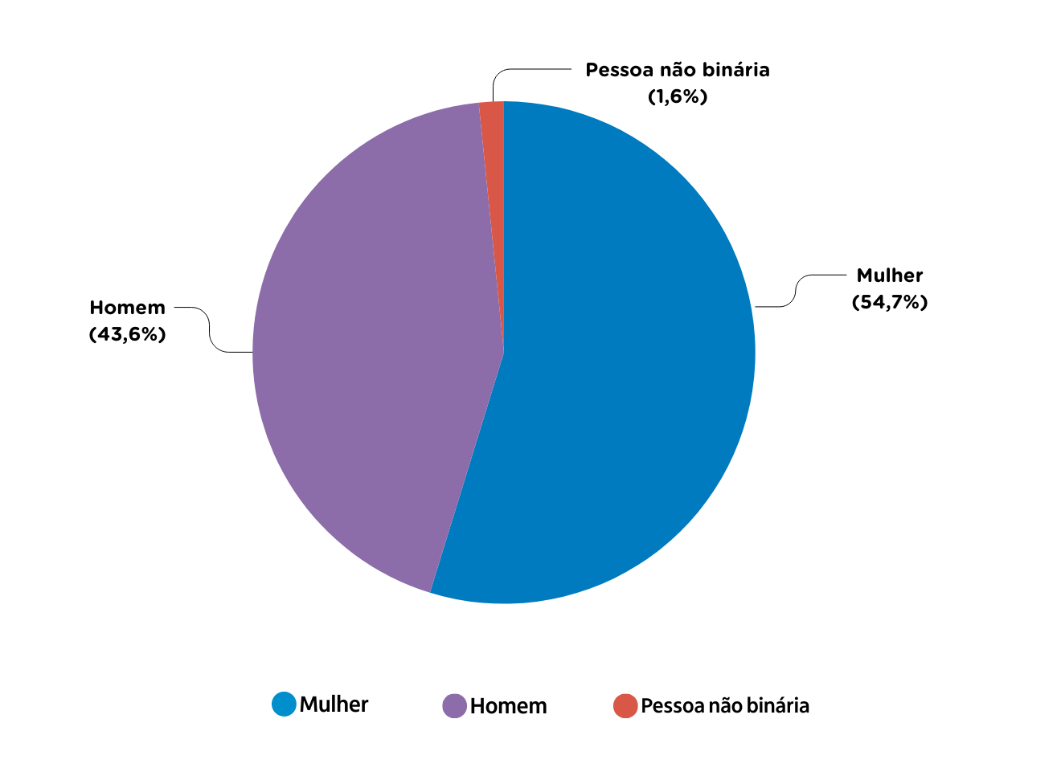

In the survey, participants selected from a list of options to indicate problems they had experienced on the internet (see Appendix). Among the problems experienced online, female respondents most often mentioned: hate speech (15%), false information about that person (12%), harassment, molestation, sexual abuse, sharing of images without consent (12%) (Figure 2).

Figure 2: Main problems experienced online, reported by young females
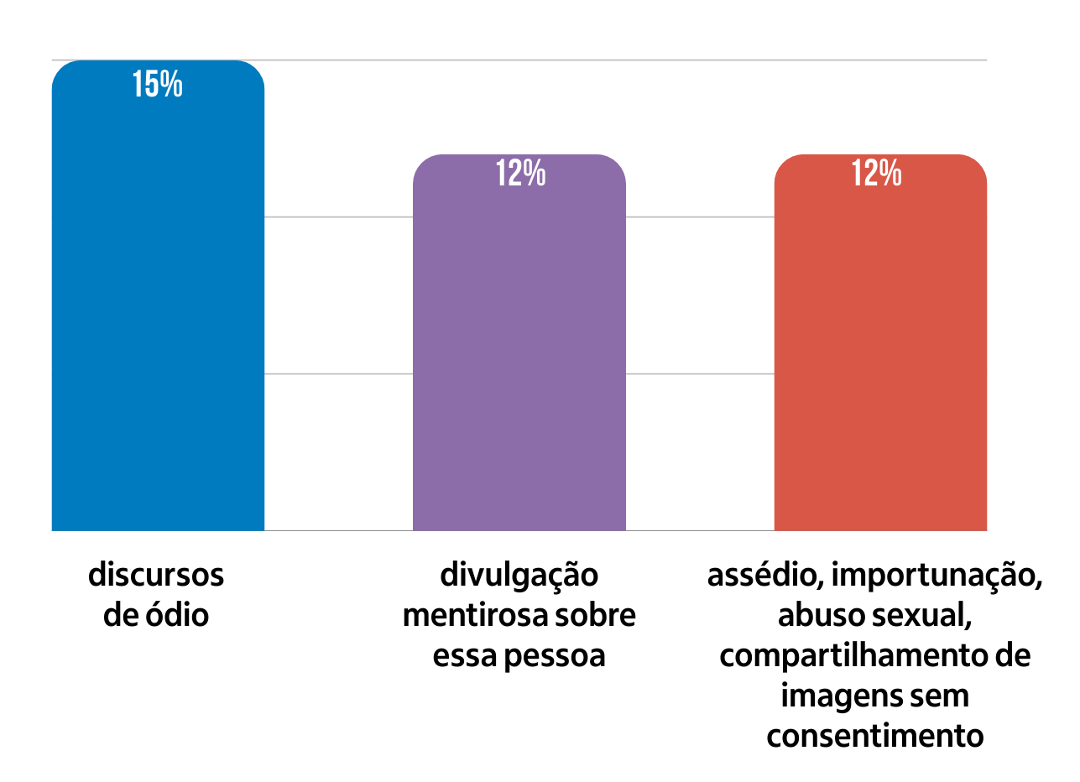
Male participants, in turn, were more likely to highlight false information about this person (12.9%), hate speech (12.7%), and financial crime (12%) as the primary problems faced on the Internet. These results are shown in Figure 3.

Figure 3: Main problems experienced online, reported by young males
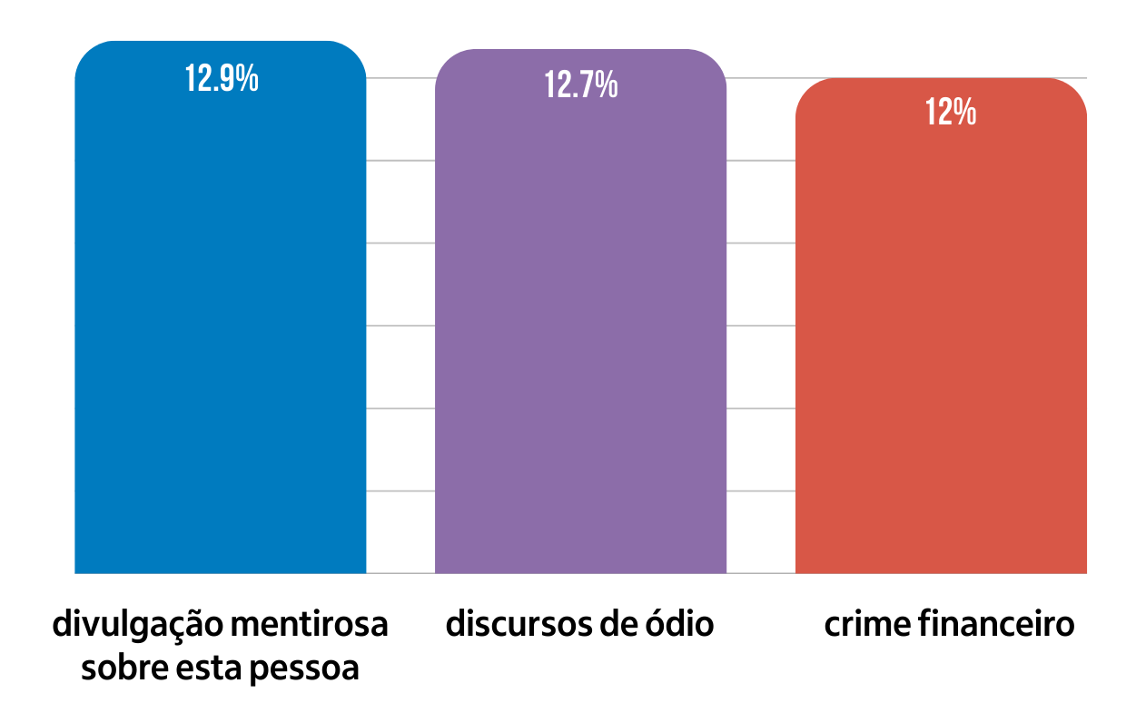
Respondents who identified as non-binary reported hate speech (26%), false information about that person (13%), a) Online discrimination (based on color or race, gender, sexual orientation, religion, among others) (13%), and financial crime (13%) as the main problems online, as shown in Figure 4.

Figure 4: Main problems experienced online, reported by non-binary people
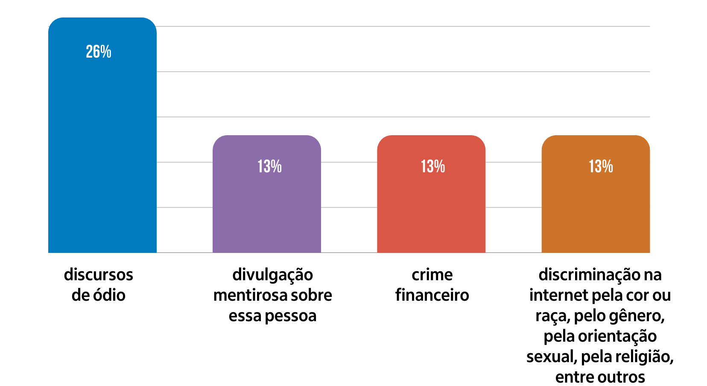
Hate speech is therefore the most frequently mentioned problem among young people, with greater intensity among females and non-binary people. This result is consistent with studies that indicate that aggression is more related to women and people in the LGBTQIPN+ community (Center for Countering Digital Hate, 2022; UN Women Brazil, 2024; UNESCO, 2021). Not surprisingly, discrimination is another problem cited by young females and non-binary people but is absent among male participants.

The survey also delved into the problems young people experienced online that are associated with physical and mental health and included their perceptions of themselves and other young people (see Appendix). Among the impacts on physical and mental health, females primarily perceive exhaustion and/or constant tiredness (34.5%), difficulty sleeping (29.7%), and anxiety (27%) to be the main impacts, as shown in Figure 5. In considering other young people, female respondents most often reported self-harm and/or suicidal thoughts (67.2%), increased alcohol and/or cigarette/and/or other drug use (66.9%), and extremist thoughts and behaviour (64.6%) to be the main impacts, as shown in Figure 6.

Figure 5: Main impacts on physical and mental health, reported by young females
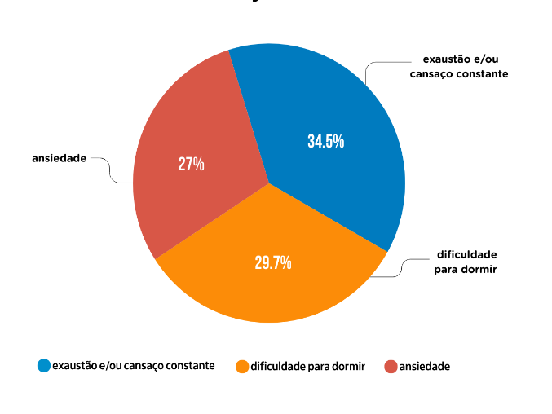
Figure 6: Main impacts on physical and mental health of other young people, reported by young females
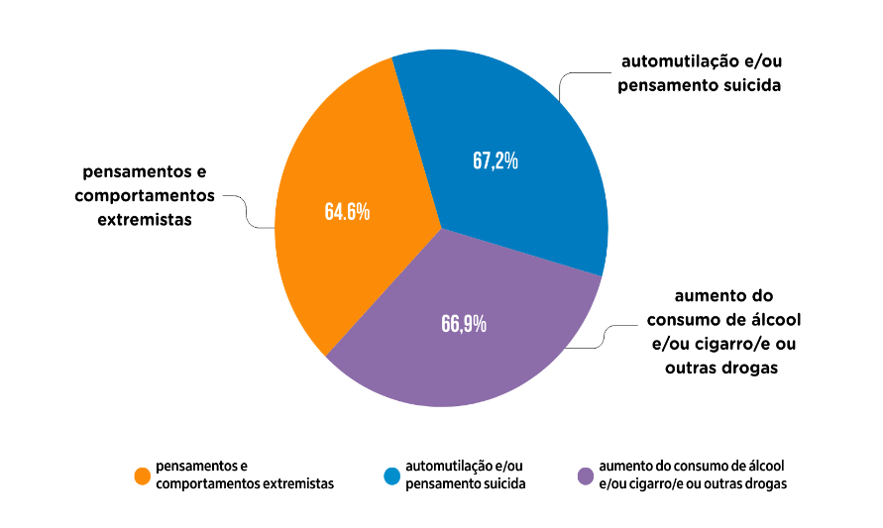
Male participants most noted difficulty sleeping (28.3%), exhaustion and/or constant tiredness (24%); and attention deficit, difficulty concentrating (18.4%) as the main impacts (Figure 7). In considering the impact on other young people, however, males reported self-harm and/or suicidal thoughts (72.1%), depression (67.9%), and extremist thoughts and behaviours (66%) to be most impactful, as seen in Figure 8.

Figure 7: Main impacts on physical and mental health, reported by young males
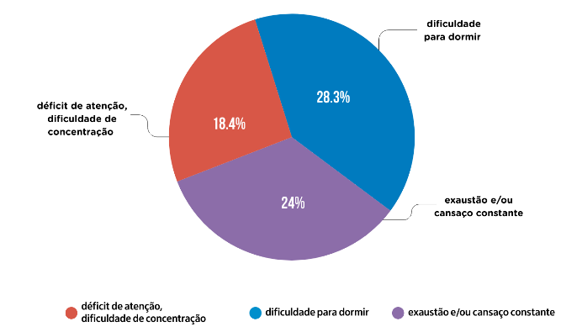

Figure 8: Main impacts on physical and mental health of other young people, reported by young males

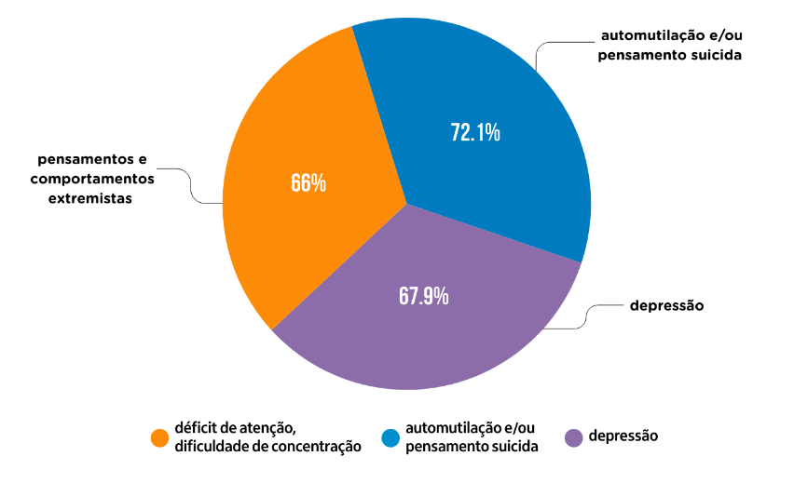
The non-binary youth group reported a more diverse perception of their problems, with seven categories tied at 25 percent: anxiety; addiction related to social media or gaming; exhaustion and/or constant fatigue; excessive weight gain or loss; difficulty interacting with others; fear; and isolation, as shown in Figure 9. When considering other young people, their assessment rises to 50 percent of participants selecting self-harm and/or suicidal thoughts; addiction related to social media or gaming; depression; and increased alcohol and/or cigarette/and/or other drug use. It is important to note that social media and gaming addiction appeared as a significant concern for both themselves and other young people, although twice as intense for others, as seen in Figure 10.

Figure 9: Main impacts on physical and mental health, reported by non-binary people
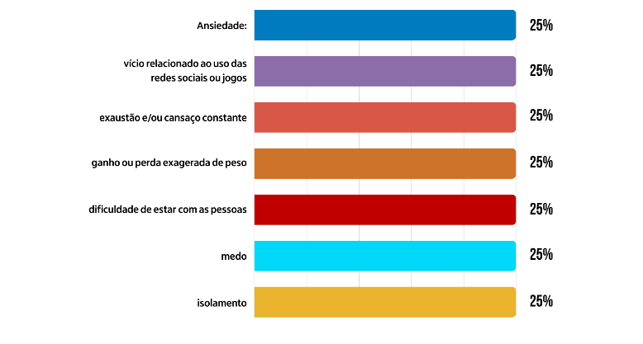

Figure 10: Main impacts on the physical and mental health of other young people, reported by non-binary people
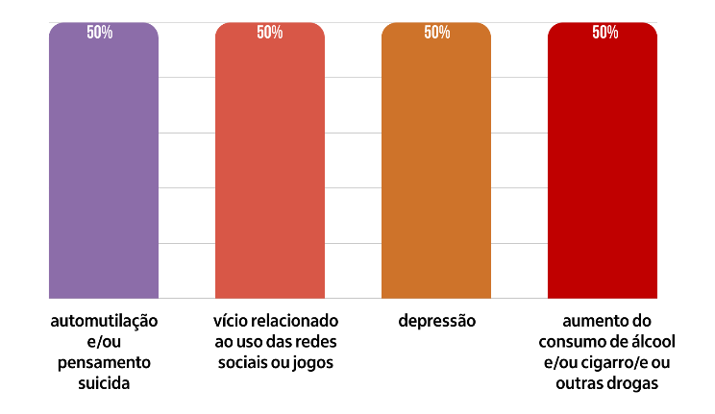

5. Discussion
One pattern that emerges from the participants' responses is the disparity between their perception of problems in their self and the perception of problems in other young people. Generally speaking, the participants tended to identify more serious problems in their peers, indicating a greater concern with risky behaviours and serious mental health issues, such as self-harm and/or suicidal thoughts (Figure 11), while self-concerns suggest a physical and mental overload that affects daily life, such as exhaustion and/or constant fatigue.

Figure 11: Main impacts on the physical and mental health of other young people, reported by all participants
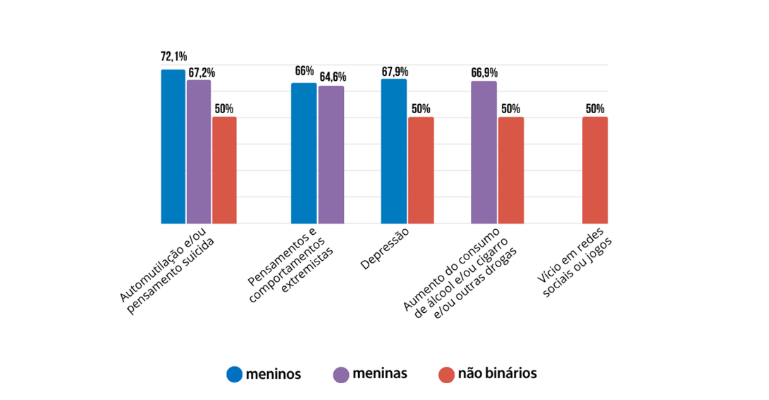
Among male participants, self-reported symptoms are milder than those female participants reported, and these symptoms are less severe than those non-binary people report about themselves (see Figure 12).

Figure 12: Main impacts on the physical and mental health of young people, reported by all participants
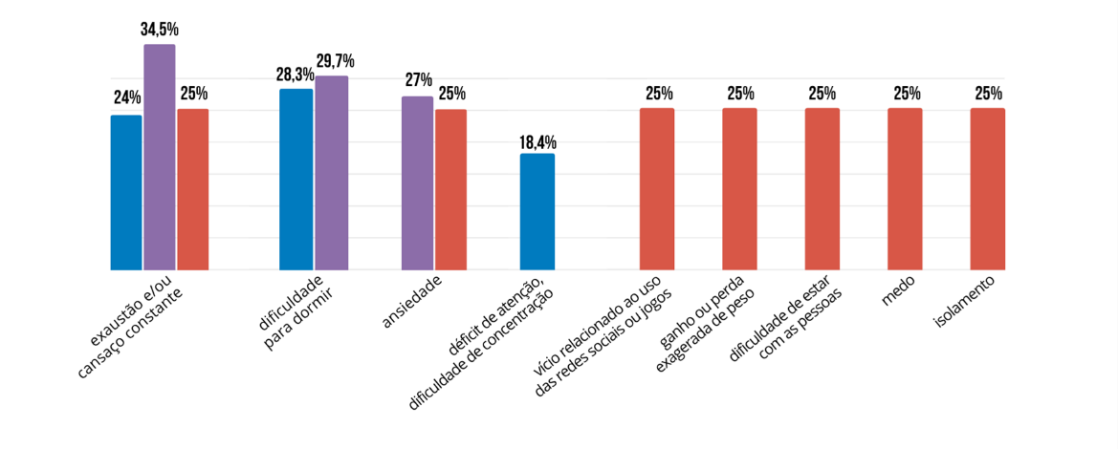

Thus, the greater variety among non-binary people may indicate a broader range of challenges faced by this group, corroborating the concerns of Butler (2000), UNESCO (2021), and the Center for Countering Digital Hate (2022). In a complementary manner, Silva et al. (2023) also explored the debate on the effects of disinformation associated with transphobic fake news, highlighting the social and psychological consequences of this practice for trans and non-binary people. Therefore, the greater vulnerability reported by non-binary young people may be related to the specific types of symbolic and digital violence addressed by the authors.

The differences between male, female, and non-binary individuals also reveal that gender matters primarily when it comes to the perception of impacts on oneself, although a perception of a greater impact on one's peers prevails among all young people. This difference in how young people perceive physical and mental health problems, namely alleviating them when they refer to themselves and intensifying them in other young people, can be explained by the Dunning-Kruger Effect. This cognitive bias, named after psychologists David Dunning and Justin Kruger, leads people to overestimate their own capabilities and underestimate their limitations (Kruger & Dunning, 1999). Applied to this context, young people may fail to recognise the severity of their own physical and mental health problems, while overestimating their occurrence and severity in their peers. This can be exemplified by the survey data, where respondents point to more serious problems such as self-harm and suicidal thoughts in other young people.

This inability to recognise one's own condition, whether due to a lack of awareness or a self-confidence bias, compromises the development of self-knowledge and the pursuit of help. This creates a cycle of neglecting one's own health. An additional concern can be added when the discussion of the Dunning-Kruger Effect is expanded to include the phenomenon of disinformation. If individuals fail to recognise their own lack of knowledge or overestimate their ability to identify the truth or its negative impacts, they become more susceptible to believing false information and miss opportunities to seek appropriate treatment and support. This also compromises the development of critical thinking.

Similarly, a lack of critical thinking can lead young people to become involved in prejudiced, racist, homophobic, and misogynistic movements. When the ability to analyse, question, and evaluate information independently is not well developed, young people become more vulnerable to radical, violent, and extremist discourse. Therefore, they are more susceptible to gender misinformation (Acquolini & Sousa, 2022).

In this context, IL—and, in Brazil, as it's known in public policy, media education—proves crucial for developing more aware and resilient youth. Both concepts are linked and strengthen each other by aligning with different areas of knowledge, such as Information Science, Communication, and Education. They share the need for critical thinking and civic awareness for decision-making, based on information committed to the common good.

As Buckingham (2023) argued, we need to recognise "...media literacy as a basic prerequisite for contemporary citizenship, and therefore as a fundamental right throughout the educational system" (p. 30). The author suggested a critical-reflexive approach that includes the perspective of those who consume and produce content, but also those who create and profit from the platforms' business models.

IL, in turn, allows individuals to acquire and develop their understanding of the world around them; to reach informed views; to challenge, credibly, appropriately, and in an informed way, assumptions or orthodoxies (including one’s own), and even authority; to recognise bias and disinformation; and thereby to be engaged citizens, able to play a full part in democratic life and society (CILIP, 2018, p. 3). We also emphasise the need to identify and understand the market for disinformation and hate speech, which profits from misogynism and LGBT phobia.

5.1 Limitations
Although it provides input for timely and urgent discussions, this study has limitations that can be addressed by further research. For example, the small number of participants in the non-binary group is acknowledged, as well as the fact that only young people from two Brazilian state capitals took part.

The different forms of intersectionality as a vector for increased vulnerabilities (bell hooks, 2000), as well as ideological and racial asymmetries (Freelon et al., 2022), may be other variables considered in future analyses. The current interpretations are considered excerpts from an academic study which contributes to but does not exhaust the possibilities of understanding the phenomenon of gender disinformation.

Future research could explore broader samples of young people across the country, including comparisons between regions and countries. Investment in qualitative studies, such as focus groups with young people, is also encouraged to gain a deeper understanding of the impacts of gender misinformation on this population.

6. Conclusion
This article revealed gender and disinformation challenges within digital environments faced by young people living in Salvador and Porto Alegre (Brazil). Empirical research data shows that hate speech is the most frequently cited problem among young people, particularly among females and non-binary people. Discrimination is another concern mentioned by these groups except among male participants.

The research also reveals variation in the intensity of self-reported impacts: males experience the mildest impacts, followed by females, and finally, non-binary young people, who report the most severe impacts. A greater variety of challenges is also observed among non-binary people, suggesting a broader range of challenges experienced by this group.

Furthermore, the results show high rates (between 50-72 percent) of self-harm and suicidal thoughts perceived by participants when assessing the health impacts on other young people as a result of internet use. This finding constitutes a serious warning for the mental and physical health of young people in Brazil, reiterating the need for interventions and support from the health system for this population. It is crucial that professionals, family members, public authorities, and other social actors who work with young people create spaces and moments of sensitive listening for this audience, so that they feel confident sharing their experiences and pain experienced or triggered by the use of digital environments. Likewise, health services need to be prepared to address the specific demands of young people and each gender group, considering the particularities of their perceptions and experiences. Providing comprehensive health care for young people is an investment in the future and quality of life for the next generation.

When launched in 2023, the Brazilian Media Literacy Strategy proposed training initiatives, primarily for education and health professionals, in line with IL, which aims to contribute to the fight against social exclusion, providing disadvantaged or marginalised groups with the means to claim their rights and participate equally in society, free from prejudice and violence. These strategies are becoming increasingly prominent. Training policies for these audiences must begin by listening to young people and these professionals, so they understand that gender disinformation and hate speech can turn into hate crimes, as warned by United Nations Secretary-General António Guterres (United Nations Brazil, 2025).

This engagement also requires the involvement of companies that own digital platforms. In addition to being held accountable for allowing the dissemination of hate speech, misogyny, and LGBT phobia in digital environments, they must curb the monetisation of this perverse market. Civil society, in turn, must increasingly exercise social control and rely on public policies that promote the healthy, respectful, and fair functioning of digital technologies and environments, as well as all interactions within them.

Declarations

Ethical approval
Ethical approval for the research was granted by the Federal University of Bahia and the Federal University of Rio Grande do Sul. Study ID: social research (CAAE: 78762224.0.0000.5347, opinion: 6.845.657).

Funding
This research was supported by scholarships from the Coordination for the Improvement of Higher Education Personnel – CAPES Brazil (Postdoctoral scholarship and Masters scholarship).

AI-generated content
No AI tools were used.

References
Acquolini, N., & Sousa, R. (2022, November 11). Gendered disinformation: Information practices that contribute to combating it [Paper]. 22nd National Meeting on Research in Information Science, Porto Alegre, Brazil.

Atkinson, R., & Flint, J. (2001). Accessing hidden and hard-to-reach populations: Snowball research strategies. Social Research Update, 33(1), 1–4.

Barbosa, F. (2024, October 26). População LGBTQIA+ denuncia mais casos de violência no país. Agência Brasil.

Beauvoir, S. (2009). The Second Sex. Nova Fronteira.

Bourdieu, P. (1999). Male Domination. Bertrand Brasil.

Brazil Ministry of Education. (2023). Ataques as escolas no Brasil: Análise do fenômeno e recomendações para a ação governamental.

Brazil Ministry of Education. (2025a). Resolution CNE/CEB No. 2.

Brazil Ministry of Education. (2025b). Digital and media education: How to develop and implement the curriculum in schools.

Buckingham, D. (2023). Manifesto for media literacy. SESC-SP Editions.

Butler, J. (2000). Bodies that matter: On the discursive limits of “sex” (T. T. Silva, Trans.). In G. L. Louro (Ed.), The educated body: Pedagogies of sexuality. Authentic.
Center for Countering Digital Hate. (2022). The Incelosphere: Exposing pathways into incel communities and the harms they pose to women and children.

Chartered Institute of Library and Information Professionals (CILIP). (2018, October 25). CILIP definition of information literacy 2018. Information Professional.
D'Ancona, M. (2017). Post-truth: The new war on truth and how to fight back. Ebury Press.

Dayrell, J. (2003). The young person as a social subject. Brazilian Journal of Education 24, 40–52.

de Andrade, F.C.B., & Gonçalves, C.C. (2024). Schools, stage and target of massacres: (Trans)formations of the code of violence. Brazilian Journal of International Politic, 29(3), 328–342.

Freelon, D., Bossetta, M., Wells, C., Lukito, J., Xia, Y., & Adams, K. (2022). Trolls negros importam: Assimetrias raciais e ideológicas na desinformação nas mídias sociais. Social Science Computer Review, 40(3), 560–578.

Freire, P. (2018). “Gender ideology” and education policy in Brazil: Exclusion and manipulation of a heteronormative discourse. Ex aequo, 37, 33–46.

G1. (2022, June 6). Casa de adolescente transgênero é apedrejada após ele reivindicar ser chamado pelo nome social em escola na Bahia. Portal G1.

Gil, A.C. (2008). Social research methods and techniques (6th ed.). Atlas.

Griffin, J. (2021, August 22). O mundo sombrio dos “incels”, celibatários involuntários que odeiam mulheres. BBC News Brasil.
High Level Expert Group (HLEG). (2018). A multi-dimensional approach to disinformation: Report of the independent High Level Group on fake news and online disinformation. European Commission.

hooks, b. (2000). Feminism is for everybody: Passionate politics. South End Press.

Horton, F. W. (2013). Overview of information literacy: Resources worldwide. UNESCO.

Kruger, J., & Dunning, D. (1999). Unskilled and unaware of it: How difficulties in recognizing one's own incompetence lead to inflated self-assessments. Journal of Personality and Social Psychology, 77(6), 1121–1134.

Kuo, R., & Marwick, A. (2021). Critical disinformation studies: History, power, and politics. Harvard Kennedy School Misinformation Review, 2(4).

Lloyd, A. (2017). The information literacy landscape: Information literacy in education, workplace and everyday contexts. Chandos Publishing.

Marwick, A. E., Losh, E., Schlüter, M., Markham, A., & Phipps, E. B. (2022, November 2–5). Feminist approaches to disinformation studies [Paper presentation]. 23rd Annual Conference of the Association of Internet Researchers, Dublin, Ireland.

Matamoros-Fernández, A., Bartolo, L., & Troynar, L. (2023, January 25). Humor as an online safety issue: Exploring solutions to help platforms better address this form of expression. Internet Policy Review, 12(1).

Ministry of Human Rights and Citizenship. (2023). Report of recommendations for combating hate speech and extremism in Brazil.

Nery, R. L. (2019). Discourse analysis on social media: The “School Without Parties” program and its contributions to the legitimization of hegemonic masculinity [Masters dissertation, Federal University of Alfenas].

Oliveira, L., Costa, P., & Azevedo, T. (2023). Monitoring massive threats of attacks on schools and universities: the role of online subcommunities that culminate in school shooters and their relationship with the rumors that produced widespread panic in Brazil from April 9, 2023 onwards [Report]. SlideShare.

Papadamou, K., Zannettou, S., Blackburn, J., De Cristofaro, E., Stringhini, G., & Sirivianos, M. (2021, October 13). “How over is it?” Understanding the incel community on YouTube. Proceedings of the ACM on Human-Computer Interaction, 5(CSCW2), 1–25.

Richardson, R. J., Peres, J. A. S., Wanderley, J. C. V., Correia, L. M., & Peres, M. H. M. (2012). Social research: Methods and techniques. Atlas.

Ruediger, M. A., & Grassi, A. (Coords.). (2023). Movimento Red Pill no YouTube: Eixos argumentativos e recomendações algorítmicas. FGV ECMI.

Santini, R. M., Salles, D., Belin, L. L., Belisário, A., Mattos, B., Medeiros, S. G., Mello, D., Grael, F., Seade, R., Borges, A., Murakami, L., Cardoso, R., Dau, E., Loureiro, F., Yoneshigue, B., do Carmo, V. , & Maia, F. (2024). “Learn to avoid 'that kind' of woman”: Discursive strategies and monetization of misogyny on YouTube. NetLab Laboratory of Internet and Social Network Studies, UFRJ.

Santos, A. C., & Rebello, I. S. (2025). Hate speech addressed to teaching identity: A semiolinguistic analysis of the “School without Party” page on Instagram. Matraga, 32(65), 307–324.

Secker, J., & Coonan, E. (Eds.). (2013). Rethinking information literacy: A practical framework for supporting learning. Facet Publishing.

Secretariat of Digital Policies of the Secretariat of Social Communication of the Presidency of the Republic. (2023). Brazilian strategy of media education.

Silva, D. D. A. (2022). Pelo celular e pelas ruas de Salvador: Participação política de jovens e a relação com as competências infocomunicacionais.

Silva, D., & Mouta, A. B. (2024). Media education and artificial intelligence: How to involve young people in these discussions. The 47th Brazilian Congress of Communication Sciences – Univali.

Silva, E. C. M. (2024). Anti-woke agenda, gender issues, revisionism and hate speech communities on Brazilian Telegram: From harmful reactionary speech to the crime of glorifying Nazism and Hitler. arXiv. Disponível em.

Silva, L., Pinto, V., & Pinho Neto, J. (2023). The impact of fake news on transphobia. The 23rd National Meeting on Research in Information Science, Aracaju.

Silva, T., Buckstegge, J., & Rogedo, P. (2018). Estudando cultura e comunicação com mídias sociais. Brasília: Editora IBPAD, 97–111.

UNESCO. (2021). Media and information literacy: Policy and strategy guidelines.

United Nations. (2023). Policy brief for our common agenda: Information integrity on digital platforms. United Nations in Brazil.

United Nations Brazil [@onubrasil]. (2025, July 21). Hate speech on social media has real-world consequences. [Instagram post]. Instagram.

United Nations Women Brazil. (2024, October 17). #No wonder: UNITE to end violence against women and girls. UN.

Viana, A. R. L., Lima, P. R. S., Arruda, A. M. A., & Miranda, M. K. F. O. (2023). Research trends in gender misinformation in the Web of Science and Scopus. National Meeting of Research and Postgraduate Studies in Information Science.

Wardle, C. (2024). A conceptual analysis of the overlaps and differences between hate speech, misinformation and disinformation. United Nations.

Appendix
Questions included in the questionnaire answered by young people from Salvador and Porto Alegre, whose responses were analysed in this article:

- What type of problem have you experienced online?

  - Hate speech
  - Cancellation
  - Online discrimination (based on color or race, gender, sexual orientation, religion, among others)
  - Harassment, molestation, sexual abuse, sharing of images without consent
  - Excessive use of games or digital technologies
  - Financial crime
  - Hacking of data or personal networks
  - Access to age-inappropriate or violent content
  - False information about this person
  - Other. Which?
  - I don't know
  - I prefer not to answer.

- What impacts have you perceived on your health as a direct or indirect result of internet use in the last three months?
a. On myself
b. On other young people

- Anxiety
- Addiction related to the use of social media or games
- Exhaustion and/or constant tiredness
- Difficulty sleeping
- Excessive weight gain or loss
- Difficulty being with people
- Frequent fights, aggressiveness
- Depression
- Self-harm and/or suicidal thoughts
- Increased consumption of alcohol and/or cigarettes and/or other drugs
- Low self-esteem
- Attention deficit, difficulty concentrating
- Fear
- Isolation
- Extremist thoughts and behaviors
- None of these situations
- Another situation. Which one?

We adopted the term “Youths” in the plural in this article to respect the different ways of being young (Dayrell, 2003).

