**Conference report**

# LILAC 2025: Focusing on what counts

**<http://dx.doi.org/10.11645/19.1.745>**

**Mary (Marette) Hickford**

Business and IP Information Specialist, British Library. Email: [marette.hickford@bl.uk](mailto:marette.hickford@bl.uk). BlueSky: [@maretteh.bsky.social](https://bsky.app/profile/maretteh.bsky.social).

**Keywords**

information literacy; librarians; LILAC

Being a first timer attending a LILAC conference, I had felt a mix of emotions at the start. Coming from the British Library, would I be treated as a bit of an outsider to a conference clearly aimed at the university library sector? Furthermore, I work in the Reference Services Department where we host one-to-one information support and workshops on various topics but which are not necessarily aimed at students. Well, I shouldn’t have feared anything. It is clear that the LILAC conference has evolved since its grassroots initiative (and it is heartening that the originals are still present!). Just like teaching librarians wanting their students to be nudged gently into learning about what critical thinking is about, the committee has done the same thing with experienced information literacy (IL) practitioners, opening with standard presentation sessions rather than straight into the keynote presentations which were placed in the second spot on all three days.

The keynote sessions presented by Stephen Thorne, Jane Secker and Elinor Carmi all shared a common thread – the lack of awareness about IL, the ability of students and the wider public to understand what critical thinking is, and how it is applied to the sources they use, and the capability of committed and passionate librarians to make themselves known across the sectors. Jane Secker was the one of three who deployed as many tricks as possible into making her presentation upbeat, by playing snippets of music in-between the points she wanted to make about the visibility of what IL practitioners have been working hard to do. Stephen Thorne’s presentation was firmly planted in the academic sector and must be applauded in his main job as a Politics lecturer who implements IL principles into his teaching. His tactics of incorporating the sources used by students into his marking assessment should hopefully support student’s self-motivation in doing well in other disciplines. Elinor Carmi’s presentation is already ideally set up to present to a much wider audience than the academic library sector. She praised the contributions made by recent dramas such as *Adolescence* and *Mr. Bates vs the Post Office* for making the public aware of the impact of influential content of social media networks and the failure of big companies not wanting to take responsibility over defects found in their systems. She called for more government legislation to enforce big tech to undergo mandatory testing for all the tools they want to bring into the market.

Reviewing the schedule post-conference, I liked that there was a balance of content so that the focus was not just on the students being taught IL, but also aimed at IL practitioners developing themselves—a clever way of emphasising the importance of applying critical thinking to their own work. A presentation by Hope Power from Simon Fraser University showed her sharing how her and her library colleagues have set up a community of practice enabling them to exchange knowledge and thoughts from their teaching experiences. The scheme is impressive—different types of platforms were deployed by the organisers to attract the involvement of all their staff, from roundtable discussions to journal club sessions.

Another presentation by Natalia Kapacinskas and Veronica Arellano-Douglas from the University of Texas, spoke of an initial 2-year research project which they carried out with the aim of encouraging library colleagues to deploy critical assessment as a way of managing their professional development learning. One of the presenters shared a realisation that her teaching approach was too fast and by being much more appropriately paced, she was able to have exchanges with her students which allowed her to become creative and understanding of their thoughts and attitudes.

A third presentation I was intrigued by was about how the term *collaboration* is viewed by library practitioners. Tatiana Usova (Carnegie Mellon University in Qatar) and Amy Andres (Virginia Commonwealth University School of the Arts in Qatar) carried out a literature review of published reports between 2002 and 2022, chosen for their inclusion of the word “collaboration”. They discovered that these projects did not stick to using this word but instead alternated collaboration with other words such as “co-operation”, “partnership” and “service”. They emphasised that these words do not necessarily have the same meaning and do not imply the equity and equality which is inferred in “collaboration”. Their presentation content also highlighted examples of both good and bad collaborations e.g. Nike and Tiffany vs Nike and Ben & Jerry’s.

Other presentations were very thoughtfully organised, enabling attendees to share practical insights into how they carry out activities or stimulate discussion with students. Mark Ogden and Becky Whyley-Smith from University of Huddersfield, spoke about their version of *Race Against the World*, whereby library teams worked together in setting up timed activities as a way of developing students' confidence in using library services, such as learning how to take a book out of the library and a shelving task. This session highlighted the importance of not making assumptions that university students have used public libraries prior to university. The presenters distributed a pack of some of the activities and invited us to take part (see Figure 1). We were all timed and I am glad to say that with another attendee, we came second!!

**Figure 1**: An activity involving working out how to assemble a citation following the Harvard style of referencing.

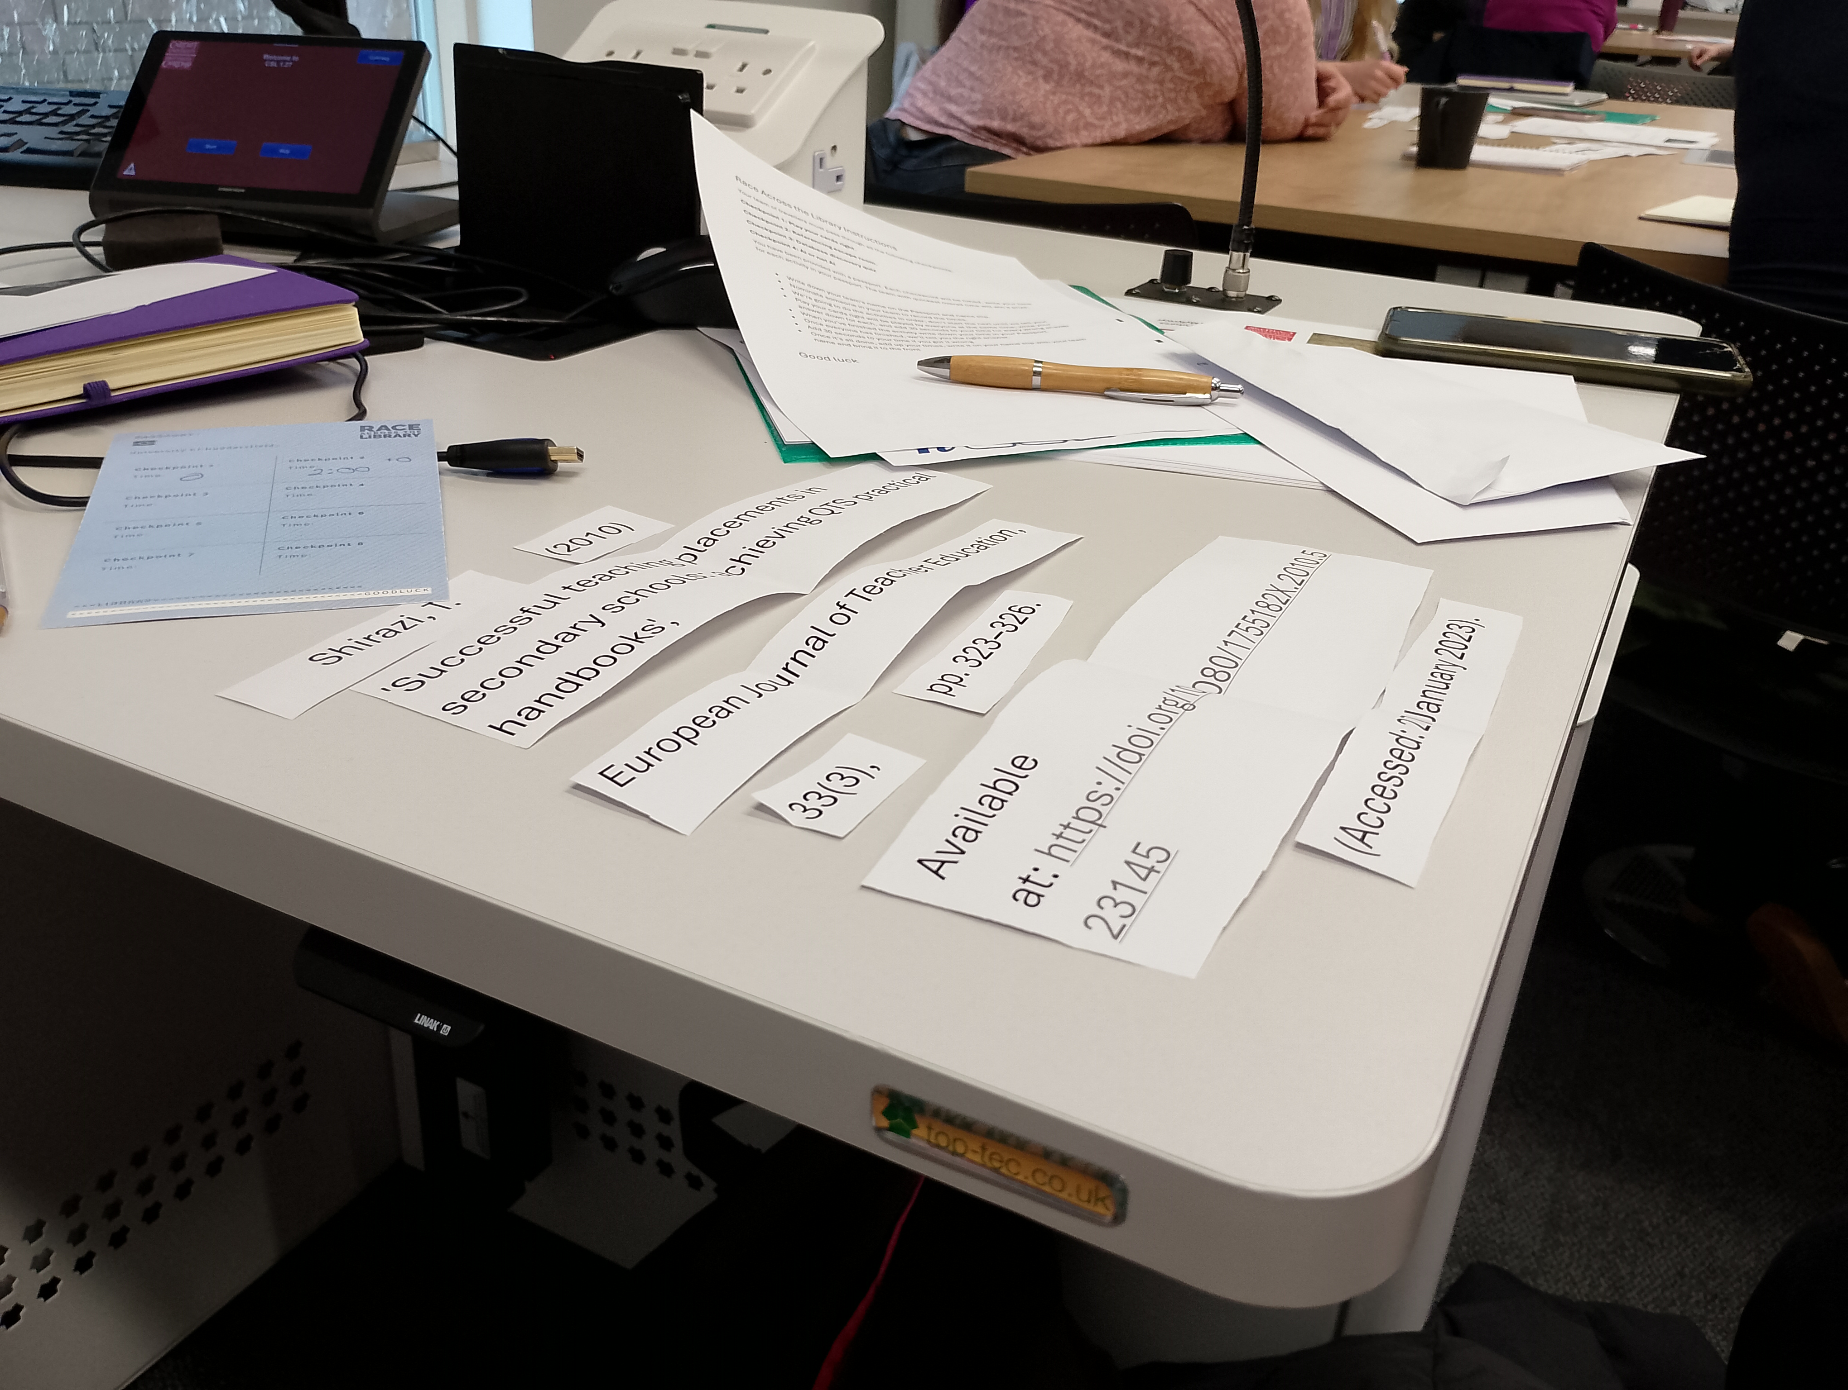

Alberto Garcia, of Wolfson College tried to soothe attendees concerns over the threats posed by Artificial Intelligence and through his research following the publication of a library guide, he discovered that students were aware of the deficiencies of AI tools, as well as revealing their fear of being accused of copying. Alberto introduced a small exercise for each table of attendees in which they were asked to place cards of student tasks and rate them as to how useful they thought they were to student learning (see Figure 2). This provoked discussion between the group and all the contributors.

**Figure 2**: An activity involving librarians rating the utility of AI tools when used by students to support their learning.

A person holding a piece of paper

An image depicting an activity whereby librarians have to rate the utility of AI tools when used by students to support their learning. The image shows hands placing blue squares with text on them on a red scale.

Outside of the formal conference sessions, the organisers put on a splendid conference dinner event with plenty of opportunities for interaction with other attendees. A quiz is always a good icebreaker! The choice of DJ was good as his mix of music choices appealed to all music interests. On the previous night, a reception was held at the National Museum of Wales, and it was a joy to view sculptures by Degas, and paintings by Monet and Van Gogh.

While the conference presenters, when speaking about their practices, provided a good window into what they do inside the classroom, description can only go so far, and the session length can present challenges in expanding on this information. It would be beneficial to perhaps provide an outlet for presenters to organise additional demonstrations or videos of their practices to help librarians who might want to implement similar activities in their workplace. Overall, I felt that the sessions had plenty of content for me to take back to share with my colleagues across the British Library, not least to assess the difficulties academic libraries appear to be having. There is perhaps some food for thought in terms of what kind of sessions the British Library should consider in the future. Hopefully, there will be a diverse representation from the British Library in the years to come and perhaps, contribute towards widening library sector representation at future LILAC conferences.

## References

Andres, A. & Usova. T. (2025, April 14–16). *Strengthening our research and training: A critical examination of information literacy collaboration*, [Conference Presentation]. LILAC conference, Cardiff, Wales.

Arellano-Douglas, V. & Kapacinskas, N. (2025, April 14–16). *Reflection as a means to assess information literacy instruction* [Conference Presentation]. LILAC conference, Cardiff, Wales.

Carmi, E. (2025, April 14–16). *Data citizenship: Learning to take actions in the datafied society* [Conference Presentation]. LILAC conference, Cardiff, Wales.

Garcia, A. (2025, April 14–16). *Inside the artificial phármakon: Observations from an academic librarian engaging with generative AI through the lens of information literacy* [Conference Presentation]. LILAC conference, Cardiff, Wales.

Ogden, M. & Whyley-Smith, B. (2025, April 14–16). *Race across the library; demystifying the library space* [Conference Presentation]. LILAC conference, Cardiff, Wales.

Power, H. (2025, April 14–16). Learning from and with Each Other: developing and Sustaining a Community of Practice for Library Instructors [Conference Presentation]. LILAC conference, Cardiff, Wales.

Secker, J. (2025, April 14–16). *Reflecting on information literacy: lessons from a lifelong advocate* [Conference Keynote]. LILAC conference, Cardiff, Wales.

Thorne, S. (2025, April 14–16). *Twenty years of information literacy in the politics classroom* [Conference Presentation]. LILAC conference, Cardiff, Wales.

## Declarations

Ethics approval

Ethics approval was not considered necessary for the nature of this report.

Funding

Not applicable.

AI-generated content

No AI tools were used.