**Project Report**

# Three shots are better than one: Establishing and evaluating the English Library Instruction Pilot

[**http://dx.doi.org/10.11645/18.2.651**](http://dx.doi.org/10.11645/18.2.651)

**Amy McLay Paterson**

Associate Librarian, Thompson Rivers University. Email: [apaterson@tru.ca](mailto:apaterson@tru.ca).

ORCID: [0000-0002-0016-6356](https://orcid.org/0000-0002-0016-6356).

**Benjamin Mitchell**

Assistant Librarian, Thompson Rivers University. Email: [bmitchell@tru.ca](mailto:bmitchell@tru.ca).

ORCID: [0000-0002-0142-2075](https://orcid.org/0000-0002-0142-2075).

**Stirling Prentice**

Assistant Librarian, Thompson Rivers University. Email: [sprentice@tru.ca](mailto:sprentice@tru.ca).

**Elizabeth Rennie**

Associate Librarian, Thompson Rivers University. Email: [erennie@tru.ca](mailto:erennie@tru.ca).

Abstract

In an attempt to expand Information Literacy (IL) instruction beyond the one-shot, the Thompson Rivers University (TRU) Library established the English Library Instruction Pilot (ELIP) in 2023-2024. Students involved in the project participated in a series of three tutorials. The outcomes of the tutorials were aligned to both their Introduction to Academic Writing (English 1100) class and the *ACRL Framework for Information Literacy*. In experimenting with the new model, we asked the following questions:

* Did the ELIP programme help students succeed in their associated English 1100 courses?
* Does more integrated instruction aid in relationship-building between the library and the TRU community?
* How can we improve our instruction practices to better meet student needs?

This paper discusses the formation of the programme, the results from our evaluation of it, and reflects on future directions and improvements. Through an examination of student assignments, a faculty feedback survey, and reflective journaling of librarian instructors, we conclude that the programme helped students complete the outcomes of their associated English 1100 class. It also contributed to relationship-building between the library and the university community and helped significantly improve existing teaching practices and materials in the library. The ELIP programme is unique in its departure from both the one-shot and credit course IL models, and we hope that our reflections will encourage other librarians to reflect and experiment with their instructional spaces.

**Keywords**

academic libraries; assessment; Canada; critical information literacy; information literacy; information literacy education; information literacy model

1. Introduction

Like many academic libraries, the Thompson Rivers University (TRU) Library enacts its Information Literacy (IL) instruction programme primarily through the provision of one time in-class sessions delivered at the behest of course instructors; or one-shots, as they are more popularly known. Between 2017-2020, an average of 40 sessions per year were delivered to Introduction to Academic Writing (English 1100) classes, a first-year course taken by most TRU students to learn basic principles of academic research, writing, and citation. We also aspire to empower our learners to recognise both the power structures and the opportunities for social change inherent in information, as per the goals of critical IL (Tewell, 2018), but that is difficult to do in the space of an hour.

It is a truth universally acknowledged that one-shot IL sessions are inadequate to deliver the “complex set of core ideas” (Association of College and Research Libraries, 2015, p. 2) contained within the ACRL *Framework for Information Literacy for Higher Education*. TRU librarians are no different in this belief. The COVID-19 lockdowns of 2020-2021 required that we diversify our approach to library instruction: embedded librarianship in Moodle courses, interactive tutorials, and instructional videos, to name a few of these changes. Instead of relying on what we’d always done, creativity and flexibility were necessary; we were required to emerge from our *stuck place* (Eisenhower and Smith, 2010) to play and experiment with new methods. As instructional patterns revert to pre-lockdown visions of normality, our department retained a vague glimpse of what was possible and maintained a still-burning hope for something better.

In Winter 2023, we entered into a dialogue with the English department about expanding library instruction for English 1100. As a course taken by most first year TRU students and the most popular class for one-shot instruction sessions, English 1100 was an obvious choice for such a project. These conversations resulted in the establishment of the English Library Instruction Pilot (ELIP), a series of three tutorial sessions taken by students in select English 1100 classes as part of their course grade. It is beyond the purview of our study to determine the long-term effects of IL writ large, but the three-session structure, as well as the enhanced collaboration and integration with course instructors, meant that we could seriously assess the impact of our efforts in a way that we had not previously had the necessary structures or relationships to do. To that end, our study asks the following questions:

1. Did the ELIP programme help students succeed in their associated English 1100 courses?
2. Does more integrated instruction aid in relationship-building between the library and the TRU community?
3. How can we improve our instruction practices to better meet student needs?
4. Literature Review

2.1 One-shot instruction

Like much of the modern literature on IL, we will primarily rely on Nicholson’s (2016) definition of the one-shot: “when a faculty member invites a librarian into the classroom to provide one-time IL instruction, typically related to a research assignment” (p. 25). Pagowsky’s (2021) definition adds the caveat that one-shot content is typically tacked on to the curriculum, and that the superficiality of their connection to the curriculum is more important than the number of sessions.

While the literature on library instruction, particularly the one-shot, is vast, there remains no conclusive evidence of its effectiveness. Spievak and Hayes-Bohanan (2013) found a benefit to one-shot instruction in their study, adding that,

negative, ambiguous and null results in studies of library instruction may be due in part to weak measures, study designs that lack enough power to detect change, biased sampling, and difficulties inherent to any study of the lasting effects of instruction (p. 489).

Some studies, using a pre-test/post-test methodology found a slight net positive improvement in IL skills (Hsieh & Holden, 2010), while Portmann and Roush (2004) saw an uptake in library use but no noticeable increase in skills. Using qualitative measures, Rinto and Cogbill-Seiders (2015) saw a positive impact on themed bibliography development after library instruction, while Wong et. al (2006) saw students non-specifically self-reporting that the sessions had helped them. Cook’s (2022) recent meta-analysis verifies the trend of small but noticeable impacts of library instruction on undergraduate students, noting several limitations of evaluating library instruction, including the lack of longitudinal studies. Nevertheless, Wittkower et. al (2022) found a correlation between library instruction and course grades in a three-year study.

Martin (2008) on the other hand famously concluded that one-shot sessions had no effect on students’ information-seeking behaviour. Martin’s study noted that even though “students realised that library resources were more credible than Internet sources, they still chose to use Internet sources instead of academic library sources for both personal and class work” (p. 9). Howard et. al (2014) also concluded that one-shot sessions alone do not increase the use of scholarly journals. While Howard et. al advocated for further collaboration with course instructors and a focus on active learning activities, Martin focused on the need for multiple IL sessions or full-semester courses.

2.2 Alternatives to the One-shot

While one-shot instruction remains the most common form of library instruction (Downey, 2016), many alternative forms of instruction are emerging, as librarians experiment with class forms and teaching methods that best impact students and confirm that impact through evaluation. Tomaszewski (2021) found that the increased flexibility provided by transitioning the one-shot to asynchronous, online sessions was helpful, while Cohen et. al (2016) used a flipped classroom approach to add content to their one-shots. Henry et. al (2015) expanded their one-shots to two-shots and found improvements in student understanding and comfort levels through pre- and post- surveys, while McCartin et. al (2021) expanded their IL sessions to eight weeks.

Credit courses in IL are increasing in popularity, with 31.6% of the librarians in Downey’s (2016) study involved in teaching one- or three-credit courses. Mulherrin et. al (2004) and Mery et. al (2012) both examined their one-credit IL courses, with Mery et. al finding that student scores were significantly better than in one-shots. Smith and Sanger (2023) embedded their IL course within the health science curriculum for greater collaboration with course instructors. Jones and Mastrorilli (2022) looked at student grade point average and student questionnaire results to underscore the importance of their three-credit IL course. After the establishment of the *ACRL Framework for Information Literacy*, many IL course designs, including Ward and Kmetz (2023) have used the Framework to align student learning outcomes. Critten (2015) asserts that IL is necessary as a standalone credit course, because “contexts and concepts of research should be the focus of instruction rather than a side note in an instruction session focused on the tools and mechanics of research” (p. 155). Critten (2015) however ultimately does not feel that the framework goes far enough in reinforcing the political nature of information.

2.3 Assessment of IL instruction

One of the roadblocks in advancing or developing IL is that there is little agreement among the profession about what should be prioritised in limited sessions and how to go about assessing effectiveness. Sobel and Sugimoto (2012) emphasise the range of assessment practices, while pointing out the lack of training by Library and Information Studies degree programmes in instruction or assessment. In their study, the most common assessment method of IL was through worksheets completed during the class, followed by tests at the end and then at the start of class. Least common were methods that assessed the learning days or weeks after the class.

Many of the studies reporting the impact (or not) of one-shot instruction sessions were sparse in their details about what was taught in the sessions and how specifically learning was evaluated; Cook (2022) reported that of the 66 studies of educational effectiveness identified through their structured literature search, only nine contained sufficient data for inclusion in the study. Even those studies reporting specifics are far from immune to criticism: for example, Howard et. al (2014) based much of their analysis on the diversity of sources used, reporting that “it was often difficult to determine whether a student found a resource from the library or the Internet” (p. 33), an ultimately meaningless metric. Spievak and Hayes-Bohanan (2013) confirmed that one-shots were partially effective based on the fact that, when given a variety of webpages to choose from, students receiving library instruction “were significantly more likely to choose the US Government webpage as the best source and to choose Wikipedia as the worst source” (p. 493). This measure, if not outright incorrect, should at least be considered highly susceptible to context.

Fisher (2016) decries IL assessment methods that primarily gauge student comfort and satisfaction with the provided instruction. Similarly, Magnus et. al (2018) extend this critique to any quantitative assessment method that positions students as customers. Pho et. al (2022) assert that “without measurable standards for success beyond numbers, the qualitative outcomes and preparation involved in library instruction are undervalued, thereby reducing both students and instructors to transactional variables” (p. 733). Finally, Accardi (2010) argues that due to the overall marginalisation of IL in the academy, a librarian can “leverage this marginal status and have the freedom to experiment with critical instructional methods and assessment strategies” (p. 252). Ironically, the limited nature of the one-shot excludes the time, relationship-building, and structural influence needed to do so.

Limitations of time and of assessment opportunities may also prevent experimentation with content. Lowe et. al (2018) focus their study on Boolean searching, techniques that often monopolise the bulk of one-shot instruction sessions. Comparing Boolean vs. natural language search results in a number of prominent databases, Lowe et. al (2018) conclude that the average relevance of search results is very similar. Rosenblatt (2010), on the other hand, argues that librarians need to spend more time teaching students how to use the sources that they find, which is not often focused on in IL sessions. Nataraj and Ibarra Siqueiros (2022) assert that the lack of time for reflection in IL sessions is detrimental to students’ critical engagement with scholarship.

2.4 Critical Information Literacy

While the challenges of incorporating critical outcomes into a limited time frame have been well documented, we concur with Pagowsky (2022) that constant problematisation is the only way to break free from our stuck places; “we critique because we care and hope for better” (p. 714).

Given the persistent ambiguity of its impact and the lack of consensus over content or directions, it is unsurprising that Eisenhower and Smith (2010) would refer to the library as a stuck place or that Wilson (1979) would describe the idea that librarians are teachers as “a comforting fiction” (p. 147). In contrast, Cadogan et al (2023) assert that, though teaching is one of academic librarians’ main responsibilities, our “disconnectedness from the teacher identity” (p. 12) persists, partially due to differences between typical IL instruction and what we believe teaching is supposed to look like. Seale and Nicholson (2024) relate the current state of IL to Berlant’s (2011) notion of cruel optimism; “when something you desire is actually an obstacle to you flourishing” (p. 1). They concur with Hicks’ (2018) assessment of IL as a sociocultural practice and express scepticism that it can be taught or obtained in a classroom at all.

Tewell (2018) defines critical IL as “an approach to education in library settings that strives to recognise education’s potential for social change and empower learners to identify and act upon oppressive power structures” (p. 11). Tewell’s study found five prominent themes around the advantages of incorporating critical IL into librarian teaching practices: increased engagement, meaningful for students, meaningful for librarians, connecting with faculty, and creating community. Creating space for dialogue (Downey, 2016; Pankl & Coleman, 2010; Tewell, 2018) and problem-based learning are often used as critical teaching methods (Downey, 2016; Jacobs, 2010; Peterson, 2010; Tewell, 2018), to shift the focus of the lesson onto active learning and acknowledge the students’ prior experiences as relevant and important (Peterson, 2010; Accardi, 2013).

While learning may not be a service, focusing on relationship-building and community creation—which has a lot to do with whether students feel comfort and belonging in the library—has increasingly become a focus of critical library instruction. Arellano Douglas and Gadsby (2022) argue that quality of presence, which they define as “a commitment to openness, mutual respect, and a willingness to change and grow through the educational interaction” (p. 807) is the most important factor in creating meaningful teaching interactions, while Edwards and Lane (2023) assert that relationality is central to a decolonialised approach to teaching. If, as Hughes (2024) envisions, the future of IL is focused on student well-being, then relationship-building needs to become central to the IL project.

1. Methodology

3.1 Establishing the English Language Instruction Pilot (ELIP)

In the Winter of 2023, we contacted the TRU English Department to gauge interest in expanding library instruction for Introduction to Academic Writing (English 1100) classes beyond the usual one-shot. In March 2023, an initial meeting was held with several interested English 1100 instructors to discuss the current state of library instruction, review goals for expanding instruction, and to hear feedback from instructors about their needs and priorities.

Taking the feedback into account, we established an initial proposal for ELIP: a series of three in-person one-hour library tutorials, complete with weekly mini-assignments, and aligned with both English 1100 course goals and the *ACRL Framework for Information Literacy*. The initial pilot proposal is available in Appendix A. The three-session structure was chosen as a way to provide significantly more library instruction than what students would normally receive while still being a manageable increase in workload for the library; attendance at the tutorials was mandatory for students, and participating instructors reserved 10% of the course grade for this purpose. Mini assignments were given extensive comments by librarian instructors and their completion was part of course attendance. Three instructors initially signed on for the Fall semester, for a total of six English 1100 sessions. In the Winter semester, an additional two instructors signed on, resulting in an additional six sessions, for a total of 12 sections of the course participating in the project. The initial proposal of assessment measures and outcomes were refined based on conversations with course instructors about perceived student needs. Thematically, we chose to concentrate on three of the six ACRL frames: *Authority is constructed and contextual, Searching as strategic exploration,* and *Scholarship as conversation*. Students received a small portion of their English 1100 grade for attending the sessions but were not graded on any of the quizzes or assignments completed in the sessions.

The first session, Authority is constructed and contextual, introduced students to sources, discussed characteristics of the sources they would need for their English 1100 assignments, and reviewed the advantages and limitations of academic sources. The session included a five-question multiple choice quiz on identifying scholarly sources, and at the end of the class the students were asked to submit answers to four questions:

1. Summarise your research topic in 1-2 sentences.
2. What academic discipline(s) do you think will have expertise on your topic?
3. What are two other factors that you will need to consider when finding information on your topic, and why?
4. Do you have any remaining questions about the information covered in today’s class?

In the Fall semester, responses to these questions were submitted via a large Post-it from each student. Librarians provided comments on the answers, as well as answers to any questions submitted by the students. In the Winter semester, a web form was established to submit the questions at the end of class, which were refined as follows:

1. What is your ENGL 1100 research topic?
2. What would you like to learn about this topic?
3. Do you have any remaining questions about the information covered in today’s class?
4. What is one question you have about your ENGL 1100 research that you hope will be covered in this tutorial?

The second session, Searching as strategic exploration, covered search techniques, including turning topics into keywords, using the Boolean AND, and how to access the sources found. The mini assignment was to complete a *Developing Effective Search Strategies Worksheet* based on their chosen topic for their English 1100 research paper. Librarian instructors gave feedback on the search strategies. In the Winter semester, the worksheet was revised significantly. Both versions of the worksheet can be found in Appendix B.

The third session, Scholarship as conversation, focused on academic integrity and citation of sources. Because citation techniques are already part of the English 1100 curriculum, the goal of the tutorial was to reinforce general principles of citation, rather than either duplicating content or attempting the herculean task of teaching proper citation practices in the space of an hour. The session included a short multiple-choice quiz on academic integrity, and at the end of the session students were asked to submit a citation for one of their chosen sources through a web form, along with a few sentences about why they chose that source for their paper. Librarian instructors gave comments and corrections on the submitted citation and rationale.

3.2 Assessing the Programme

The following tools were used to assess the programme based on our objectives: analysis of student assignments, a faculty feedback survey, and reflective journaling by librarian instructors. Nvivo was used to assist in document organisation and thematic analysis.

3.2.1 Student Assignment Data

At the advice of the TRU Research Ethics Board, student consent to participate in this project was provided through an opt-out consent form, delivered as part of the course syllabus. The full text of the opt-out consent form is provided in Appendix C. The consent form and opt-out procedures were highlighted verbally to students during the first session of the tutorial. In Week One, the questions submitted by the students were thematically coded by the Principal Investigator to learn more about students’ information needs. Questions were themed based on which tutorial session was set to cover that information; questions not related to any of the tutorial sessions were classified as *Other*.

Search strategy assignments from Week Two of the tutorial were thematically coded based on the stage where the strategy most needed improvement. Because of the significant revisions between the Fall and Winter semester’s version of the assignment, the codes differed for each semester. For Fall, codes included: topic problems, initial search terms, and synonyms. For Winter, codes included: topic problems, concepts, and keywords. Strategies that were essentially workable as presented or with very minor tweaks were also identified.

In Week Three, the student rationale for their choice of source was thematically coded based on their submitted reasons for choosing the source, that is, the scope of their topic, the apparent credibility of the source, a combination of factors, or no logical justification. Student responses that demonstrated a thoughtful reflection on how the source would be used in their research were also identified.

3.2.2 Faculty Survey

English 1100 instructors who participated in the pilot programme were sent a short survey at the end of the Winter semester. The full survey was delivered through LibWizard and is available in Appendix D. Faculty members were asked open-ended questions about the observed impact of each of the three tutorial sessions. They were also asked to submit a response on a Likert scale from 1-5 (1 – Strongly disagree, 2 – disagree, 3 – Neither agree nor disagree, 4 – Agree, 5 – Strongly agree) to the question *Overall, I believe students benefitted from the tutorial classes*. Faculty members were also asked to provide thoughts on the logistics of the tutorial, communication from the librarians, and any changes they would like to see made going forward. Open-ended responses were thematically coded using Nvivo.

3.2.3 Reflective Journaling

As instructors of the ELIP programme, each of us kept a journal over the course of the pilot project, briefly recording our thoughts after each session that we taught. While not required to conform to any specific length or format, the following question prompts were suggested for journal entries:

1. How did the class go generally?
2. Any interesting questions asked and/or discussions generated?
3. Is there anything you would like to change or improve for next time?
4. Did anything go particularly wrong?
5. Did anything work particularly well?

Journals were collected and thematically analysed with the help of Nvivo, identifying logistical issues throughout the pilot, as well as items we thought were working, needed improvement, or were of interest.

1. Results

Based on the submission data for in-class quizzes and mini assignments, approximately 300 students participated in the ELIP project by attending at least one of the three sessions. These students were spread over a total of 12 English 1100 classes, delivered by five different course instructors.

4.1 Student Assignments

4.1.1 Week One

Of the submitted Week One mini assignments, there were 119 total responses to the question *What is one question you have about your ENGL 1100 research that you hope will be covered in this tutorial?* Of these, the highest response category (n=27) was *Other*, meaning that the student’s question was not covered by the tutorial curriculum. The bulk of these questions had to do with writing structure and how to use the sources they would find in their research. Examples include:

* *“How to properly skim read long articles, while getting enough information”*
* *“I’m not really sure, but I find linking research articles to your topic hard. Sometimes the source works and sometimes it doesn’t. Perhaps I need a better way to formulate the research question.”*
* *“How much of my own opinion should be implemented in my research paper”*
* *“How to use Scholarly article for my research topic”*
* *“Writing structure”*

After *Other*, the next highest response category was *No question* (n=25). Many of the responses anticipated having questions in the future. For example:

* *“Do not have one yet but will most likely think of one by next session.”*
* *“Nothing yet”*
* *“Still thinking about it”*

Eighteen questions were asked during the Week Two theme, Searching as strategic exploration. Examples include:

* *“what to do if your topic is difficult to research, or has a drought/lack of research about it”*
* *“How to find sources”*

Fifteen questions were asked during the Week Three theme, Scholarship as conversation, such as:

* *“How to cite”*
* *“how to perfect in-text citations.”*

Finally, 10 questions related to the Week One theme, Authority is constructed and contextual. Since these questions were submitted at the end of the Week One class, it makes sense that there were fewer questions about this topic. Examples include:

* *“how to determine academic sources”*
* *“Scholarly sources or not scholarly sources.”*

4.1.2 Week Two

In the Fall 2023 semester, 144 students completed the Developing effective search strategies worksheet. Reviewing the worksheets, 34 students had problems formulating a topic statement, generally due to lack of specificity. Examples of topic problems include:

* *“Is 3D printing the future?”*
* *“Local issues in Kamloops”*
* *“Reconciliation”*

A smaller portion of the students (n=24) were judged to have workable topic statements but did not completely reflect the essence of those topics in their initial keywords/search terms. For example, one student identified the following topic: *Effect of winter on mental health on children.* From this topic, the student identified the search terms *“winter”* and *“mental health”* but neglected to include anything that would indicate that the effect on children was included in the topic.

However, by far the most popular problems with the submitted search strategies involved identifying synonyms of the proposed search terms. For example, one of the students identified the topic, *impact of youth sports in BC* and from this topic proposed some logical keywords: sports, youth, and impact. While the initial topic could be improved by specificity, the larger problem with this search strategy came when the student attempted to identify synonyms for their keywords. The final proposed search strategy was: *(work ethic OR training OR fun) AND (cooperation OR respect OR responsibility) AND (academic OR health OR lifestyle).* Not only does this strategy completely leave out the major concepts from the initial topic, but the proposed synonyms have little relation to each other. In total, 58 students submitted search strategies containing this type of issue. Only 28 students submitted strategies that were essentially workable with very minor tweaks; often these students declined to generate additional synonyms as they did not feel that more were needed. Occasionally, the worksheet seemed to accomplish its purpose of aiding the student in expanding their thinking about the topic into further helpful keywords and synonyms, but this did not appear to be the common experience.

Because of the observed problems experienced by Fall 2023 students in completing the worksheet, it was significantly updated and simplified in advance of the Winter 2024 semester. Synonyms were removed, and students were asked only to identify concepts from their topic and convert these into keywords. Additionally, these students were asked to write the title and author of one article they found in their search. In the Winter semester, 117 students completed the worksheet.

Overall, the improvements made to the worksheet seemed to yield much better results for the students. In the Winter semester, 43 students turned in strategies that were workable with only minor tweaks. Eighteen students were identified as having problems with their topic, similar to students in the Fall semester. An additional 19 students had problems picking out key concepts from their topic statement. For example, one student proposed the topic*, The treatment of women composers in classical music history.* The concepts they identified related to that topic were: *feminism, history, and diversity/inclusion*, completely leaving out the importance of classical music and composers to their topic.

However, the largest roadblock experienced by students were transforming their concepts into search keywords. For example, one student proposed the topic, *Impact of digital sharing economy platforms on tourism accommodation,* along with the associated concepts of: *Airbnb, tourism accommodation, and economy*. However, when it came time to put together keywords for their first search, the student chose: *profitability AND economic impacts AND digital sharing*, leaving tourism out of the equation entirely.

4.1.3 Week Three

Overall, 206 students submitted a citation through the web form, along with an answer to the prompt, *Briefly explain why you chose this source in particular to help you write about your topic*. The majority of student submissions were at the very least recognisable as citations, including the necessary elements to identify and locate the source. Only 12 students submitted answers that were not recognisable as citations or did not include all the required elements. Examples of these include:

* *“American History and Life” (presumably the database the student searched)*
* *“Frontiers in Psychology 8, 1351, 2017”*

In response to the prompt of why they chose this specific source, almost half the students (n=96) gave a response that indicated that the scope of the source matched the scope of their topic. Examples include:

* *“Gave me brief detail about my topic”*
* *“This source directly relates to the research I would like to include regarding the negative effects of sleep deprivation”*
* *“Because it touches on the struggles international students have trying to rent a home in Canada.”*

Fifteen students gave answers related to the apparent credibility of the source, including:

* *“Because I had to use scholarly sources to support my research”*
* *“it was a scholarly article and I found this article from tru library research”*
* *“I think this source will be very informative and have a lot of the required knowledge.”*

39 students either declined to provide a coherent reason or appeared to confuse the source with their overall topic. Finally, 56 students gave answers that combined multiple factors and/or provided specifics about how this source would be useful to their papers specifically. Examples include:

* *“It provides information in an easily understandable format. It is also very specific to a point I am trying to argue in my writing.”*
* *“The book offers well-researched explanations and practical strategies that I can incorporate into my writing to enhance understanding and offer actionable advice to readers.”*
* *“It gave me a good jumping off point to continue my research on my topic through the perspective of trans people and their experience with horror film representation.”*

4.2 Faculty Feedback Survey

All five participating English 1100 instructors completed the feedback survey. In response to the question, *Overall, I believe students benefitted from the tutorial classes*, all five respondents chose *Strongly agree* (4) or *Agree* (1). When asked to comment on the communication from the library about and during the tutorial, four out of five responded that the communication was *good* or *excellent*. One responded that there would ideally be more communication during the weeks of the tutorial. When asked to suggest changes to the programme, three had no suggestions and reinforced their support for the programme, while two suggested some logistical changes to the timing of the tutorials.

The bulk of the survey asked about the observed impacts of the tutorial, in terms of each of the three themes. Reported impact on identifying appropriate information sources, including scholarly sources, was very strong, with all five instructors commenting that there was a noticeable difference in source selection for ELIP students. One respondent suggested finding a simple activity to reinforce these concepts. Sample responses to this question included the following:

* *“For those who attended, I think this helped quite a bit. I can see a lot better source choices on final papers.”*
* *“Students demonstrated a clear understanding of how to find and identify scholarly sources. I noted that the students who engaged in these tutorials included at least five scholarly research sources in their final research essay. In terms of identifying scholarly sources, there was a notable difference between students who participated in the tutorials and those who didn't.”*
* *“I saw significant improvement in the level of confidence students had with the research process.”*

When asked to report impacts related to searching or investigation of their topic through research, three out of five instructors mentioned a positive impact. One mentioned that this session would be more relevant if it was held earlier in the term, and finally, one was unclear about the impact, mentioning students’ additional difficulties with argumentation. Sample responses to this question included the following (some abridged for length):

* *“Students who participated in the tutorials could identify key search words and comfortably use the TRU Library search platform. Students told me that they learned how to use filters and limits to refine their searches. Their understanding of these database features helped them work independently.”*
* *“ELIP students effectively utilized the sources that they found in there [sic] research essay. Students who did not participate in the ELIP did not use sources as effectively in their essays.”*
* *“I think students could actually benefit from a standalone workshop on argumentation, in addition to the ones currently offered in this project.”*

Finally, when asked to report impacts related to engaging in appropriate citation practices, responses remained positive but were more lukewarm than the other two sessions. Two instructors mentioned some duplication with what is already covered in English 1100. Sample responses included the following:

* *“This was mixed. For those who attended, I do see a greater aptitude in citing, and less missed citations. Quoting, using sources, and integrating them is still a bit shaky, but many are new to writing as a whole.”*
* *“The majority of students who participated in the tutorial included appropriate and correctly formatted in-text citations and references. Citations were less consistent for those who didn't participate in the tutorials. However, the students who didn't participate in the tutorials were also generally less committed to the class.”*
* *“Good, but perhaps more can be included within the learning modules pertaining to citations. There was some repetition with respect to what I had covered in class.”*

4.3 Reflective Journaling

Many similar themes emerged across each of our journals. Despite the expanded number of sessions, the most common theme was the feeling of being pressed for time. To address this, certain sections were cut out as the sessions went along, most notably, a database comparison from Week Two, and a paraphrasing exercise from Week Three. The section on Inclusive Language was seen as awkwardly shoehorned into Week Three, and in the Winter semester, it was moved to Week One. We felt trapped between wanting to pursue interesting discussion threads and making sure all the material was covered. As one of us wrote, “Timing is still a concern, and there is a pressure between encouraging class conversation trying to get through everything.”

Along with the overall timing concerns, we sometimes questioned what content we had chosen to prioritise. The Academic Integrity quiz in Week Three was sporadic at provoking conversation, and the connection between Academic Integrity and citation was tenuously drawn. While the paraphrasing exercise was cut for time in Week Three, some of us suggested that this might have been more important to include.

Regarding what we observed was working about the programme, the bulk of the content, particularly in Weeks One and Two, were perceived to be making a positive impact on students. One of us recorded a situation where students brought guests to the class:

*Weirdly, a group of students brought two of their friends to the class as guests. Overheard them explaining what it was: “a library thing we have to do for English…but it will make you smarter.” The guests stayed and both took worksheets and worked on their strategies, and one of them actually participated and asked questions….We started on the worksheets with about 20 minutes left in the scheduled time. I thought that everyone would finish quickly and leave eagerly, but the largest group spent the whole time working on their sheets (including one of the guests). People put a lot of work into it. As they were leaving one of the guests said he might come back next week, and one of the students said, “If this were a class, I’d take it every year.”*

The scholarly sources quiz and the search strategies worksheet were observed as eliciting engagement, discussion, and effort from students. Though many students arrived at the tutorial without chosen topics, they were able to use the tutorial time to make progress on their work. Though we all struggled with the timing, we managed to consistently make it work.

We also appreciated the opportunity to foster a critical lens and to help inculcate a curious mindset in our students. We had time to include discussions about ethical uses of information and to incorporate Indigenous content. While it was a challenge to find a line between encouraging critical thinking and reinforcing practical skills, the additional time provided at least gave us time to experiment with approaches. As one of us wrote,

*One thing that took a bit of extra finessing to communicate to students was how the nature of academic authority and peer review as a “gold standard” is not absolute across knowledge domains and that just because a classroom setting often asks you to specifically seek out academic sources, that doesn’t mean that they’re the only ones that matter. One student asked if it made sense that some rando economist could claim to know more about how a farm worked that someone who picked apples. While this was covered in the PowerPoint, it came up rather early on in class discussion and was thoroughly discussed.*

Most importantly, we all noticed impacts in the relationships we were able to build with students over the course of the three sessions. We were able to tailor our classes to student needs and help students iterate on their chosen topics in ways that were not possible within the confines of the one-shot. One comment stated,

*One student spent the hands-on time researching one topic, and brainstorming with me about it, only to hang back at the end of class and ask whether I thought there might be enough material to research an entirely different topic – one that was clearly of a far more personal nature and interest. I think it took the class to see that second topic as a potential area of research, and/or to see me as someone safe enough to ask about it...*

We saw this programme as an opportunity for a closer look at the continuing journey and struggles of students, and the students often expressed a wish to continue working with the specific librarian who taught their class.

1. Discussion and Conclusions

5.1 Student Success

Our research indicates that the ELIP programme did help students succeed in their English 1100 courses. While many of our own observations through journaling captured learning in progress, the faculty feedback is most compelling in this regard. Collaborating faculty members consistently reported through the survey that participating students found, identified, and used appropriate sources more effectively than those that did not attend the programme. It should be noted that all participating faculty members were those for whom we had taught numerous one-shots in past years, so in reporting the impact of the programme, these instructors were asked to factor these students into their comparative assessments. When asked directly whether students benefitted from the programme, four out of five faculty members chose *Strongly agree*, while the fifth chose Agree.

Our study was not designed to capture long-term impact of the tutorial; nor was it intended to validate the project of IL instruction writ large. Our focus on integrating the tutorial outcomes within the context of a single course is similar to Seale and Nicholson’s (2024) call to “envision ourselves as helping students learn ‘how to library’” (p. 133). Neither a one-shot nor a credit course, the structure of the ELIP model was unique in comparison to any IL programme we encountered in the literature. As Cadogan et al (2023) note, librarians’ “teaching reality is misaligned” (p. 12) with our traditional conceptions of teaching. The ELIP programme did not correct that alignment but played within a non-traditional classroom to discover and build our own image of the teaching librarian.

Accardi (2010) rightfully identifies the underused power librarians can leverage via our unique (and marginalised) instructional positions. Unbeholden to grading rubrics, we hoped to create a space, as Edwards and Lane (2023) suggest, where “people could bring their curiosity and lean into the potential discomfort of change” (p. 12). For example, we have not reported the student quiz results in this paper, because the point of the quizzes was not to assess student learning but to practice that learning, and more importantly, to surface points of discussion or confusion.

Similarly, success in the mini assignments was not the primary goal of those exercises. Research repeatedly suggests that outside of structured IL sessions, students default to what they know, “and what they know is frequently limited to Google searches” (Howard, 2014, p. 28; see also: Martin, 2008). Thus, the programme was structured to provide the time and space for students to meaningfully engage with processes they may not otherwise devote their energies towards. Furthermore, structured help and feedback were provided to students in return for their efforts. We consistently observed in our journals that students seemed to approach their search strategies assignments with genuine thought and effort, often soliciting our opinions on certain points or staying after class was dismissed to finish writing. Although, in the case of the search strategies worksheet, the tool was not ideal to facilitate the process, we still made good use of the opportunity to provide students with detailed, individual feedback.

5.2 Relationship Building

Hughes (2024) contends that the future of IL “shifts the focus from an abstract concept to continuous active engagement with information as a pervasive element of human life and the natural world” (p.89). Thus, building relationships and connections must be essential to our IL practices.

Once again, the scope of our study precludes any long-term analysis of relationships built with students in the programme. While our journals reflect numerous instances of students self-reporting that they will seek help from us and from the library in the future, we do not yet know if this will prove true. Though Arellano Douglas & Gadsby (2022) argue that the duration of teaching is less important than *“*quality of presence*”* (p. 807), our journals are consistent in finding it much easier to achieve authentic connection with students over the course of three weeks and without the course instructor present. The situation where students invited their friends to class, for example, would not have been possible in a one-shot scenario. Nor, we would argue, would students have had the time to cultivate any strong opinions about the class, its content, and effect.

Similarly, the student who developed the level of trust necessary to disclose, and discuss a very personal research topic, would be a rare thing indeed in a one-shot classroom. Nataraj and Siqueiros (2022) note that students often “struggle to acknowledge their own pre-existing interests or expertise” (p. 820) because they are preoccupied with frantically checking the boxes of assignment requirements. In this scenario, it took the existence of the ELIP programme for the student to discover that an area of personal interest could also be a site for research and scholarly reflection. This experience highlights that “sense of mutuality and active collaboration” (p. 814) that Arellano Douglas and Gadsby (2022) find in fulfilling educational collaborations.

In working explicitly towards the outcomes of English 1100, the ELIP programme embraced problem-based learning as a teaching strategy. The programme structure excluded many of the pitfalls that Peterson (2010) describes of her one-shot teaching: superficial engagement, lack of reflection, no accountability to students. Accountability and reflection were, by contrast, built into the programme through the repeated sessions and assignment feedback.

In terms of our relationship with faculty, the collaborative effort to align programme content and goals with the course curriculum was itself meaningful and significant to our connection with course instructors. Pagowsky (2021) calls the one-shot “the antithesis of collaborative work and collective action” (p. 306); in order to succeed in this programme, we had to break out of our silo and work not only with faculty in the English programme but with each other, communicating, brainstorming ideas, and making adjustments on the fly. All involved instructors expressed their hope that the programme would continue. Like Howard et al (2014), we found that a collaborative approach was necessary for assessment of the programme, and we believe that it was this close collaboration that gave the programme a lot of its power. Most of the criticisms and suggestions about the programme present in the faculty survey emerged from imperfections in that collaboration. One prominent example is the faculty member who suggested that the search strategies activity would be more effective earlier in the term. Our own journals reflect this point as well, particularly our consternation over attempts to teach search strategies to students who mostly did not yet have research topics. Improving the ELIP programme going forward will inevitably mean improving our relationships and connections with students and faculty.

5.3 Improving our Teaching Practices

If the TRU Library was a stuck place (Eisenhower & Smith, 2010) in terms of our IL programme, it is that no longer. If the ELIP programme was anything, it was an opportunity to break out of teaching the same sessions repeatedly with no time to grow or reflect, a peril that many have observed of the one-shot model (Pho et al, 2022; Pagowsky, 2022; Seale & Nicholson, 2024). This programme was the closest opportunity we have had to observe the research journey of early undergraduate students, and in doing so, we were able to drastically improve our teaching practices.

The most salient example of our own improvement is the evolution of the Developing Effective Search Strategies mini assignment. This worksheet had been posted on the library website for student use for many years before being used in the ELIP programme. Other libraries, as well as a Pearson textbook, have at various times requested to adapt or use the worksheet. However, particularly in the Fall semester, the tool itself was detrimental to improving student strategies. The concept of finding synonyms sidetracked many students away from their original topics and keywords, and we found it difficult to provide the feedback and commentary necessary to course correct. This experience prompted us to drastically simplify the worksheet before the Winter semester, resulting in much better search strategy assignments that term. However, many students remained confused by the process of converting concepts into keywords. While the simplified search strategy worksheet seemed to be overall a much greater success than the original version, every extra step we included in the process took some students further away from their goal.

Our experience with the Developing Effective Search Strategies worksheet is reminiscent of Lowe et al’s (2018) findings about Boolean logic. Lowe et al observed that continuing to teach Boolean is “out of sync with the framework” (p. 518), and furthermore, may not yield better results than a natural language or phrase search for beginning researchers. Boolean logic has long been a staple of library instruction, but especially considering our collective struggles with time parameters, it is intriguing what we might use our freed-up time for, if we eliminated or minimised instruction on Boolean logic.

Both our own journals and the student assignments suggest that we should at least rethink some of the content we chose to prioritise. When one of the faculty members proposed in their survey answer that a workshop on argumentation would be beneficial, our initial reaction was to wonder if this would be outside the tutorial’s scope. However, as Rosenblatt (2010) suggests, “Shouldn’t we, as instructional librarians, be concerned about students’ abilities to use the information that they have discovered?” (p. 60) Incorporating more content around source use and argumentation would also be consistent with student needs as expressed in our mini assignment from Week One, where many students submitted questions about using the sources they would find. While the paraphrasing exercise in Week Three was cut from the curriculum early on, there may well be more value in devoting time to such an active writing exercise than in attempting to shoehorn citation principles together within such a short period.

Though less concrete, we will also continue to struggle with the classroom space “as a dialogic space” (Pankl & Colemen, 2010, p. 10) and the incorporation of creativity, social justice, relationality, and liberation within our teaching practices. Seale and Nicholson (2024) caution against a return to “uncritical bibliographic instruction” (p. 133), while Eisenhower and Smith (2010) wonder how often our practices simply mirror those of “the faculty with whom we collaborate” (p. 306). Though we have explicitly tied our outcomes to a particular course, our object is to make space for our own practices and philosophies within that context. For example, one initially interested faculty member ultimately declined to participate in the programme after hearing that we would discuss the importance of inclusive language, as defined by both the APA and the MLA citation manuals.

The format we chose for our programme was partially dictated by the context of our institution and by the capacity of our department. However, it was through our attempt at experimentation that we were able to discover student needs, improve our practices, and build relationships. We encourage other librarians to break out of a stuck place, through similar experimentation within the contexts of your own institutions and programmes; our programme is evidence that the daunting prospect of a credit course is not the only answer to revitalising an IL programme. In fact, the ELIP programme was able to play with the library’s unique instructional position to break down silos in a way that a credit course may not have been able to achieve. Our programme was far from perfect, but it opened up a space for dialogue, collaboration, and continuous improvement. Our journals frequently grapple with balance—between trust versus scepticism of established authority, pursuing discussions versus ensuring content coverage, emphasising practice versus theory. This is a tightrope we cannot but cease to walk, in the hopes of finding our finesse through the practice.

**Declarations**

Ethics approval

Ethical approval for this project was received from the Thompson Rivers University Research Ethics Board on 27th September 2023.

Funding

Not applicable.

AI-generated content

No AI tools were used.

Acknowledgements

We would like to sincerely thank the English department faculty and English 1100 students who participated in this pilot project.

We would also like to thank the *Journal of Information Literacy* editors and staff for their work on this paper.

**References**

Accardi, M. T. (2010). Teaching against the grain: Critical assessment in the library

classroom. In A. Kumbier, E. Drabinski, & M. T. Accardi (Eds.), *Critical library instruction: Theories and methods* (pp. 251–264). Library Juice Press.

Accardi, M. T. (2013). *Feminist pedagogy for library instruction*. Library Juice Press.

Arellano Douglas, V., & Gadsby, J. (2022). [The power of presence: One-shots, relational teaching, and instruction librarianship](https://doi.org/10.5860/crl.83.5.807). *College & Research Libraries*, *83*(5), 807–818.

Association of College and Research Libraries. (2015). [*Framework for information literacy for higher education*](https://www.ala.org/sites/default/files/acrl/content/issues/infolit/Framework_ILHE.pdf)*.*

Berlant, L. (2011). *Cruel optimism*. Duke University Press Books.

Cadogan, D., Rice, B. C., Maher, S., & Torian, S. (2023). [One within many, many within one: A collaborative, dialogical exploration of librarian-teacher identity](https://doi.org/10.33137/cjal-rcbu.v9.40956). *Canadian Journal of Academic Librarianship / Revue Canadienne De Bibliothéconomie Universitaire*, *9*, 1–28.

Cohen, M. E., Poggiali, J., Lehner-Quam, A., Wright, R., & West, R. K. (2016). [Flipping the classroom in business and education one-shot sessions: a research study](https://doi.org/10.11645/10.2.2127). *Journal of Information Literacy*, *10*(2), 40–63.

Cook, D. B. (2022). [Is the library one-shot effective? A meta-analytic study](https://crl.acrl.org/index.php/crl/article/view/25578/33485). *College & Research Libraries*, *83*(5), 739–750.

Critten, J. (2015). [Ideology and critical self-reflection in information literacy instruction](https://doi.org/10.15760/comminfolit.2015.9.2.191). *Communications in Information Literacy*, *9*(2), 145–156.

Downey, A. (2016). *Critical information literacy*. Library Juice Press.

Edwards, A., & Lane, J. (2023). [Imperfectionist: A friendship-grounded approach to academic library instruction.](https://doi.org/10.33137/cjal-rcbu.v9.40952) *Canadian Journal of Academic Librarianship / Revue Canadienne De Bibliothéconomie Universitaire*, *9*, 1–27.

Eisenhower, C. & Smith, D. (2010). The library as “stuck place”: Critical pedagogy in the corporate university. In A. Kumbier, E. Drabinski, & M.T. Accardi (Eds.), *Critical library instruction: Theories and methods* (pp. 305–317). Library Juice Press.

Fisher, Z. (2016, November 18). [*Learning is not a service*](https://coalliance.org/sites/default/files/Fisher.pptx) [Conference presentation]. Library assessments workshop, University of Denver.

Henry, J., Glauner, D., & Lefoe, G. (2015). [A double shot of information literacy instruction at a community college](https://doi.org/10.1080/02763915.2015.1120623). *Community & Junior College Libraries*, *21*(1–2), 27–36.

Hicks, A. (2018). Making the case for a sociocultural perspective on information literacy. In K. P. Nicholson & M. Seale (Eds.), *The politics of theory and the practice of critical librarianship* (pp. 69–85). Library Juice Press.

Howard, K., Nicholas, T., Hayes, T., & Appelt, C. W. (2014). [Evaluating one-shot library sessions: Impact on the quality and diversity of student source use](https://doi.org/10.1080/02763915.2014.1009749). *Community & Junior College Libraries*, *20*(1–2), 27–38.

Hsieh, M. L., & Holden, H. A. (2010). [The effectiveness of a university’s single-session information literacy instruction](https://doi.org/10.1108/00907321011070937). *Reference Services Review*, *38*(3), 458–473.

Hughes, H. (2024). [Flourishing in an ocean of information: A futures vision for information literacy](https://doi.org/10.11645/18.1.565). *Journal of Information Literacy*, *18*(1), 84–93.

Jacobs, H. L. M. (2010). Posing the Wikipedia “problem”: Information literacy and the

praxis of problem-posing in library instruction. In A. Kumbier, E. Drabinski, & M. T. Accardi (Eds.), *Critical library instruction: Theories and methods* (pp. 179–197). Library Juice Press.

Jones, W. L., & Mastrorilli, T. (2022). [Assessing the impact of an information literacy course on students’ academic achievement: A mixed-methods study](https://doi.org/10.18438/eblip30090). *Evidence Based Library & Information Practice*, *17*(2), 61–87.

Lowe, M. S., Maxson, B. K., Stone, S. M., Miller, W., Snajdr, E., & Hanna, K. (2018). [The Boolean is dead, long live the Boolean! Natural language versus Boolean searching in introductory undergraduate instruction](https://crl.acrl.org/index.php/crl/article/view/16729/18669). *College & Research Libraries*, *79*(4), 517–534.

Magnus, E., Belanger, J., & Faber, M. (2018). [Towards a critical assessment practice](https://www.inthelibrarywiththeleadpipe.org/2018/towards-critical-assessment-practice/). In the Library with the Lead Pipe.

Martin, J. (2008). [The information seeking behavior of undergraduate education majors: Does library instruction play a role?](https://doi.org/10.18438/B8HK7X) *Evidence Based Library and Information Practice*, *3*(4), 4–17.

McCartin, L. F., Markowski, B., & Evers, S. (2021). [Developing an assessment plan for information literacy learning outcomes: Process and planning](https://crln.acrl.org/index.php/crlnews/article/view/24770/32614). *College & Research Libraries News*, *82*(1), 32–44.

Mery, Y., Newby, J., & Peng, K. (2012). [Why one-shot information literacy sessions are not the future of instruction: A case for online credit courses](https://doi.org/10.5860/crl-271). *College & Research Libraries*, *73*(4), 366–377.

Mulherrin, E., Kelley, K. B., Fishman, D., & Orr, G. J. (2004). [Information literacy and the distant student: One university’s experience developing, delivering, and maintaining an online, required information literacy course](https://doi.org/10.1300/J136v09n01_03). *Internet Reference Services Quarterly*, *9*(1/2), 21–36.

Nataraj, L., & Ibarra Siqueiros, A. (2022). “[Slow your roll”: Making time for reflection and diverse epistemic practices in library instruction](https://doi.org/10.5860/crl.83.5.819). *College & Research Libraries*, *83*(5), 819–832.

Nicholson, K. (2016). “Taking back” information literacy: Time and the one-shot in the neoliberal university. In N. Pagowsky & K. McElroy (Eds.), *Critical library pedagogy handbook: Volume 1: Essays and workbook activities* (pp. 25–39). American Library Association.

Pagowsky, N. (2021). [The contested one-shot: Deconstructing power structures to imagine new futures](https://crl.acrl.org/index.php/crl/article/view/24912/32760). *College & Research Libraries*, *82*(3), 300–309.

Pagowsky, N. (2022). [Critique as care: Disrupting narratives of the one-shot instruction model](https://crl.acrl.org/index.php/crl/article/view/25576/33460). *College & Research Libraries*, *83*(5), 713–725.

Pankl, E. & Coleman, J. (2010). “There's nothing on my topic!” Using the theories of Oscar Wilde and Henry Giroux to develop critical pedagogy for library instruction. In A. Kumbier, E. Drabinski, & M. T. Accardi (Eds.), *Critical library instruction: Theories and methods* (pp. 3–12). Library Juice Press.

Peterson, E. (2010). Problem based learning as a teaching strategy. In A. Kumbier, E. Drabinski, & M. T. Accardi (Eds.), *Critical library instruction: Theories and methods* (pp. 71–80). Library Juice Press.

Pho, A., Abumeeiz, S., Bisbee, K. V., Mody, N., Romero, R., Tranfield, W., & Worsham, D. (2022). [You only get one shot: Critically exploring and reimagining the one-shot instruction model](https://crl.acrl.org/index.php/crl/article/view/25577/33484). *College & Research Libraries*, *83*(5), 726–738.

Portmann, C. A., & Roush, A. J. (2004). [Assessing the effects of library instruction](https://doi.org/10.1016/j.acalib.2004.07.004). *Journal of Academic Librarianship*, *30*(6), 461–465.

Rinto, E. E., & Cogbill-Seiders, E. I. (2015). [Library instruction and themed composition courses: An investigation of factors that impact student learning](https://doi.org/10.1016/j.acalib.2014.11.010). *The Journal of Academic Librarianship*, *41*(1), 14–20.

Rosenblatt, S. (2010). [They can find it, but they don’t know what to do with it: Describing the use of scholarly literature by undergraduate students](https://doi.org/10.11645/4.2.1486). *Journal of Information Literacy*, *4*(2), 50–61.

Seale, M., & Nicholson, K. (2024). [Cruel optimism, or, this time will be different!](https://doi.org/10.11645/18.1.594) *Journal of Information Literacy*, *18*(1), 130–135.

Smith, D. A., & Sanger, S. (2023). [Scaffolded, embedded required: Information literacy education in undergraduate health sciences](https://doi.org/10.29173/jchla29666). *Journal of the Canadian Health Libraries Association (JCHLA)*, *44*(2), 27–35.

Sobel, K., & Sugimoto, C. R. (2012). [Assessment of learning during library instruction: Practices, prevalence, and preparation](https://doi.org/10.1016/j.acalib.2012.04.004). *The Journal of Academic Librarianship*, *38*(4), 191–204.

Spievak, E. R., & Hayes-Bohanan, P. (2013). [Just enough of a good thing: Indications of long-term efficacy in one-shot library instruction](https://doi.org/10.1016/j.acalib.2013.08.013). *The Journal of Academic Librarianship*, *39*(6), 488–499.

Tewell, E. C. (2018). [The practice and promise of critical information literacy: Academic librarians’ involvement in critical library instruction](https://crl.acrl.org/index.php/crl/article/view/16616/18453). *College & Research Libraries*, *79*(1), 10–34.

Tomaszewski, R. (2021). [A STEM e-class in action: A case study for asynchronous one-shot library instruction](https://doi.org/10.1016/j.acalib.2021.102414). *The Journal of Academic Librarianship*, *47*(5).

Wong, G., Chan, D., & Chu, S. (2006). [Assessing the enduring impact of library instruction programmes](https://doi.org/10.1016/j.acalib.2006.03.010). *Journal of Academic Librarianship*, *32*(4), 384–395.

Ward, L., & Kmetz, T. (2023). [Using the ACRL framework for information literacy to revise a for-credit, online course](https://doi.org/10.1080/1533290X.2023.2190323). *Journal of Library & Information Services in Distance Learning*, *17*(1–2), 15–28.

Wilson, P. (1979). [Librarians as teachers: The study of an organization fiction](https://www.jstor.org/stable/4307078). *The Library Quarterly: Information, Community, Policy*, *49*(2), 146–162.

Wittkower, L. R., McInnis, J. W., & Pope, D. R. (2022). [An examination of relationships between library instruction and student academic achievement](https://doi.org/10.1080/01930826.2022.2117953). *Journal of Library Administration*, *62*(7), 887–898.

**Appendices**

Appendix A

Pilot Proposal: Expanded Library Instruction for ENGL 1100

Background

English 1100 is one of TRU’s largest courses, and the most popular course for library instruction, with appx. 40 one-shot sessions per year. Often these sessions prompt further visits to librarians and the library for research consultations. During COVID, alternate instructional methods were used included embedding librarians in the Moodle courses and interactive tutorials.

However, these one-off sessions are not well positioned for students to retain concepts; nor do they create enough space for in-depth exploration or relationship-building with students. With the rise of AI and ubiquity of Internet sources, information literacy skills are needed more than ever, integrated with existing curriculum to encourage student success and to build relationships to a network of support structures as students begin their academic and research journeys.

Our Proposal

As a collaboration between ENGL 1100 instructors and librarians, we establish a pilot program for a library tutorial attached to ENGL 1100 in the 2023-24 academic year. At the end of the pilot year, we evaluate success using pre-determined assessment outcomes. We can then determine if the pilot can or should be extended or expanded to the best advantage of both students and faculty.

Our proposal for the enhanced library instruction is a series of 3 workshops that would be done outside of class over 3 weeks in the middle of term. The number of workshops available would be dependent on the number of faculty participants in the pilot. Students in participating courses could choose the series that works best for them based on the time (similar to a tutorial set-up).

Goals

Specific learning outcomes will be developed as the shape of the program is finalized, but largely we are working towards the following goals:

1. Growing Capacity

* Ideally, we want all students to receive information literacy instruction
* We want to explore information literacy concepts in more depth
* Taking instruction outside the regular class would allow instructors more time to cover foundational academic writing concepts

1. Relationship building for student success

* Growing help-seeking behaviour
* Connecting with students at the beginning of their academic journeys to help establish a long-lasting relationship with academic supports
* More proactive and positive academic integrity education

1. Integrating Learning Outcomes

* ACRL Framework for Information Literacy
* Program Learning Outcomes for English
* Institutional and General Education Learning Outcomes at TRU

The Workshop Series

The workshop series would scaffold information literacy concepts consistent with the ACRL Framework for Information Literacy, integrating Program Learning Outcomes from the English department and the Library. Each week in the series would heavily incorporate active learning, ideally in conjunction with an assignment from their regular ENGL 1100 class.

While the following outline will be necessarily adjusted through input from the Faculty pilot participants, we anticipate covering the following topics.

Week 1: Authority is Constructed and Contextual

* How do we know what sources are authoritative?
* What types of authority do we turn to?
* What are academic sources and why do we use them?
* Identifying academic sources
* Hands-on practice and/or mini-assignment

Week 2: Searching as Strategic Exploration

* Where to look for sources on your topic
* Keywords searching, Boolean AND/OR logic
* Using databases
* Google Scholar
* Interlibrary loan
* Hands-on practice and/or mini-assignment

Week 3: Scholarship as Conversation

1. Enhanced citation
2. Inclusive language
3. Indigenous citation practices
4. AI
5. Academic integrity
6. Hands-on practice and/or mini-assignment

Assessment Measures

These identified measures (and any related tools) will be refined in collaboration with faculty pilot participants. However, we anticipate that it may be valuable to assess the pilot on any or all of the following measures.

* Fewer academic integrity cases, either formal or informal
  + We anticipate that participants in this pilot project will gain a more positive relationship to citation and academic integrity, and we would hope to see fewer academic integrity cases reported in the pilot group
  + This would need to be reported by the faculty member participants, either in comparison to other classes or to previous years.
* Positive student feedback
  + We would do a student survey, similar to a course evaluation but also getting more targeted thoughts about the logistics of the pilot
  + Qualitative assessment, like a 3-2-1 or similar to gauge what concepts and practices initially stuck with the students and what questions remain
* Assignment based on the tutorial work
  + Methods of assessment in comparator with other groups would need to be worked out in collaboration with faculty pilot participants, but we would likely expect more slightly more sophisticated work from pilot participants
* Help-seeking behaviours
  + One of our goals would be to build relationships between students and academic supports at the beginning of their academic journey, so we would hope that this relationship would encourage a deeper relationship with the library.
  + In measurable terms, we anticipate seeing more consultations from this group of students
* Feedback from faculty participants
  + Finally, we would want to gather any additional feedback from the faculty pilot participants about how they thought the program went, any observations they noticed
  + We would also want to think about changes or refinements that we would make for future versions of the program

What we Need

We are looking for full-time faculty who would be willing to participate in this pilot program for 2023-24 with some or all of their ENGL 1100 classes. These faculty members would need to make completing the workshop series mandatory for their identified classes, ideally by reserving a small portion of the course grade for either attending the series or the completion of associated assignments. We would also want to meet with the pilot participants before the program to discuss details of assignment integration and after the program to discuss outcomes. Pilot participants are welcome to collaborate further in course development, assessment, and any other Scholarship of Teaching and Learning outcomes that emerge from this program.

Questions/Comments/To Learn More

Contact Amy McLay Paterson ([apaterson@tru.ca](mailto:apaterson@tru.ca)) or Elizabeth Rennie ([erennie@tru.ca](mailto:erennie@tru.ca))

Appendix B: Original Search Strategy

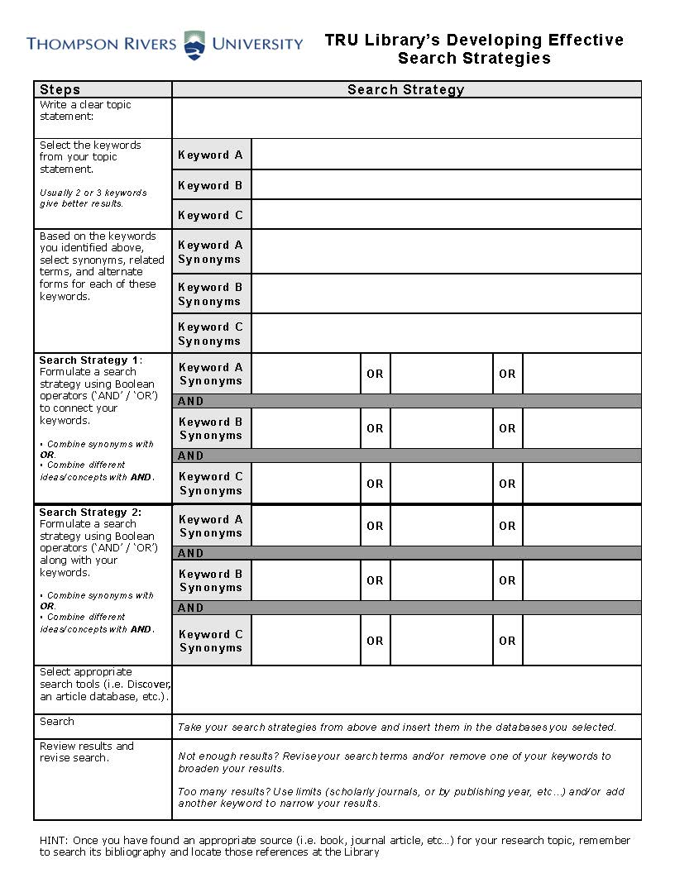

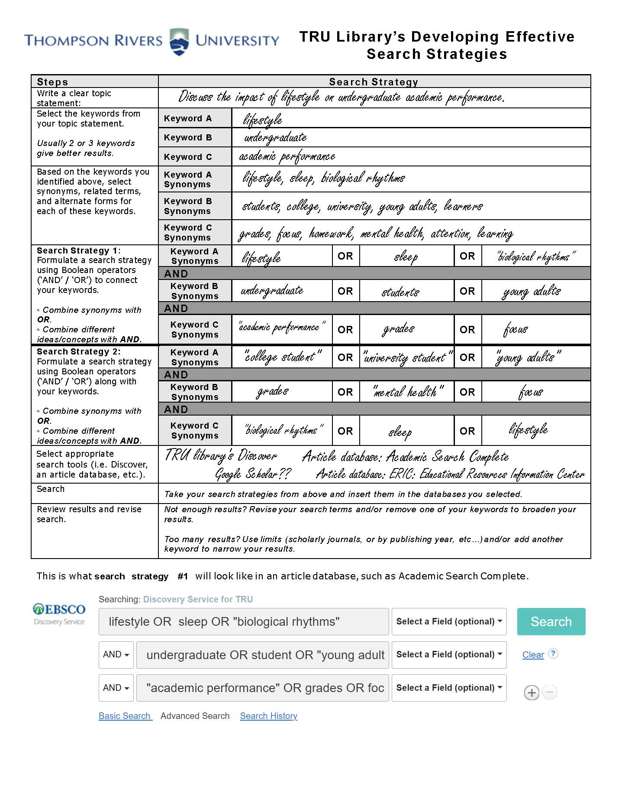

Revised Search Strategy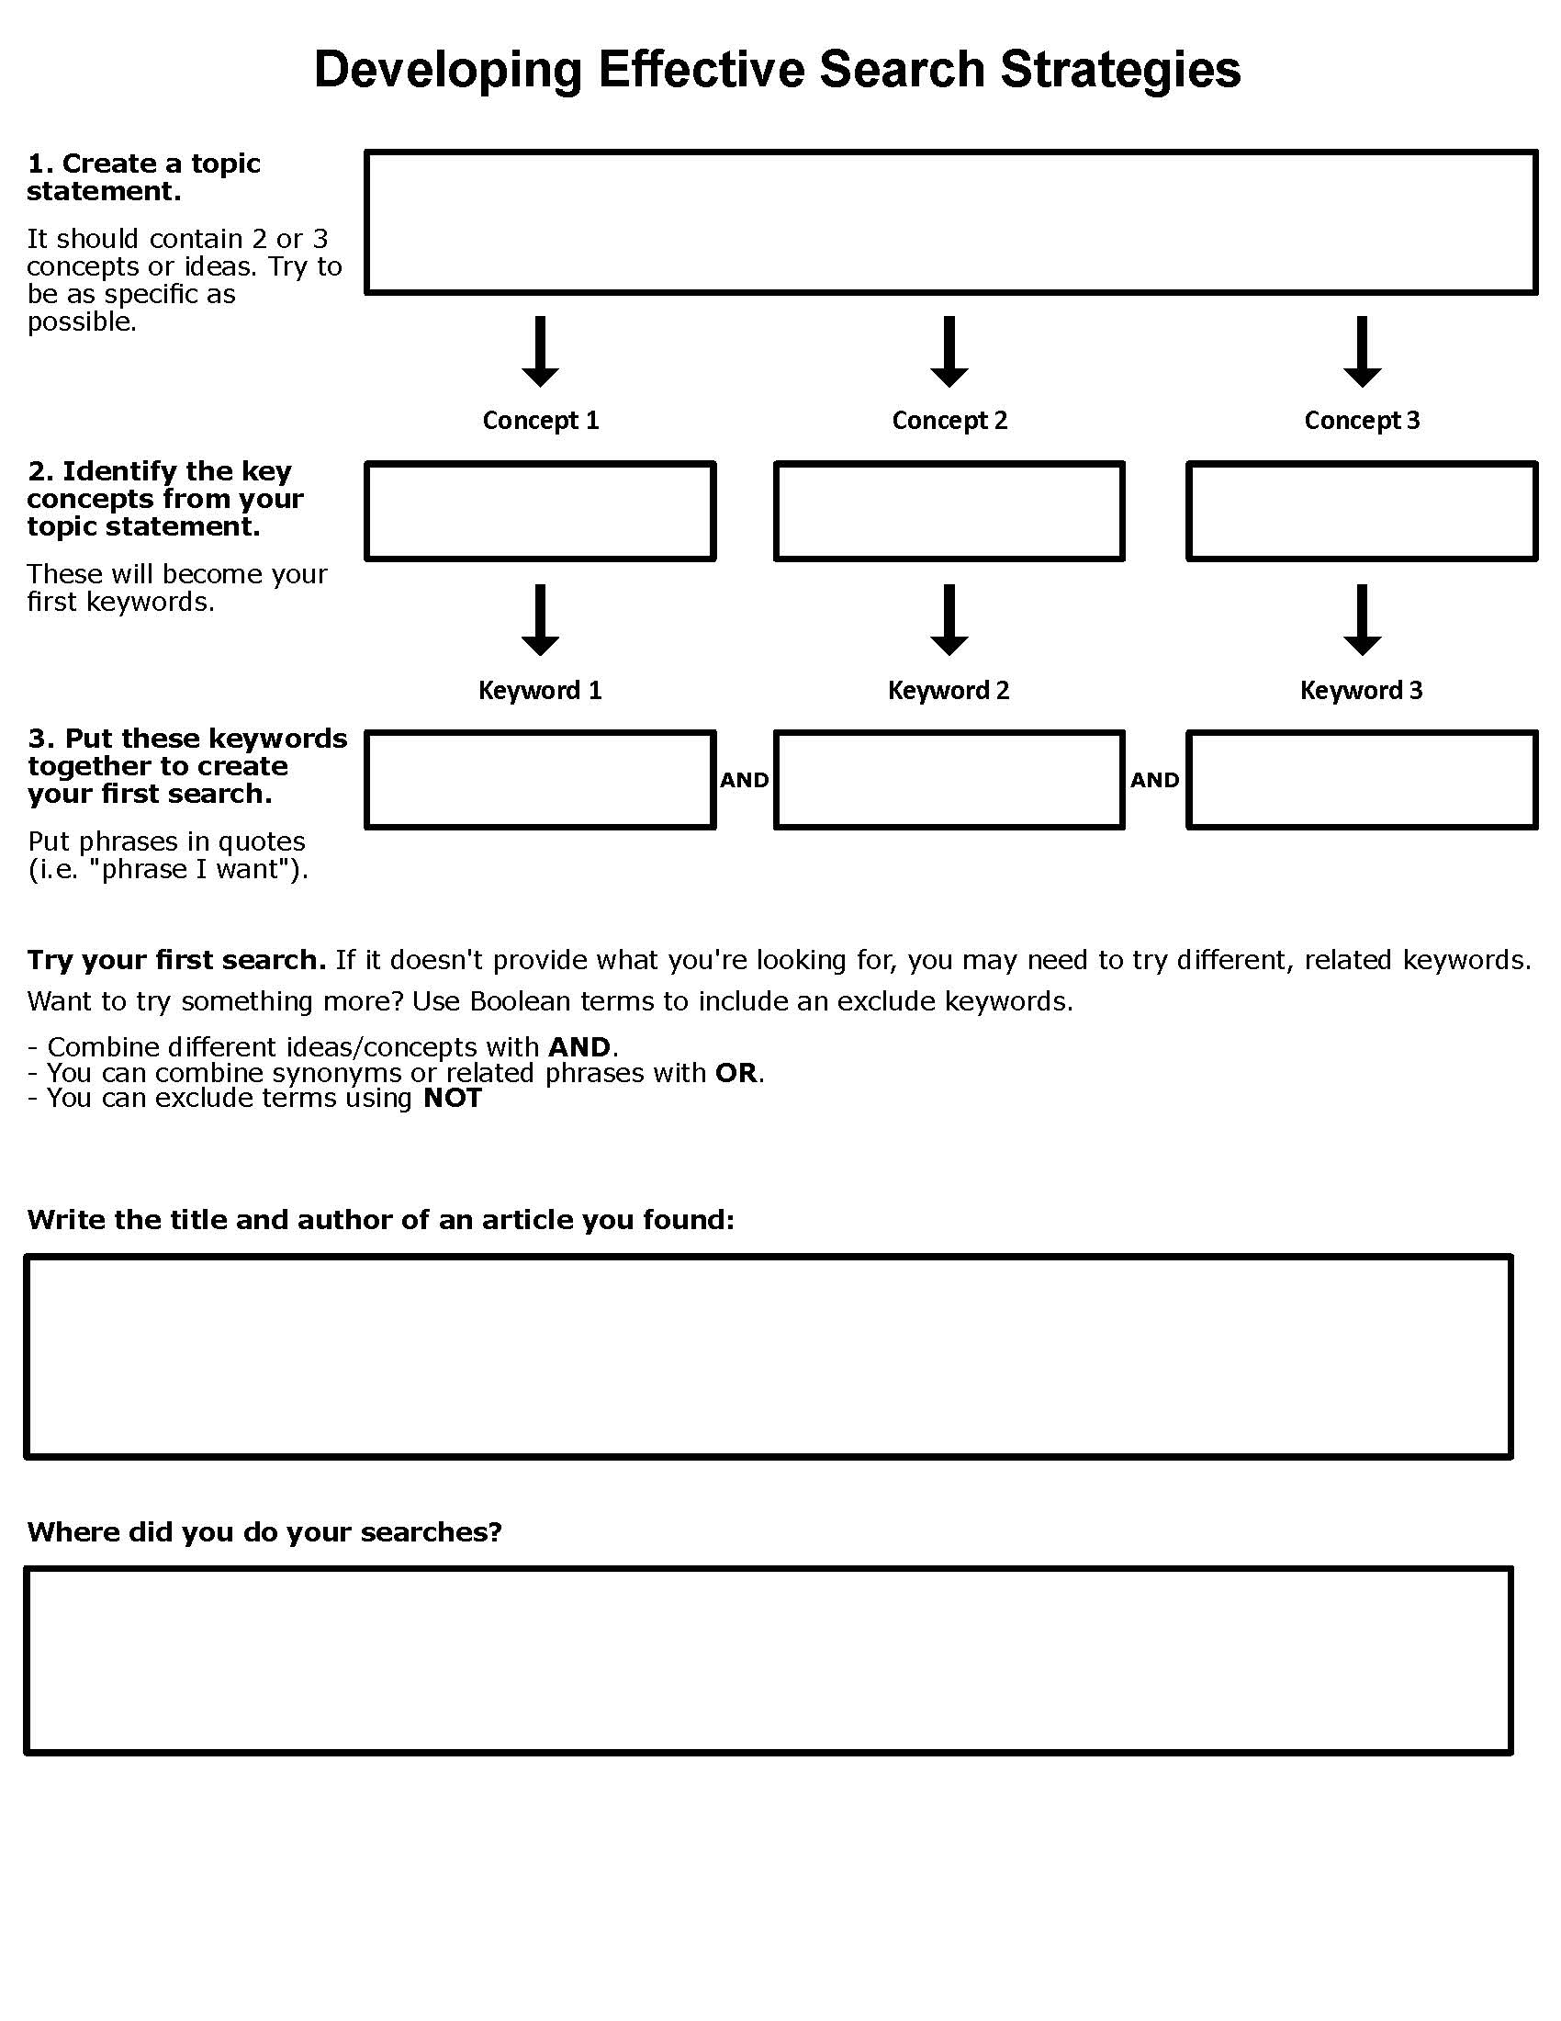

Appendix C

English Library Instruction Pilot (ELIP) opt-out consent to share assignment data

This tutorial series is a pilot project partnership between the TRU Library and TRU English 1100 instructors. Part of our goals are to evaluate the impact of the instruction you will receive over the next 3 weeks by analyzing the submitted mini-assignment for points of learning and growth.

While no one outside the project team will have access to any identifying information, overall themes, trends, and other non-identifying information from these assignments may be made available to people outside the project team through publications and presentations meant to improve information literacy instruction at TRU and overall. **Your assignments will be included in the project dataset, unless you choose not to participate.** Opting out means that you will still participate in the mini-assignments and receive the associated feedback, but data from your assignment will not be included in the dataset to be analyzed for the research portion of this project, nor will any information from your assignments be available to people outside this course.

To opt-out of including your assignment data in the ELIP project, contact the project lead, Amy McLay Paterson ([apaterson@tru.ca](mailto:apaterson@tru.ca)) with your name, student number, and the phrase “opt-out” in the subject line. You can choose to opt out at any time during the three week period of your tutorial. If you have any questions about this study, please contact Amy McLay Paterson, Associate Librarian, Thompson Rivers University (apaterson@tru.ca). This research project has been approved by the TRU Research Ethics board. Questions regarding your rights as a participant in this research may be addressed to the Thompson Rivers University Ethics board (email: TRU-REB@tru.ca or phone: 250.828.5000).

Appendix D

English Library Instruction Pilot (ELIP): Feedback Survey

This online survey is being conducted to gauge educational outcomes and participant satisfaction with the ELIP pilot project that you took part in during the 2023/24 academic year. The information collected here will be used to evaluate the pilot project and to make choices about the library instruction program going forward. Completing the survey will provide the benefit of contributing to improved information literacy instruction at TRU. Your participation in this research project is completely voluntary. You have the right to withdraw at any time. Online survey participants can withdraw at any time prior to the completion of the online survey by simply abandoning the survey. Online survey participants may also skip any question(s) that they do not wish to answer. To have your responses included, please click the “submit” button at the end of the survey. The survey will take 5-10 minutes to complete.

Participant privacy and confidentiality will be protected throughout this study. Survey results will be stored on a secure, Canadian-based server. No identifying information collected. Anonymous responses may be used in publications or presentations related to this project and may be seen by parties outside the project team.

If you have any questions about this study or if you would like to receive a summary of results, please contact Amy McLay Paterson, Assessment and User Experience Librarian (apaterson@tru.ca or 250-852-7832). This survey has been approved by the TRU Research Ethics board Chair contact information: TRU-REB@tru.ca or 250.828.5000).

I certify, by clicking Submit, that I consent to the above terms of participation in this survey.

**Intro text:** Thank you for your participation in the ELIP project this year. We are seeking your feedback in evaluating the pilot tutorials in terms of both logistics and outcomes.

**Section 1: Learning**

Please discuss any observed impact on ELIP students related to each of the following areas. If possible, please compare ELIP students with students from prior years or with students who did not participate or complete the ELIP tutorial.

1. Identifying appropriate information sources, including scholarly sources (open text response)
2. Investigation of their chosen topic through research (open text response)
3. Engaging in appropriate citation practices (open text response)
4. Overall, I believe the ELIP students beneﬁtted from the tutorial.
5. Strongly Agree
6. Agree
7. Neutral
8. Disagree
9. Strongly Disagree
10. Please add any additional comments about observed student learning outcomes in the ELIP project (open text response)

**Section 2: Logistics**

* 1. Please comment on the logistics of the pilot setup, including the number and availability of sections, the sign-up process and/or other aspects of the ease and/or eﬀectiveness of the pilot setup. (open text response)
  2. Please comment on the communication you received from the librarians department about and during the pilot project. (open text response)
  3. Please comment on any changes you would like to see made to the pilot going forward. (open text response)