**Conference report**

**LILAC 2024: Attendee conference report**

[**http://dx.doi.org/10.11645/18.2.615**](http://dx.doi.org/10.11645/xx.x.xxxx)

**Ryan Woodward**

Assistant Liaison Librarian, Newcastle University. Email: [ryan.woodward@newcastle.ac.uk](mailto:ryan.woodward@newcastle.ac.uk).

Abstract

A brief, light-hearted report of my bursary-funded attendance at a day of the LILAC conference hosted by Leeds Beckett University.

**Keywords**

information literacy; librarians; LILAC

**Figure 1**: Leeds Beckett University, The Rose Bowl, Tuesday 26th March

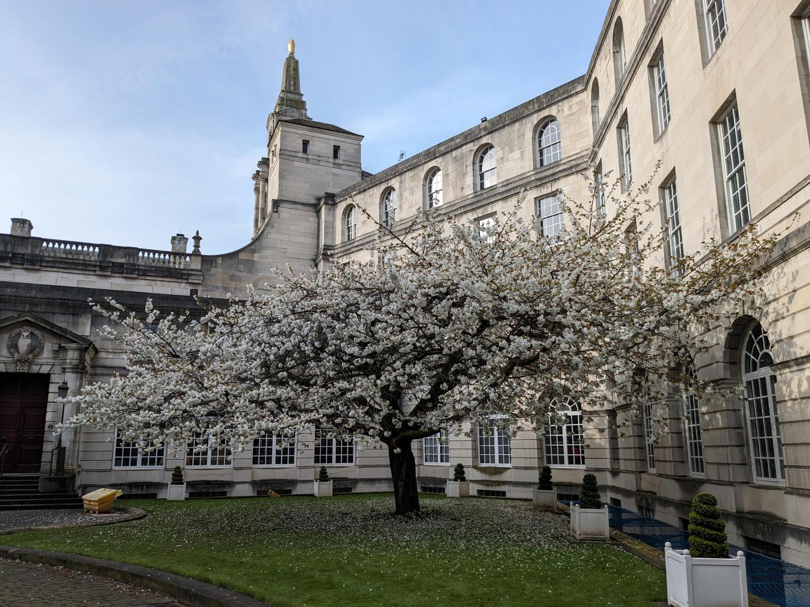

I have been working as an Assistant Liaison Librarian at Newcastle University for the last couple of years, teaching across multiple schools and engaging students with information literacy (IL) in ways that are meaningful to them, their studies, or their research. As a challenging but rewarding job in an ever-changing field, it does feel like the rate of change is developing at an increasingly fast pace (or maybe that has always been the case?). As such, I have been keen to interact with my peers and try to get along to my first in-person conference since the pandemic. I was delighted to see that LILAC was taking place in Leeds this year (just down the northern road), and even better, the existence of the *Local to LILAC bursary*, which I successfully applied for—a full day of attendance and my train fare!

My day began with a 5am alarm and the first of many cups of black coffee. After managing to put my trousers on the correct legs, I found my way to the train station, took my seat and the opportunity to revisit the programme and remind myself which sessions I had signed up to attend, all while enjoying coffee #2.

It was a crisp sunny day in Leeds as I worked my way around the building works inconveniently taking place in front of the station exit. I countered my abysmal sense of direction by following Google Maps all the way to The Rose Bowl (see Figure 1), making sure to take a photo of one of the golden owls outside Leeds Civic Hall so I could send some terrible “owl-some” puns to my colleagues back in the Toon (see Figure 2).

**Figure 2**: Owl sculpture at Leeds Civic Hall, Tuesday 26th March

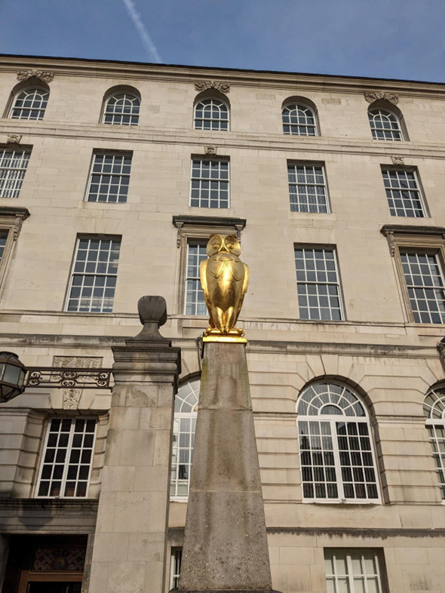

Once at the impressive Rose Bowl building, I quickly registered and orientated myself, then partook in coffee #3. There was strong enticement to speak to all the sponsors in attendance, gaining enough stamps from each of them to enter the prize draw—already there were wild claims being whispered in every corner that the prize was an air fryer, but I never did find out the true prize for day two. Time then to begin my day properly with session one, but I had already realised that just being in this environment felt so positive, talking to peers who were fizzing with energy and keen to share, something I have sorely missed.

I stopped to have a nose at the submitted posters display, a part of conferences I often overlook, so I made sure to have a look while I thought of it. With artificial intelligence (AI) being the big discussion topic of the moment, I was interested in the [poster](https://www.slideshare.net/slideshow/developing-an-online-module-to-support-the-use-of-ai-for-student-learning-and-research-paula-funnell-pdf/270045129) by Paula Funnell from Queen Mary University of London about the online module they have produced for students using AI in learning and research, which was full of ideas and sensible practice. At Newcastle we have been developing materials and a self-enrol module on our VLE, which two colleagues [Emily Dott and Terry Charlton](https://www.slideshare.net/slideshow/humans-are-still-needed-developing-newcastle-universitys-approach-to-ai-literacy-emily-dott-and-terry-charlton/266789720) had presented at LILAC the previous day (this presentation seemed to have made an impact as multiple people mentioned it to me throughout the day). Working out our teaching remit in exploring the possibilities of AI, tempered with how students need to learn and develop key skills, is going to be a terrific balancing act over the next few years. I was also pleased to see a poster by [Laura Woods](https://www.lilacconference.com/lilac-archive/lilac-2024-1#papersandposters) from the University of Sheffield promoting a piece of active research into the experience of female engineering students in the learning environment and their interactions with information. Having previously supported the school of engineering, it is clear there is a large divide in experiences for female students and I will be interested in the results of this research.

At this point I realised the hall was emptying and I had better secure a seat for my first choice of session. I briefly contemplated taking a coffee inside with me but thought better of it and made my way to the room where Karen Fisher from Leeds Beckett was presenting [Serendipitous Searching](https://www.slideshare.net/slideshow/serendipitous-searching-taking-art-students-on-a-visual-research-journey-karen-fisher/266801860), her experiences of taking art students on a visual research journey. I am supporting arts students this year and I have had multiple requests for sessions where academics are asking us to lead seminars that get students into the physical library and interacting specifically with the physical resources, alongside our standard teaching exploring our digital support offering. These seminars have been interesting to plan but tricky to pitch at the right level, so it was affirming to see what Karen has been finding success doing, introducing serendipity as a way of encouraging literature searching for inspiration not just for answering a question. This tallies with my experience of the art students and how changing the focus of lessons slightly can meet their unique needs from the library.

Embedding the teaching within the module is always key, but Karen has made impressive inroads and delivered some brilliant sessions for art and architecture students. I loved the session where she gave the students a starting image and had them produce keywords, then search for those keywords in an art image database to see what type of new and unexpected works were returned. A balanced mix of sparking creativity and essential IL skills. Another session Karen discussed involved framing the researcher as a detective, with students giving a presentation showing how they had searched from a set stimulus, the different directions and approaches they had taken, and delivering it visually with post its and string. It all sounded so much fun and allowed a flexible approach to the presentation where the students can demonstrate their own style and creativity while still displaying their logical search process.

The next session was the keynote, delivered remotely by Maha Bali from Cairo on [Teaching Critical AI Literacies](https://www.slideshare.net/slideshow/teaching-critical-ai-literacies-maha-bali/267125300). There was a great mood in the largest lecture theatre and a Mentimeter poll quickly confirmed the good feelings around the conference so far. This session was about AI and learning, a topic everyone has an opinion on. Maha made the excellent point that we can teach and research AI but it still does not make us experts, so we do not need to expect that of ourselves. This was an excellent talk from a warm, engaging speaker, emphasising the need for public deliberation and conversation around AI, and necessary vigilance in actively monitoring and engaging with developments in the field. Mala touched on lots of different applications for AI in education; I especially liked some of the tools that aid in improving accessibility, but the key message for me was the approach to critical AI literacy, focusing on different needs for students at a variety of stages and levels, so there is a clear progression for what is taught to students around AI, intentionally adapting to changing needs by folding it into teaching. It is appropriate for students to use AI in diverse ways, depending on the skills they have been able to develop already and the focus of their current work, and teaching can reflect and respond to this.

This led to the most popular section about using metaphors to teach AI in a meaningful way and unpicking the often-unhelpful metaphors that the media tend to use. The reason this was so popular was Maha's choice of cake as a metaphor for AI, which I won’t try and explain here but I would strongly suggest looking at the materials from Mala’s [presentation](https://www.slideshare.net/slideshow/teaching-critical-ai-literacies-maha-bali/267125300) on the LILAC website. As we continue peppering AI into our teaching and developing critical literacy for AI, these sorts of talks and the conversations that follow are going to be essential. The talk also signposted lots of useful links and resources and my hand was sore from quickly jotting them down. The final poll was to ask for our key takeaway, I submitted that *the overwhelm is justified*, which got agreement from Maha.

I will not bore on about lunch other than to say I ate well and had coffees #4 and #5. I also made use of the much-appreciated quiet room, for a little respite from crowds and the buzz of large gatherings.

To combat the post-lunch yawns, I took my seat for Gillian Siddall’s involved presentation, [Moving beyond words: using photovoice to understand international students](https://www.slideshare.net/slideshow/moving-beyond-words-using-photovoice-to-understand-international-students-information-literacy-practices-gillian-siddall-eec1/267228846). I'm starting to teach a lot more cohorts of mainly international students and there is a lot of work taking place to look at their experiences and academic needs and work out how we can better meet them, so I was intrigued at the use of photovoice as a tool to engage them more on their own terms. In small groups we tried two different activities, firstly looking at a supplied photo of a city and describing what we could see and what stood out to us. We all approached it slightly differently, picking out different aspects (the sky, the architecture, rundown areas). We next looked at grouping a selection of supplied photos, trying to make logical associations and classify them into smaller groups, again all spotting different things or having different lived experiences that influenced how we grouped them (they were pictures of plants, so having any sort of green finger was an advantage). Gillian has used this with public health students where they choose their image and identify their own keywords, showing something of their own subjective experiences, background, and influences. This then encourages their engagement and is a way to remove the teacher and focus on the student experience.

My fourth and final session was Dr Bruce Ryan presenting the results of a systematic review on [Information literacy and society](https://www.slideshare.net/slideshow/information-literacy-and-society-presentation-bruce-ryan/267302151), which has been conducted at Edinburgh Napier University. This large-scale systematic review has looked at socially impactful IL research, impact can be hard to measure in our field and the work that has been carried out by this team has made significant attempts to remedy this, looking at the wider social and political effect of IL practice. The discussion part of the session was quite spirited and a lot of significance was given to defining IL and where it can be embedded within society in places other than libraries.

Sadly, I had to leave early to catch my train, so cut short the final session of the day, but conference fatigue was starting to set in, so I was glad to get outside for fresh air. Overall, a sparkling day connecting with peers —finding reassurance in them encountering similar issues and frustrations and finding inspiration in the approaches and innovations they are making to overcome them. There is plenty of reason to be optimistic.

Ah, and you are probably wondering about the coffee count. Well, I conveniently left out the afternoon break…and I did take a coffee for the walk to the train station…so I think that puts us at #7.

Declarations

Ethics approval

Ethics approval was not considered necessary for the nature of this report.

Funding

My attendance at LILAC was funded by the ‘local to LILAC’ bursary directly from LILAC, this conference report was requested by them.

AI-generated content

No AI tools were used.