Anniversary of IL Special Issue 2024

Beginnings of information literacy in Latin America: A recognition of the pioneers
http://dx.doi.org/10.11645/18.1.583

Alejandro Uribe-Tirado
Professor-Researcher (Inter-American School of Library Science), University of Antioquia. Email: auribe.bibliotecologia.udea@gmail.com. ORCID: 0000-0002-0381-1269. X: @alejouribet.

Juan D. Machin-Mastromatteo
Professor-Researcher (School of Philosophy and Letters), Universidad Autónoma de Chihuahua (UACH). Email: judamasmas@gmail.com. ORCID: 0000-0003-4884-0474. X: @juantifico.

Abstract
This article is part of a study that synthesised the origin, evolution, current state, and future trends of information literacy (IL) in Latin America. For this special issue, the first part (the past) is presented as a recognition of the pioneers of this topic in the region; this will be followed up by a future article that will present IL’s current and future developments, following the same methodology and structure. This study employed a quantitative and qualitative review of documents published by Latin American authors to map out IL's development in the region, which was structured around four pivotal “moments” in the development of IL in Latin America: 1) beginnings (1997–2007), which is presented in this article, and marks the initial phase of IL's introduction and early development in Latin America, characterized by foundational texts and the organisation of critical events that set the stage for IL's growth in the region; and three other moments that will be presented in the future article: 2) advances–positioning (2008–2019) pre-pandemic, 3) main trends (2020–2023), and 4) some perspectives (2024–…). The beginnings presented in this article recognise the work of the librarians, professors, researchers and institutions that introduced IL in our region: without these foundations, it would not have been possible to reach the current developments (present) and the emerging perspectives (future).

Keywords
development; information literacy; Latin America; past; pioneers

Introduction
This article, as indicated by its title, aims to identify how information literacy (IL) started growing as a concept and area of practice and research in the Latin American context. To fulfill this aim, it is necessary to present two considerations:
- IL has had different developments over the last 50 years (1974–…), which have evidently occurred in various contexts and taken place earlier in some regions of the world than in others, or with differentiated advances, depending on each context's needs, resources, and possibilities. Discussions about the development of IL at a global level should not be taken to imply that such growth has not affected or influenced the development of IL in Latin America. However, the particularities of this region of the world mean that some specific contributions and characteristics can also be helpfully acknowledged and might be a reference for other regions. Therefore, it is essential to know and recognise them.
- To achieve as complete a review as possible of the development of this topic in the region, it is necessary to combine sources, products, and methods that range from traditional documents (articles, books, and dissertations) to online or other content (such as websites where IL training services are presented and provided), while also considering the expertise and research experience in this topic of the authors of this work with their previous publications and research (IL as a line of research). Hence, a triangulation between the available documentation, content, and expertise was carried out, which is reflected in the methods and results of this work.
Considering these aspects indicated above, it is possible to delve into the topic in question to achieve the most complete view possible. As stated above, this article will be limited to the first moment of IL’s development in Latin America (past: beginnings–pioneers, while a future article with the same methodology will include the remaining three moments: advances–positioning (2008–2019), the present: main trends (2020–2023), and future: some perspectives (2024–…).

Literature review: Background and conceptual framework

IL in the Latin American context: An overview
Although this article deals with the development of IL in Latin America, it is essential to turn to previous studies as a reference framework (Uribe-Tirado, 2010; Uribe-Tirado & Pinto, 2014; Uribe-Tirado, Pinto & Machin-Mastromatteo, 2017; among others), to highlight some initial and fundamental aspects. In this context, it is relevant to mention that for this study, Latin America comprises the 20 countries that are located in South America, Central America, Mexico, and the Caribbean islands, and that their native language is Spanish or Portuguese. Through their geographical and linguistic proximity, together with their common historical, economic, and political realities, these countries and populations can be identified as a region with interrelations regarding educational practices, including IL.
This reality of being a region of the world where the main languages are either Spanish or Portuguese has led, in relation to IL, to multiple words with which the concept and its training practices have been identified during the last decades. Therefore, in this region of the world, IL is referred to by using the following terms:
In Spanish: alfabetización informacional, desarrollo de habilidades informativas (DHI), alfabetización en información, alfabetización informativa, competencias informacionales, competencias en información, competencias informativas, formación de usuarios para la búsqueda de información.
In Portuguese: literacia informacional, literacia em informação, alfabetização informativa, alfabetização em informação, competência em informação, competência informacional, mediação informacional, treinamento de usuários na procura da informação.
Such terms include some of the most widely used today, as evidenced by different studies.
However, in Spanish, the preferred terms would be: Alfabetización informacional and Competencias informacionales; and in Portuguese: Competência em informação and Competência informacional.
As an early antecedent of IL in the region, we could begin by locating ourselves in the 1990s, when the following aspects became evident: 1) the increasingly urgent need to develop better information systems; 2) the information demand of users from libraries was still somewhat insufficient and incipient (in numbers of users and requests, quantity and quality) to justify the work of information professionals; and 3) the challenge of offering information training beyond classic bibliographic instruction (teaching users how to use the bibliographic catalogue or providing guided visits to libraries), which required a more didactic and active type of training to respond to the growth of information resources, a greater incorporation of information and communication technologies (ICTs) and the development of the internet (Machin-Mastromatteo & Lau, 2015).
Considering the first contributions to literature and events, the beginnings of IL in Latin America can be located between 1997 and 2007 (the first decade). Machin-Mastromatteo & Lau (2015) specify that these years were critical to the arrival of IL in Latin America: 1) the 61st World Conference of the International Federation of Library Associations and Institutions (IFLA), held in Istanbul (1995), which was attended by professionals from the region, who had contact with IL, mainly through Hannelore Rader's conference (User education and information literacy for the next decade: an international perspective) and were inspired to implement IL in their institutions; and 2) the first translations to Spanish of some standard reference works, such as those from the American Library Association and of the document Information Literacy in the Reference Environment: Preparing for the Future (Rader, 2000).

Methods
The methodology used to achieve the objectives proposed in this study is framed in a qualitative and documentary-type approach; more specifically, content analysis. It was initially based on a search, selection, and detailed analysis based on previous systematisation processes conducted in the “Wiki ALFIN Iberoamérica” (2018) to complement several databases that represented the publications of the region, such as SciELO, RedALyC, and LA REFERENCIA, in addition to LENS and SCOPUS.
Thus, with an up-to-date documentary database having been developed, we proceeded to conduct a thematic-conceptual review of the content of such works to determine the main milestones (past), perspectives (present), and trends (future) of IL in Latin America. Therefore, to be more specific, three phases were employed to conduct this study: bibliographic search, selection criteria, and database and content analysis.

Moment 1. Beginnings (1997–2007)
IL’s most notable milestones in Latin America began in the late 90s and early 2000s, differing from country to country, with pioneering texts from Mexico by Lau, Cortés-Vera, Mears, Angulo Marcial, Solís Valdespino, Hernández Salazar, Vega Díaz and Córdoba (between 1997-2006). These initial publications sought to present what IL (or the Development of Information Skills (DHI, in Spanish, or DIS, in English) entailed. These initial publications sought to present what IL implied for our contexts regarding lifelong learning, the function of libraries, and how librarians could prepare to offer this new form of training:
To succeed in a knowledge-based society, students must develop skills to learn from a lifelong perspective. Lifelong learning requires techniques and knowledge, but it is also an attitude. DIS programs do not fully cover the spectrum of needs for information literacy, but they are a practical way to begin working on this mission. Through DIS programs, librarians collaborate to become more successful professionals while we gather greater elements to succeed in our profession (Cortés-Vera, 1999, p. 10)
These pioneering publications from Mexico are closely interrelated with the precursor event organised within the region to position this topic, the “Encuentros Internacionales sobre DHI” (International Meetings on DIS), which was carried out in Ciudad Juárez (Mexico).
From this event and its various versions, the first IL declarations from the Latin American context were made and, especially notably, in 2002 the first guidelines for our context, the "Standards on information literacy in higher education", were published as a result of the Third International Meeting on DIS, which proposed eight general information competencies that grouped 45 skills. It is also relevant to highlight that a Mexican researcher prepared one of the first normative documents published by IFLA: Guidelines on Information Literacy for Lifelong Learning (Lau, 2006), which was translated into 12 languages; all of which contributed to the initial push that IL needed in the region, especially from higher education institutions. However, Mexico was not the only country that ventured into the beginnings of IL in the region, as significant contributions were made from Brazil, Cuba, and other countries within this first decade of IL in Latin America (1997–2007).
Fig. 1: Website of the International Meetings on DIS (1997-2006)

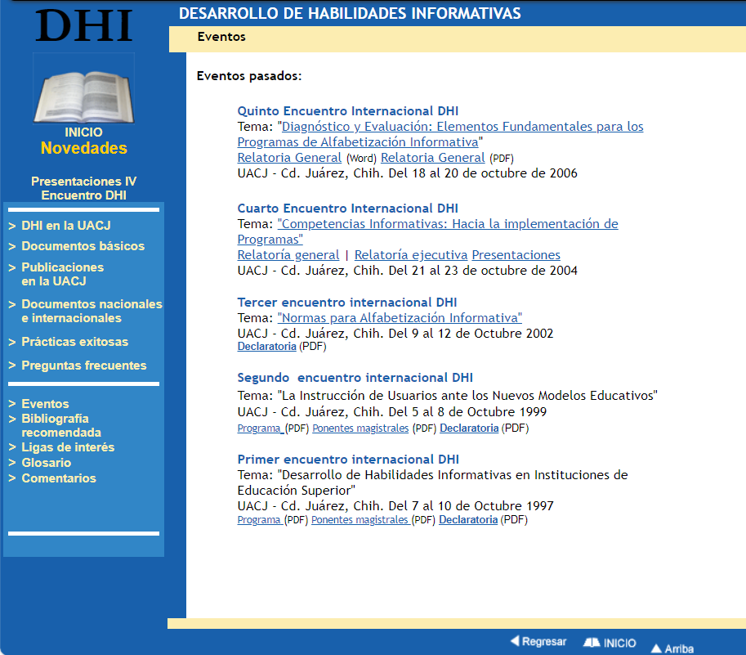
The initial contributions of authors from Brazil also started developing IL as a line of study and research in library and information science. They incorporated it in some courses in undergraduate and graduate programmes and developed new actions in library training programmes. These initial texts were contributed by Belluzzo, Campello, Dudziak and Vitorino (between 2001 and 2007).
For its part, Cuba had its first contributions by Ponjuán Dante, Martí Lahera, Sánchez Tarragó, Meneses Placeres, Zayas Mujica, and Viera Valdés (between 2002–2007). Publications closely linked to the INFO Congresses, in their 2002, 2004, and 2006 versions — another of the driving events in the region — which allowed, together with the DIS Meetings from Mexico during those initial years, LIS professionals to present and share the first IL theoretical-conceptual reflections and applications, from all over Latin America.

Fig. 2: INFO Congresses website (2006)

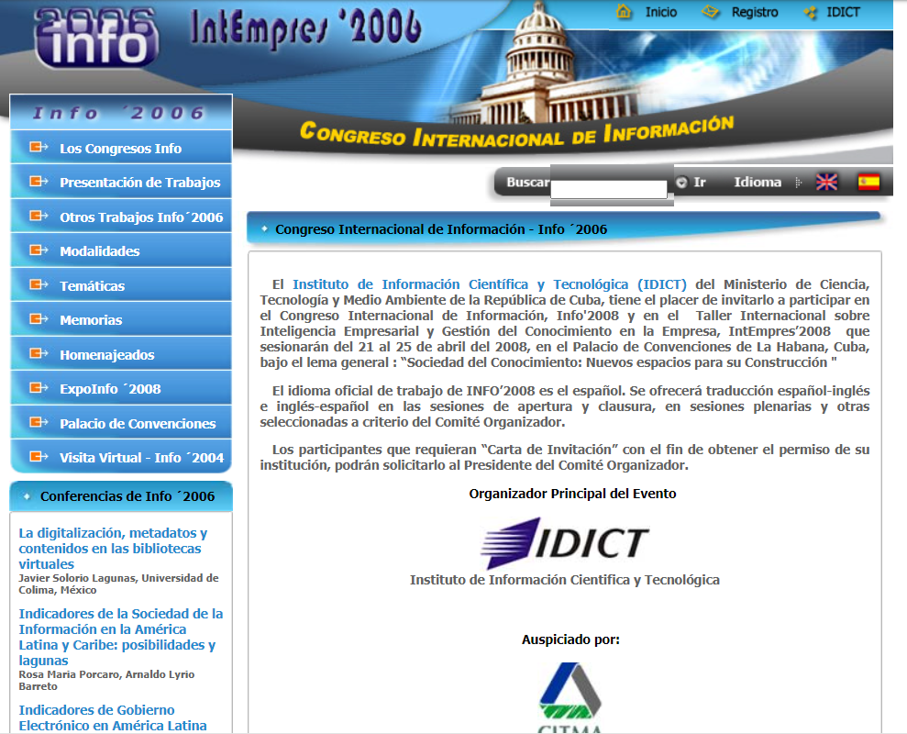

During the beginnings of IL in the region, it is necessary to highlight the contributions of different authors coming from other Latin American countries such as the bibliographies from Chile (Saurina de Solanes and Matus Sepúlveda, 2002–2007); Colombia (Uribe-Tirado and Machett’s Penagos, 2003–2007); Costa Rica (Córdoba, Miranda, 2002–2007); Perú (De la Vega, 2007) and Venezuela (Machin-Mastromatteo, 2007).

Conclusion
After this initial analysis of IL’s history in Latin America, we can conclude, first of all, that this is a conceptualisation and area of practice that, although it has been established for some decades in the wider world (since Zurkowski, 1974) and in the region (since DIS, 1997), continues to be — with its due updates and interrelations with other literacies — increasingly necessary, since it is impossible to train people in using information (either in the present or the future), without drawing on the conceptual framework offered by IL. This is the case as much in the context of traditional texts as in multimedia formats, in scientific databases as in social media, in academic information as in political and health information, in libraries as in the media, in human intelligence as in artificial intelligence.
At the same time, when considering IL’s processes, development, and history, a key aspect is to understand the conceptualisations and practices that originated from the pioneers. These mark the development of the topic, its practice, and continuing research into IL in the region. As such, they allow us to better understand the changes we are experiencing in the region as well as those occurring worldwide, also allowing us to proactively identify perspectives for the future.

Taking this view, and building the timeline of IL’s development in Latin America, allows us to adapt and enables us to continue advancing in IL within this region of the world. This remains a fundamental path we should take to ensure better information management for the benefit of all, and to achieve better educational levels in primary, secondary and university instruction in Latin America, which has been the purpose from the beginning (hence the importance of highlighting early pioneers). IL continues and will continue to be of key significance in Latin American educational and social contexts, but with new challenges and mediations.

Declarations
Ethics approval
Ethical review was not considered necessary in alignment with University of Antioquia and Universidad Autónoma de Chihuahua’s guidance on the conduct of ethical research.
Funding
Not applicable.
AI-generated content
No AI tools were used.
References
Castilla, L. R., Uribe-Tirado, A., Ramos, J. F. C., & Toledo, R. S. (2016). Análisis lingüístico y filosófico en definiciones de ALFIN aplicando técnicas bibliométricas. Anales de documentación, 19(2).

Coronel, P. H., Rengifo, T. A. L., Coronel, M. A. H., Reyes, J. P. T., & Fernández, I. F. (2020). Information Literacy in Latin America students: a review of programs and proposes. In 2020 XV Conferencia Latinoamericana de Tecnologias de Aprendizaje (LACLO) (pp. 1–7). IEEE.

Cortés-Vera, J. (1999). Desarrollo de habilidades informativas en sistemas universitarios: ¿Por qué y para quién?. En: Mesa Redonda sobre Formación de Usuarios, XXX Jornadas Mexicanas de Biblioteconomía, Morelia, Mich.

de Farias, G. B., da Mata, M. L., Meneses Alves, A. P., & dos Santos, C. A. (2021). 20 anos de pesquisa sobre Information Literacy no Brasil: análise temática das teses e dissertações do Catálogo da CAPES. Revista Ibero-Americana de Ciência da Informação, 14(1).

de Souza Alves, M., Macedo, M. D. S. A. N., & Galindo, M. (2023). A chegada da Information Literacy no Brasil: apropriação conceitual e implicações para as traduções. Páginas a&b: arquivos e bibliotecas, 302–334.

Fazzioni, D. P. D. M., Vianna, W.B., & Vitorino, E. V. (2018). O atual estágio conceitual da competência em informação em publicações de língua portuguesa. Ciência da Informação, 47(3).

García, G. G., Lucena, F. J. H., Díaz, I. A., & Rodríguez, J. M. R. (2022). Productivity analysis around information literacy in the higher education stage. Texto Livre, 14.

Kolle, S.R. (2017). Global research on information literacy: A bibliometric analysis from 2005 to 2014. The Electronic Library, 35(2), 283–298.

Lau, J. (2006). Guidelines on information literacy for lifelong learning. IFLA.

Leite, C., Simeão, E. L. M. S., de Almeida Nunes, E. M., Diógenes, F. C. B., Feres, G. G., Freire, I. M., & Belluzzo, R. C. (2016). Cenário e perspectiva da produção científica sobre competência em informação (CoInfo) no Brasil: estudo da produção no âmbito da ANCIB. Informação & Sociedade, 26(3).

Machin-Mastromatteo, J. D., & Lau, J. (2015). The arrival of information literacy. Information Development, 31(2), 190–193.

Rader, H (2000). La alfabetización informacional en el entorno del servicio de referencia: Preparándonos para el futuro. Anales de documentación, 3, 209–216.

Rivas Villena, J. A., Uribe-Tirado, A., López-Mesa, E. K., & Limaymanta, C. H. (2021). Alfabetización informacional en Bibliotecología y Ciencias de la Información. Un análisis bibliométrico en el ámbito latinoamericano (2001-2020). Información, cultura y sociedad, 45, 95–112.

Silva, S. A. A. d., & Cardoso, A. M. P. (2023). Literacia informacional uma revisão sistemática de literatura. RDBCI: Revista Digital de Biblioteconomia e Ciência da Informação, 18, e020023.

Uribe-Tirado, A. (2010). La Alfabetización Informacional en Iberoamérica. IBERSID: revista de sistemas de información y documentación, 165–176.

Uribe-Tirado, A., & Alhuay Quispe, J. (2017). Estudio métrico de ALFIN en Iberoamérica: de la bibliometría a las altmetrics. Revista española de documentación científica, 40(3).

Uribe Tirado, A., & Pinto Molina, M. (2013). La incorporación de la alfabetización informacional en las bibliotecas universitarias americanas. Análisis comparativo a partir de la información de sus sitios web. Anales de documentación, 16, 2.

Uribe Tirado, A., & Pinto, M. (2014). 75 lecciones aprendidas en programas de alfabetización informacional en universidades iberoamericanas. Revista española de documentación científica, 37(3), e057-e057.

Uribe-Tirado, A., Pinto, M., & Machin-Mastromatteo, J. D. (2017). Developing information literacy programs: Best practices from Latin America, Spain and Portugal. Information development, 33(5), 543–549.

Urra, C. V., & Castro, S. O. (2020). Análisis temático documental de las tesis de pre y post grado realizadas en las universidades públicas y privadas de Chile sobre alfabetización en información durante el período 2003-2019. Revista estudios hemisféricos y polares, 11(2), 23–54.

Zurkowski, P. G. (1974). The information service environment: Relationships and priorities. Related paper number five. National Commission on Libraries and Information Science, ERIC document ED 100 391.

Bibliometric studies, topic reviews and systematic reviews of IL in Latin America, carried out in recent years and which were considered: Leite, Simeão, de Almeida Nunes, Diógenes, Feres, Freire & Belluzzo, 2016; Castilla, Uribe-Tirado, Ramos & Toledo, 2016; Uribe-Tirado & Alhuay-Quispe, 2017; Fazzioni, Vianna & Vitorino, 2018; Urra & Castro, 2020; Coronel, Rengifo, Coronel, Reyes & Fernández, 2020; Rivas Villena, Uribe-Tirado, López-Mesa & Limaymanta, 2021; de Farias, Mata, Alves & Santos, 2021; García, Lucena, Díaz & Rodríguez, 2022; Silva & Cardoso, 2023; de Souza Alves, Macedo & Galindo, 2023.
See: https://docs.google.com/document/d/16XE9t2xZxcVLYGRwq3OvrlORXSqoHnmvbDCJxhRgB_E/
This "Desarrollo de Habilidades Informacionales - DHI" or DIS in English, was the term referring to IL adapted to Spanish and adopted for several years, from the Mexican context; but then it gave way to "Alfabetización Informacional - ALFIN" or IL in English, which is a more direct translation and has been the most used term in Spanish by the countries in the region that have it as their official language.
1997: https://web.archive.org/web/20040215074449/http://bivir.uacj.mx/dhi/DocumentosBasicos/Docs/Declaratorias/Declaratoria%20Primer%20DHI.pdf 1999: https://web.archive.org/web/20040215092034/http://bivir.uacj.mx/dhi/DocumentosBasicos/Docs/Declaratorias/Declaratoria%20Segundo%20DHI.pdf
2002: https://web.archive.org/web/20040923063650/http://bivir.uacj.mx/dhi/DocumentosBasicos/Docs/Declaratorias/Declaratoria%20Tercer%20DHI.pdf
2006: https://web.archive.org/web/20070525085938fw_/http://bivir.uacj.mx/dhi/Eventos/Default.htm
See: https://docs.google.com/document/d/1kG32Yh_V7cgqOi8DgGnIok5udsKUE0RqEqKUcwuvExU/
See: https://docs.google.com/document/d/1UCFZonFyebvocb2O1zVuR7Gq2xsq4rBDPsD_CgY617A/
See: https://docs.google.com/document/d/1yb_d1mAtQOaapIg0etsGZrsMMshOUBURazPmTeeHMAQ/
See: https://docs.google.com/document/d/142NkOmvgRee9Ha2b1lOEvZxjgPthXZQyzlC2mitLoH4/
See: https://docs.google.com/document/d/1HCX5tn8gctnn_46AmBr4VpDpTnS-y7mccwALNsdh0Cc/
See: https://docs.google.com/document/d/1EE8vACXSdvcipCP4J4vgdvmlHMxoApkgaqldB0J_mtI/
See: https://docs.google.com/document/d/166NBaOr_C6HvxHn7bw9m-Fu-wzLTpj715A-nlZk-Zkc/

