Anniversary of IL special issue 2024

Flourishing in an ocean of information: A futures vision for information literacy
http://dx.doi.org/10.11645/18.1.565

Hilary Hughes
Adjunct Professor, School of Teacher Education & Leadership, Faculty of Creative Industries, Education and Social Justice, Queensland University of Technology. Email: h.hughes@qut.edu.au. ORCID: 0000-0001-5123-1552.

Abstract
Over 50 years we have built a mature information literacy (IL) discipline through dedicated, innovative research and practice. Drawing on recent Australian referendum experience, I consider current challenges to expanding our contribution across society. These include limited government and public recognition of IL, its opaque image, fragmentation into separate literacies, and lack of a connective conceptual thread. Looking forward, to provoke fresh thinking and extend our disciplinary horizons, I present a personal vision of information literacy for wellbeing with individuals and communities flourishing in an ocean of information and a confluence of literacies, empowered by informed learning.
Keywords
AUS; information literacy; information behaviour

1. Introduction
The fiftieth anniversary of information literacy offers opportunities for us to both celebrate the distances covered so far, and to refocus on future horizons as we continue to build the discipline in an expansive ocean of information. As information mariners – researchers, practitioners, and educators – we recognise the essentiality of IL for charting safe and productive paths through ever-changing social conditions. Our cargoes are rich in concepts, research findings, standards, curricula, and practice frameworks. However, the fleet is scattered. Beyond our own disciplinary seas, IL still has many destinations to reach, as the following example illustrates.

1.1 Voters Awash with Information
Through most of 2023, Australian voters were awash with information about a referendum to be held on 13 October. The decision we faced was whether or not the Constitution should be altered to recognise the First Peoples of Australia through the establishment of the Aboriginal and Torres Islander Voice, an advisory body to Parliament (Australian Government, n.d.; Uluru statement, 2023). As with all elections in Australia, voting was compulsory.
Although we were required to give a simple yes/no answer, the underlying issue was legally and culturally complex. Many Indigenous and non-Indigenous people considered the Voice as a critical step towards reconciling colonial injustices. Other people were concerned that the proposal was flawed, even risky, as it did not define the body’s powers, funding, or administrative processes. Some First Nations citizens opposed the motion because it did not go far enough towards Treaty-making, or distracted attention from their immediate community needs.
From an IL perspective, the referendum presented multiple challenges. The onus placed on us to make an informed decision bore considerable cognitive and affective load. The choice was often misleadingly described as one of heart-over-mind or vice-versa, as if these positions were mutually exclusive.
Over many months we were inundated by referendum-related information of varying quality, including official notifications, news updates, academic analyses, flyers, opinion pieces, memes, conspiracy theories, and word of mouth. Thoughtful commentary and passionate advocacy for both sides swelled alongside expressions of hope, anxiety, and distrust. Indigenous, political, and business leaders released statements, while lawyers, celebrities, and many others shared their opinions. Their tones varied between dignified, reasoning, strident, cajoling, and racist. As sources of authoritative information, the Australian Broadcasting Corporation (ABC) and Special Broadcasting Service (SBS) provided excellent on-air and online coverage and libraries curated collections of relevant resources. The Australian Government (n.d.) also presented a usefully informative website and community toolkit. RMIT University Factlab (n.d.) provided a factchecking service.
Yet still there was widespread confusion about the purpose and subject of the referendum. Despite the flood of authentic, mis- and dis- information, people frequently blamed their indecision about which way to vote on a “lack of information.” Some residents in remote and migrant communities reportedly were not even aware of the impending referendum. Making sense of the argument was especially complicated for individuals with principal languages other than English, and for recent immigrants in transition between transcultural landscapes with little previous experience of democratic practices (Hicks & Lloyd, 2016).
Support in navigating a meaningful way through the deluge of information was limited. The official Voice Referendum Booklet, distributed by the Australian Electoral Commission (AEC, 2023), showed little awareness of IL principles in its unclear expression, awkward layout, and adversarial tone. It contained arguments for the yes and no cases prepared by parliamentarians who “desired to forward” their favoured option, plus three pages of practical instructions about where to vote and how to fill in the ballot paper. The Commission’s website presented a register to correct “prominent pieces of disinformation” about the referendum process and techniques for tackling misleading or deceptive information. But as the AEC’s role is to provide an impartial and independent electoral system, their booklet and website offered no guidance for interpreting the referendum issue, nor where or who to turn to for assistance.
1.1.1 IL Adrift
The Voice referendum illustrates the limited reach of IL across society. During the long leadup to the ballot I noticed no specific mention of IL in news or social media. Despite our highly relevant specialist expertise, as a discipline we were invisible, seemingly adrift in the tidal wave of referendum information.
This is not a unique or exclusively Australian case. In their study of previous referenda here and in the UK, law researchers Ghazarian and Laughland-Booÿ (2021) identify two (out of three) barriers that inhibit confident voting as: poor quality of officially provided resources and inability of individuals to counter the effects of unreliable information on their decision. Highlighting detrimental democratic consequences, Ghazarian and Laughland-Booÿ contend that these barriers can significantly impact the “representational outcomes and policies pursued by governments” (p.129-130). A negative vote does not always represent objection to the actual referendum matter, given a tendency to vote no among people who have trouble understanding the options or making up their minds, or who simply do not care about the issue (Kildea & Smith, 2016). Others resort to “short cut” voting based on preference for a particular party or leader rather than a considered response to the referendum question. With Brexit, a significant proportion of no voters disregarded the issue and used their ballot to punish an unpopular government (Kildea & Smith, 2016).
To address these challenges, the authors of both papers argue the need for a multifaceted educational approach that assists individuals to cast an informed referendum vote. Their recommendations include improving civics education in schools and the community that is ongoing and increases in the lead-up to polling day, and better equipping teachers with knowledge and resources to ensure students’ ability to participate in the democratic process and tackle misinformation. In addition, Kildea and Smith (2016, p.134) propose that governments, educators, and electoral commissions should work with young people to “enhance the design and delivery of targeted information to help build young Australians’ capacity to vote with confidence into the future.” While these are commendably constructive goals, neither paper refers specifically to information, digital, or media literacy, let alone the specialist expertise of IL educators and librarians.
In response to this perplexing oversight, I propose a conceptual refit.
2. Crosscurrents and Diffused Guide Lights
From my vantage point, IL seems to be weathering crosscurrents. The vessel is seaworthy but a tad rusty. In a marketing sense, it struggles to capture popular attention and would seldom rank among students’ favourite subjects. Could negative associations with information, such as the infodemic of excessive and false information, be tainting IL’s public image? Meanwhile the ways that IL can help people safely and responsibly manage threats of mis- and dis-information go under-promoted.
Could the semantic ambiguity of IL be masking its appeal? Information is both an imprecise and loaded concept, while literacy and its association with the mechanics of reading and writing carry a whiff of deficit-based measures. In conjunction, the two words suggest an uninviting focus on functional skills and traditional (print) formats.
Is the proliferation of context- and issue-specific information literacies splintering our hull? With the boundaries between physical and virtual environments becoming increasingly blurred, the need to distinguish between digital, media and “other” IL may be redundant. Separation into specialist areas – health, legal, financial, political, and so on – seems counter-productive, especially as subject knowledge often overlaps.
Possibly compounding these challenges, the disciplinary sea abounds in IL frameworks and pedagogical approaches. While these are important guiding lights through an ocean of information, their individual focus tends to diffuse the collective beam. For example, ACRL’s Framework for Information Literacy for Higher Education (2015) aims to develop the IL concepts, knowledge practices, and dispositions of higher education students. UNESCO’s Global Standards for Media and Information Literacy Curricula Development Guidelines (or, the MIL Framework) (n.d.) outlines practical digital skills and social and cultural capabilities for school students. Metaliteracy In a Connected World focuses on learners becoming reflective and constructive producers of information in a connected (digital) environment (Mackey & Jacobson, 2022). Informed Learning involves a holistic approach for experiencing different culturally inclusive ways of using information to learn in educational, workplace, and community settings (Bruce, 2008; Bruce et al., 2012).
These frameworks and approaches complement each other without being singly or collectively inclusive of IL’s multiple dimensions. For example, the MIL framework emphasises human rights and civic participation, Metaliteracy focuses on forming a metaliterate mindset, and Informed Learning supports using information to learn. While they all pursue educational goals, other elements highlighted in the IL literature are generally under-represented such as: emotional and spiritual elements (Hewitt, 2023); mental health (Aytac & Mizrachi, 2022); Indigenous knowledges (Littletree et al., 2023; Loyer, 2018); sociocultural practices (Lloyd, 2010); philosophical and moral values (Bivens-Tatum, 2022); sensory, expressive, embodied, kinaesthetic ways of experiencing information (Lloyd, 2017; Lupton, 2014); and the information experiences and needs of people transitioning between intercultural settings (Hicks & Lloyd, 2016; Sayyad Abdi et al., 2023).
This brief overview also highlights the divergence between practical and theoretical concentrations in IL that Lloyd (2017, p.91-2) identifies as “a significant challenge for the advancement of IL,” inhibiting both the theorisation of research evidence by researchers and practitioners and meaningful dialogue between them. So now, seeking to freshen the conceptual breeze while embracing the diversity of viewpoints identified above, I offer a vision of information literacy for wellbeing that enables people to flourish in an ocean of information buoyed by informed learning.
3. Flourishing in an Ocean of Information
The reimagined notion of IL (Figure 1) is framed by wellbeing and its various elements (indicated along the sides). These are connected at the corners by the seven “faces” of informed learning (Bruce, 2008). The disparate information literacies (health, digital, financial etc.) and Social Development Goals (United Nations, n.d.) unite in a confluence at the centre. All are enacted through informed learning pedagogy and support culturally inclusive sociocultural practices (Hicks & Lloyd, 2016; Lloyd, 2017) (internal lines). The central band represents an ever-widening horizon of knowledges and understandings which build through engaging fluently with information.
Figure 1.
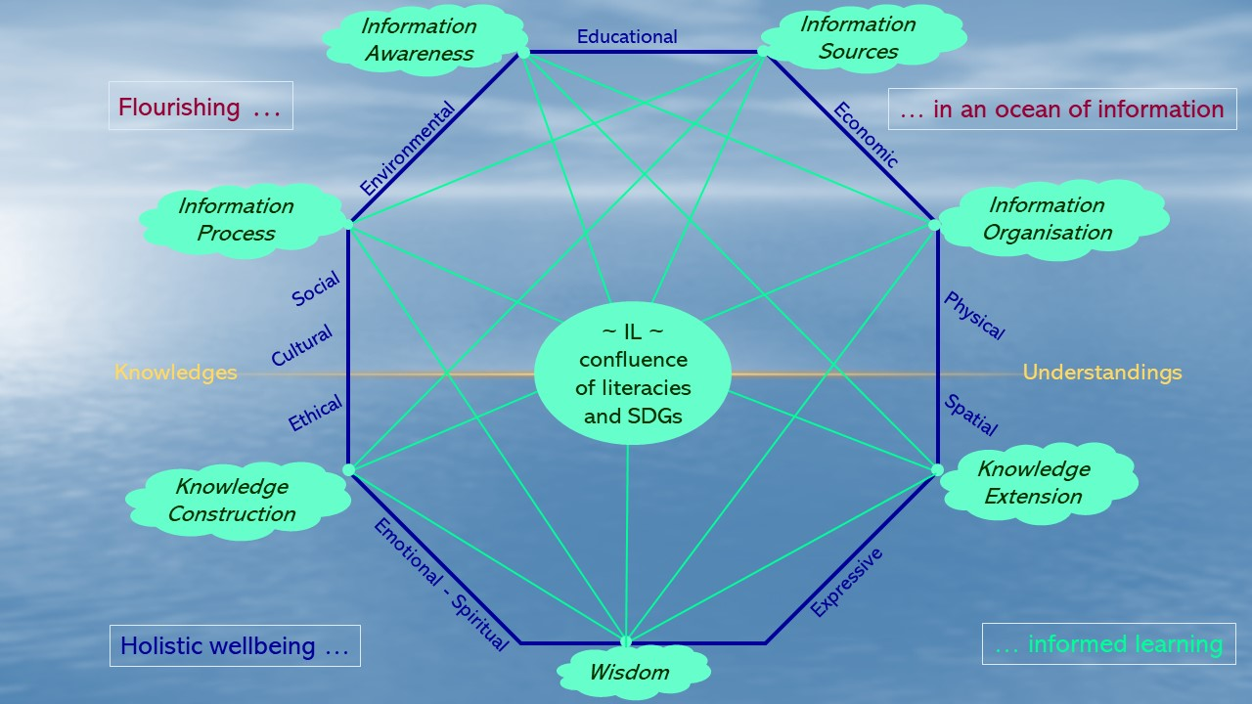
As envisaged here, wellbeing encompasses intellectual-educational, physical, psychological-emotional, social, cultural, economic-environmental, and spiritual-expressive elements. This understanding aligns with Norizi’s (2023, p.6) notion of holistic and comprehensive wellbeing, with its scope extended beyond school settings across the wider educational and community contexts of IL. Similarly, it shares common ground with Norizi’s expressed purpose to support balanced learning as “a conscious, deliberate process that requires individuals to become aware of and make choices for a more satisfying lifestyle.” Both enable flourishing which for individuals implies “feeling satisfied with life and having the ability to live to the fullest” (Chaves, 2021).
For communities and organisations, wellbeing is advanced through the Social Development Goals (SDGs) for global equality in health, education, economic growth, climate change and environmental preservation (United Nations, n.d.). Of particular relevance to the referendum dilemma, the SDGs “foster social participation and tolerance to promote democracy and peace” (United Nations, n.d., p.13). More broadly also, SDGs and information literacy are intertwined like a strong rope (Bruce, 2019). The UNESCSO MIL Framework (n.d.) highlights how SDGs may be realised through the nexus of media and information literacy and human rights, to advance cultural, linguistic and gender diversity.
Informed learning (Bruce, 2008; Bruce et al, 2012) promotes IL for wellbeing by enabling people to experience different ways of using information critically, creatively, and responsibly to learn across disciplines, social contexts, and personal interests. This ethically imbued approach raises IL awareness “through a value driven, culturally aware, inclusive, social justice lens” and it is supported by discourses and programs that “celebrate a wide variety of forms of knowledge, and the knowledges of all peoples and cultures” (Bruce, 2021, p.4). Thus, as a holistic approach to continuous learning, it can expand the capacity of organisations, policy makers, individuals, and communities to recognise, understand, and manage the potential risks and reap the rewards of engaging with information in all its guises.
4. Ripple effects
Future-focused information literacy for wellbeing shifts the focus from an abstract concept to continuous active engagement with information as a pervasive element of human life and the natural world. Active verbal expressions like “informed learning” and “flourishing with information” convey its participatory rather than deficit-addressing nature. The envisaged confluence of literacies (digital, financial, health etc.) renews disciplinary coherence. Information itself is recognised as an essential contributor to wellbeing, something to be embraced with cautious confidence rather than confronted with dread.
In light of the Voice referendum, a whole-of-community approach to flourishing with information addresses the multiple challenges that inhibit civic participation, including information overload, miscommunication, and disinformation. It offers a theoretically rich educational scaffold to underpin IL initiatives of government and public agencies that respond to the cognitive, affective, social, cultural, and contextual diversity of voters as information users.
In addition to increasing wellbeing, creative revitalisation could raise the public profile of IL beyond our library and education safe ports, capture the attention of government and business agencies, and attract media coverage. Conceptual alignment with UNESCO’s SDGs, which already have an internationally high profile, extends IL’s influence across public and private sectors.
5. Sailing Ahead
Being a seasoned IL hand, I acknowledge that aspirational visions are not easily realised in academic and professional worlds. But like John Lennon I recognise the transformative power of imagination. So in closing, I invite you to imagine the Good Ship Information Literacy beating through an ocean of information, fostering wellbeing amidst shifting social and technological tides for the next 50 years and beyond:
The GS Information Literacy (Figure 2) is on a continuous voyage, reaching towards sustainable goals that support fair and inclusive development through global citizenship. It is sturdy and hospitable to all. To ensure smooth sailing and safe navigation, the crew of expert professionals draws upon a varied mix of prevailing information, such as printed charts, GPS coordinates, radio messages, the movement and colour of the sea. As informed learners and educators they use this information critically, creatively, and wisely to weather differing conditions. By sharing practical capabilities, traditional and specialist knowledges, and technical expertise the GS Information Literacy sailors enhance the wellbeing and safety of all seafarers. Simultaneously, through innovative research and practice they will support the endeavours of those responsible for designing and constructing the craft, and for progressing the social, educational, and economic headway of all – whatever washes up in the information future.
Figure 2.
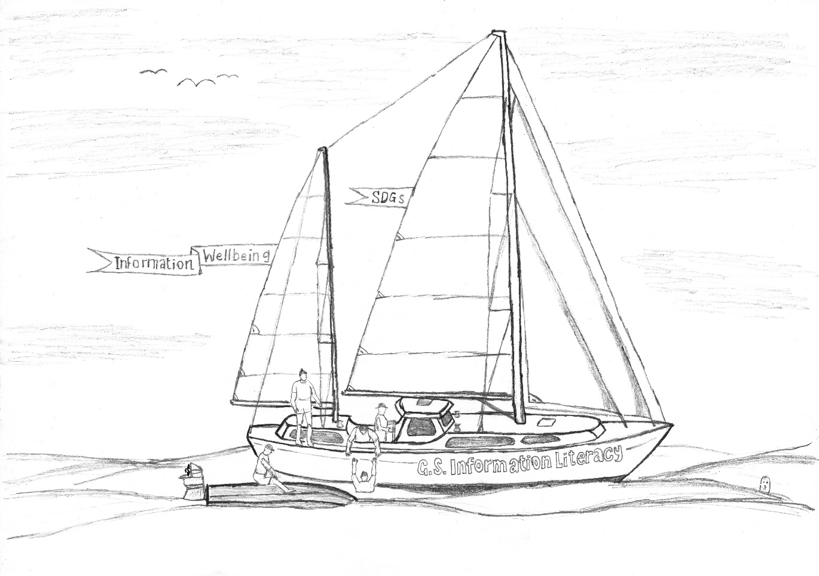
As the ocean of information ebbs and flows, IL will continue to evolve through research and innovative practice. Meanwhile, I support retaining the name Information Literacy for our discipline – with a capital letter to differentiate the field from the underlying theory and practice. This well-established name respects the contributions of the many researchers and practitioners who have built the IL discipline over the last 50 years. Its ongoing consistent use is important for signalling disciplinary integrity built on a demonstrably robust foundation.
6. Coda
Imagine one big ocean
It’s easy if you try
A flow of information
Varied, rich and free

Imagine all the people
Reliably informed

Imagine all the literacies
It isn’t hard to do
United together
Capacity for all

Imagine all the people
Engaging fluently

Imagine informed learning
I wonder if you can
No need to fear disinfo
Wellbeing in our power

Imagine all the people
Livin’ life informed

You may say I’m a dreamer
Maybe not the only one
I hope someday we’ll all be
Flourishing informed

- With respects to John Lennon

Declarations
Ethics approval
Ethical review was not considered necessary in alignment with Queensland University of Technology’s guidance on the conduct of ethical research.

Funding
Not applicable.

AI-generated content
No AI tools were used.

Acknowledgements
I acknowledge the Turrbal and Yuggera, as the First Nations owners of the lands on which I live and write, and pay my respects to their Elders past, present and emerging.

My sincere thanks from the helm to trusty information literacy shipmates: Chief Navigator Christine Bruce (critical reading), Lookout Kerry Mallan (critical reading), Chart Master David Hughes (research assistance), Naval Architect Mark Hughes (artwork).
References
Australian Electoral Commission (AEC). (2023). Your official referendum booklet. Australian Government.
Australian Government. (n.d.). Voice website.
Aytac, S. & Mizrachi, D. (2022). The mindfulness framework for implementing mindfulness into information literacy instruction. The Reference Librarian, 63(1-2), 43–61.
Bivens-Tatum, W. (2022). Virtue information literacy: Flourishing in an age of information anarchy. Library Juice Press.
Bruce, C. S. (2008). Informed learning. ALA.
Bruce, C. S. (2019, 25–27 April). Sustainable development goals: The information literacy connection. [Paper presentation]. First International Conference on Information and Knowledge Management: Dhaka, Bangladesh.
Bruce, C. S. (2021, 9–10 December). Towards ethical IL: A thought journey. [Paper presentation]. 10th International Summit of the Book 2021 & WBIMLC 2021: Bihać, Bosnia & Herzegovina.
Bruce, C., Hughes, H., & Somerville, M. (2012). Supporting informed learners in the twenty-first century. Library Trends, 60(3), 522–545.
Chaves, C. (2021). Wellbeing and flourishing. In M.L. Kern & M.L. Wehmeyer (Eds), The Palgrave handbook of positive education. Palgrave Macmillan.
Framework for information literacy for higher education. (2015). Association of College & Research Libraries.
Ghazarian, Z., Laughland-Booÿ, J. (2021). Becoming an informed voter: Compulsory voting and developing political knowledge in Australia. In M. Bonotti & P. Strangio (Eds), A Century of compulsory voting in Australia: Elections, voting, technology. Palgrave Macmillan.
Hewitt, A. 2023. What role can affect and emotion play in academic and research information literacy practices? Journal of Information Literacy, 17(1), 120–137.
Hicks, A. & Lloyd, A. (2016). It takes a community to build a framework: Information literacy within intercultural settings. Journal of Information Science, 42(3), 334–343.
Kildea, P. & Smith, R. (2016). The challenge of informed voting at constitutional referendums. University of New South Wales Law Journal, 39(1), 368–400.
Littletree, S., Andrews, N., & Loyer, J. (2023). Information as a relation: Defining Indigenous information literacy. Journal of Information Literacy, 17(2), 4–23.
Lloyd, A. (2017). Information literacy and literacies of information: A mid-range theory and model. Journal of Information Literacy, 11(1), 91–105.
Loyer, J. (2018). Indigenous information literacy: Nêhiyaw kinship enabling self-care in research. Library Juice Press.
Lupton, M. (2014). Creating and expressing: Information- as-it-is-experienced. In C. Bruce, K. Davis, H. Hughes, I. Stoodley & H. Partridge (Eds.), Information experience: Approaches to theory and practice (pp. 69–84). Emerald.
Mackey, T. P. and Jacobson, T. E. (2022). Metaliteracy in a connected world: Developing learners as producers. Neal-Schuman.
RMIT University. (n.d.). Voice to parliament referendum. Factlab.
Sayyad Abdi, E., Partridge, H., Bruce, C., & Watson, J. (2023). Understanding the information literacy experiences of Australia’s humanitarian migrants. Journal of Librarianship and Information Science, 0(0).
The Voice (2023). The Uluru statement.
UNESCO. (n.d.) Global standards for media and information literacy curricula development guidelines. UNESCO.
United Nations. (n.d.). Sustainable development goals. United Nations Department of Economic and Social Affairs.

