**Journal of Information Literacy**

**ISSN 1750-5968**

**Volume 17 Issue 1**

**June 2023**

**Conference report**

**Wheeler, A., & Dolman, L. 2023. LILAC 2023: An audio-visual report. *Journal of Information Literacy*, 17(1), pp. 265­–278.**

[***http://dx.doi.org/10.11645/17.1.42***](http://dx.doi.org/10.11645/17.1.42)

Creative Commons License  
**This work is licensed under a** [Creative Commons Attribution-ShareAlike 4.0 International License](http://creativecommons.org/licenses/by-sa/4.0/)**.**

**Copyright for the article content resides with the authors, and copyright for the publication layout resides with the Chartered Institute of Library and Information Professionals, Information Literacy Group. These Copyright holders have agreed that this article should be available on Open Access and licensed under a Creative Commons Attribution ShareAlike licence**.

"By ‘open access’ to this literature, we mean its free availability on the public internet, permitting any users to read, download, copy, distribute, print, search, or link to the full texts of these articles, crawl them for indexing, pass them as data to software, or use them for any other lawful purpose, without financial, legal, or technical barriers other than those inseparable from gaining access to the internet itself. The only constraint on reproduction and distribution, and the only role for copyright in this domain, should be to give authors control over the integrity of their work and the right to be properly acknowledged and cited.”

Chan, L. et al. 2002. Budapest Open Access Initiative. New York: Open Society Institute. Available at: http://www.soros.org/openaccess/read.shtml [Accessed: 18 November 2015]

**LILAC 2023: An audio-visual report**

**Alan Wheeler, Liaison Librarian, Middlesex University. Email:** [**a.t.wheeler@mdx.ac.uk**](mailto:a.t.wheeler@mdx.ac.uk)**. ORCID:** [**0000-0001-6513-5705**](https://orcid.org/0000-0001-6513-5705)**.**

**Lauren Dolman, Subject Liaison Librarian - Criminology and Sociology, Middlesex University. Email:** [**l.dolman@mdx.ac.uk**](mailto:l.dolman@mdx.ac.uk)**.**

**Introduction**

We work together at Middlesex University as subject liaison librarians, and were lucky enough to attend this year’s LILAC conference at the University of Cambridge. We decided that it would be interesting to combine our reflections in a collaborative report, and when considering a focus for this, we saw we had both independently signed up for a number of sessions incorporating non-traditional methods and formats, such as podcasting, cartooning and audiobooks. So, we decided to take the theme of audio-visual learning as the starting point for our conference report.

Moreover, we were keen for the format of our output to align with our content, so rather than submitting a written report, what follows is an audio-visual report comprising a discussion of our conference experiences, a photo diary and an artwork, where we reflect on our impressions, highlights and key takeaways from the 2023 event.

**Audio Files**

For transcripts, please see Appendices.

* Discussion of LILAC 2023 ([mp3 link](https://infolit.org.uk/wp-content/uploads/2023/06/LILAC-talk-final-version.mp3)).
* Discussion of artwork by Alan Wheeler ([mp3 link](https://infolit.org.uk/wp-content/uploads/2023/06/LILAC-painting-chat.mp3)).

**Artwork by Alan Wheeler**

Painting produced as a reflection on workshop “The Lego® Serious Play® Journal Club: Exploring the future of academic librarianship”, presented by Alan Wheeler and Coco Nijhoffat LILAC 2023.

**Figure 1:** painting detail. Photo by Alan Wheeler. [Link](https://infolit.org.uk/wp-content/uploads/2023/06/346123730_628627232123717_6357505019907722401_n.jpg).

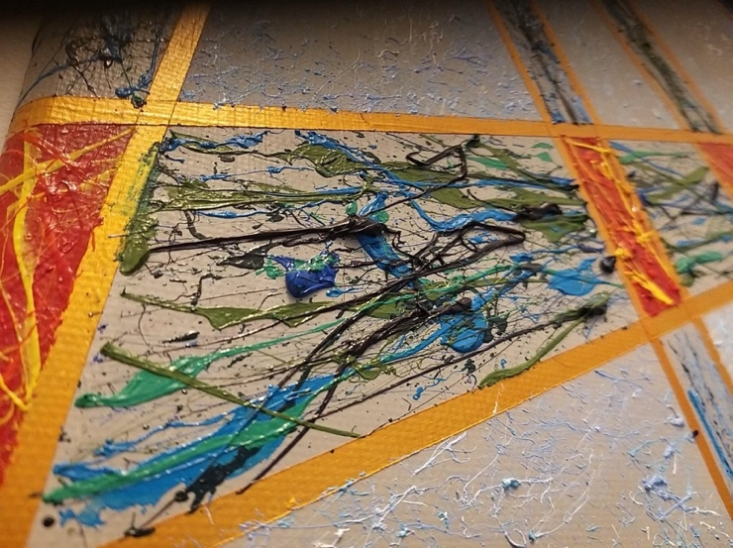

**Figure 2:** painting detail. Photo by Alan Wheeler. [Link](https://infolit.org.uk/wp-content/uploads/2023/06/346113169_964978887973004_9172223318187831725_n.jpg).

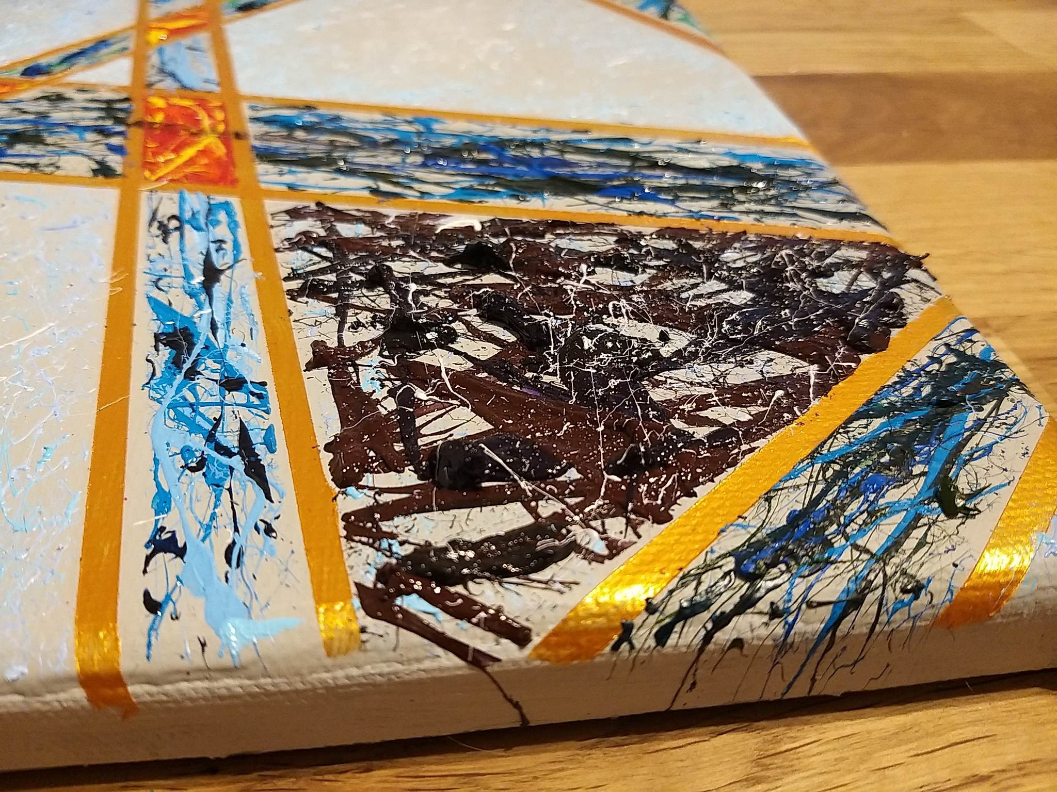

**Figure 3:** painting detail. Photo by Alan Wheeler. [Link](https://infolit.org.uk/wp-content/uploads/2023/06/346109322_1003593980634840_8544827113116116497_n.jpg).

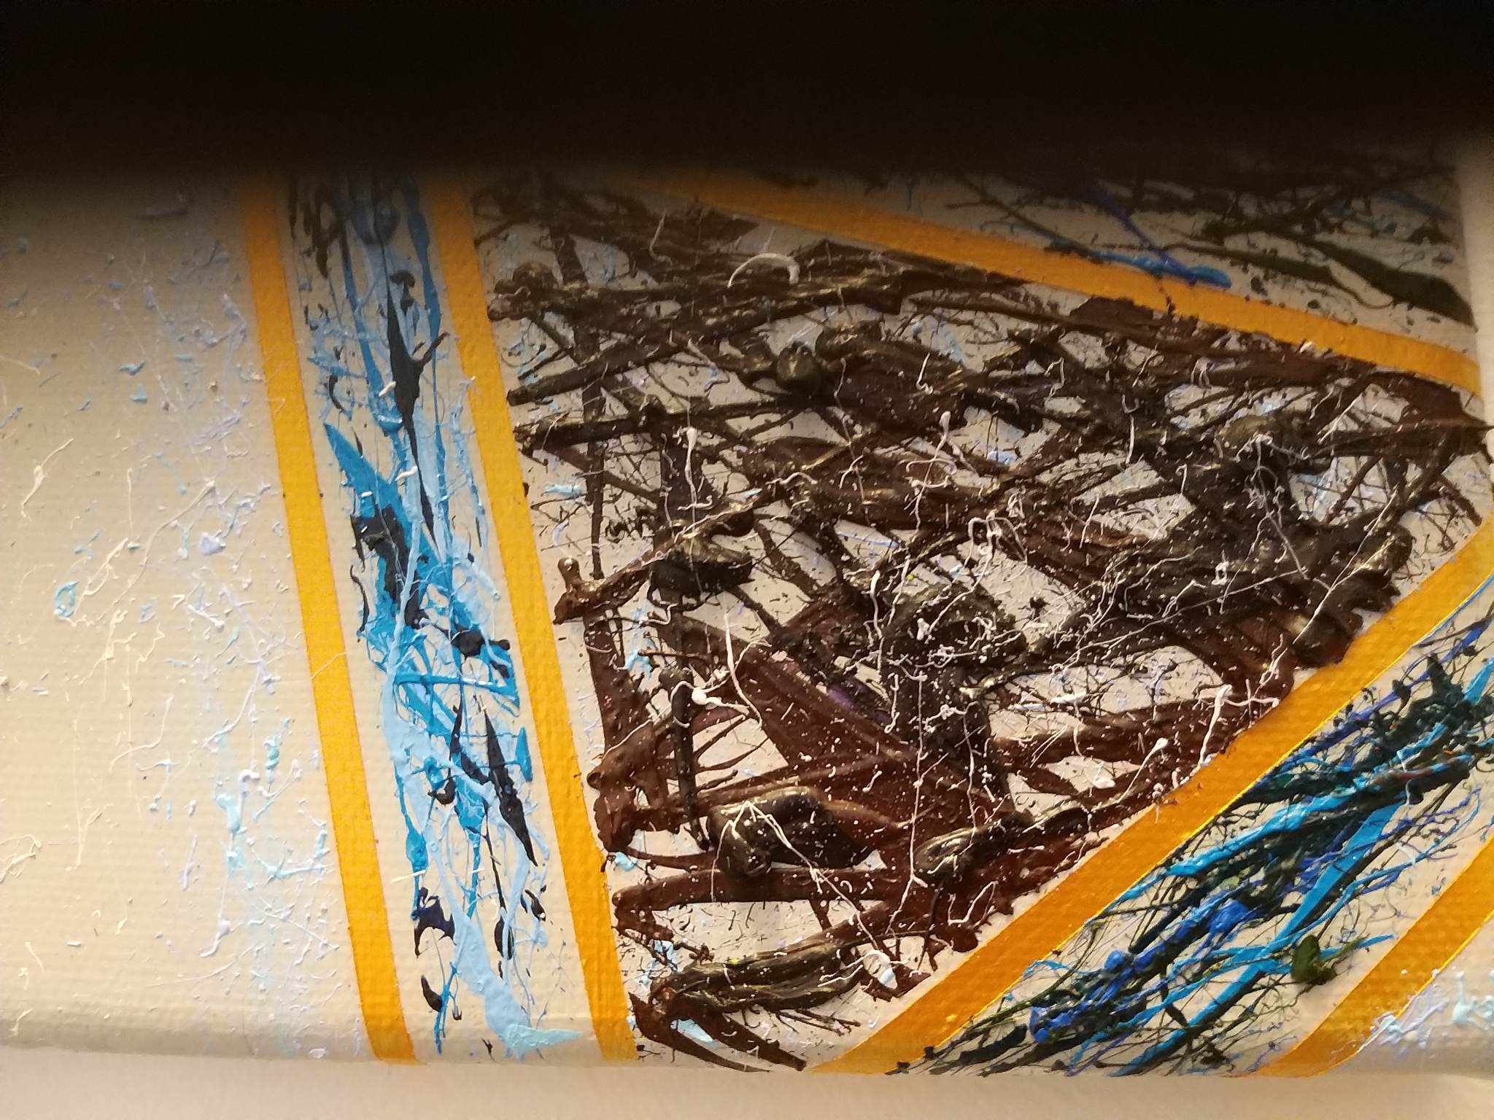

**Figure 4:** full view of painting. Photo by Alan Wheeler. [Link](https://infolit.org.uk/wp-content/uploads/2023/06/346107120_189224304063080_4092288748162910376_n.jpg).

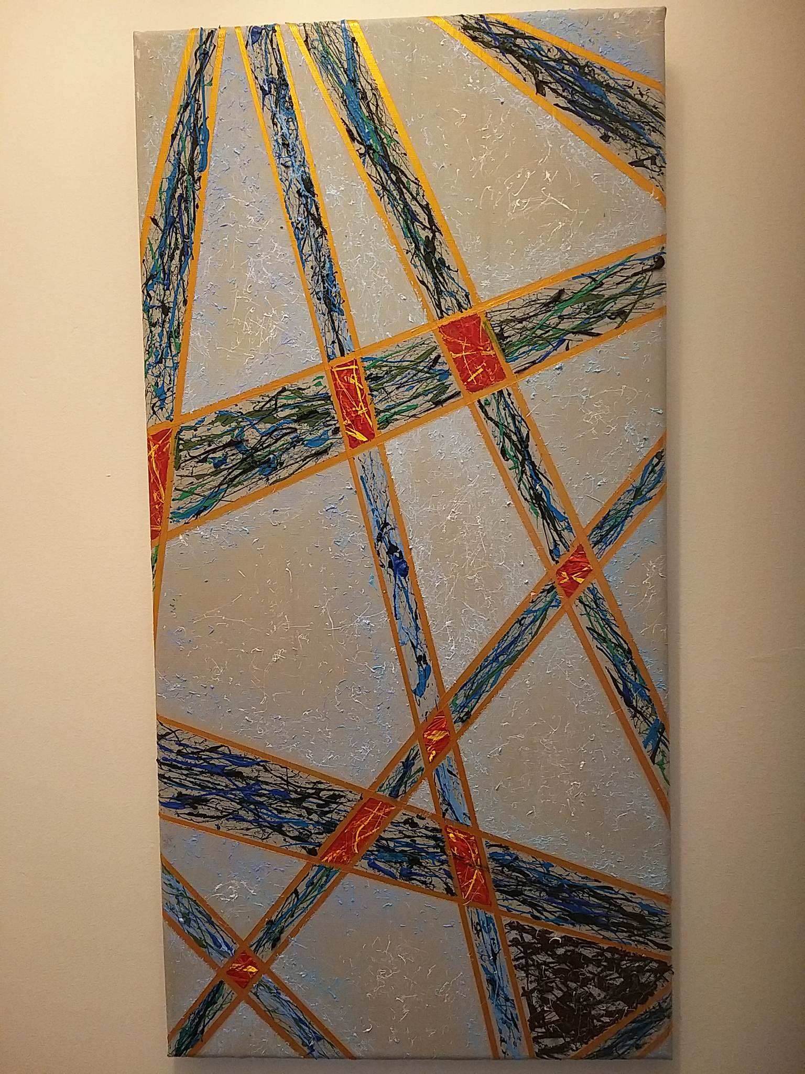

**Figure 5:** full view of painting. Photo by Alan Wheeler. [Link](https://infolit.org.uk/wp-content/uploads/2023/06/346106526_1552742518581701_3052275454194854095_n.jpg).

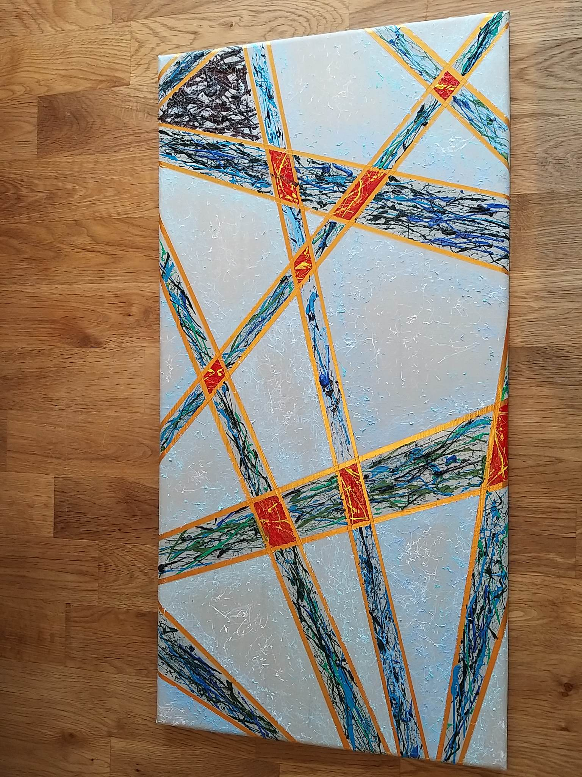

**Figure 6:** painting detail. Photo by Alan Wheeler. [Link](https://infolit.org.uk/wp-content/uploads/2023/06/346097711_967555441054895_8091877531265952965_n.jpg).

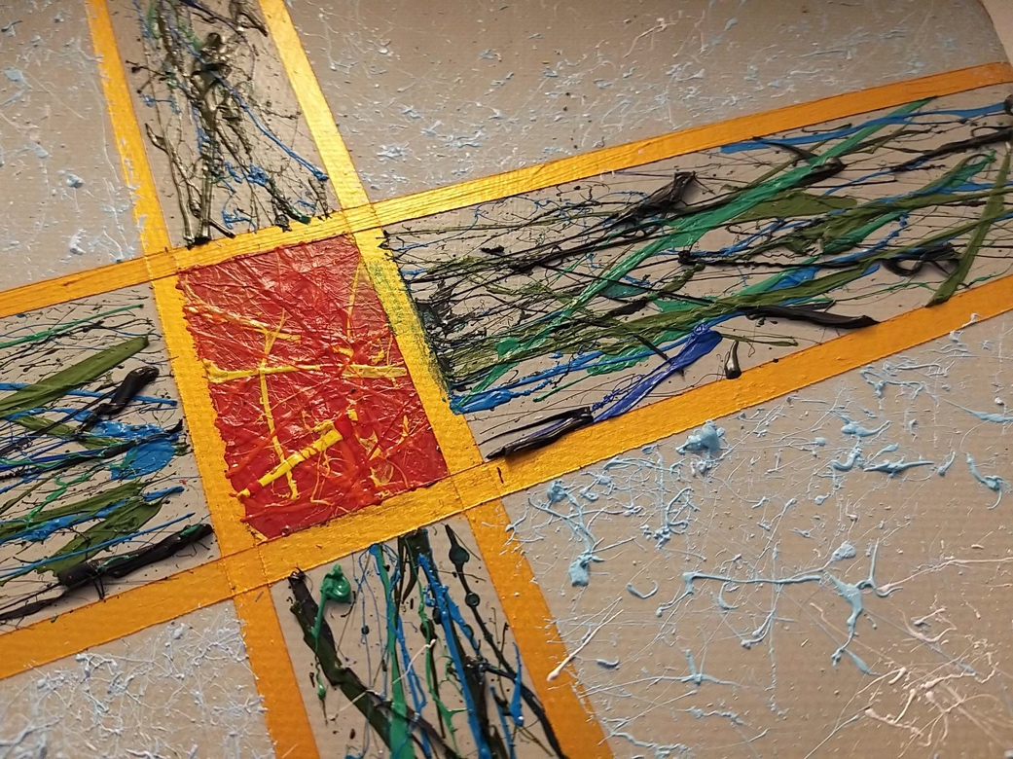

**Figure 7:** angled view. Photo by Alan Wheeler. [Link](https://infolit.org.uk/wp-content/uploads/2023/06/346096987_753345193199944_2871732962694538364_n.jpg).

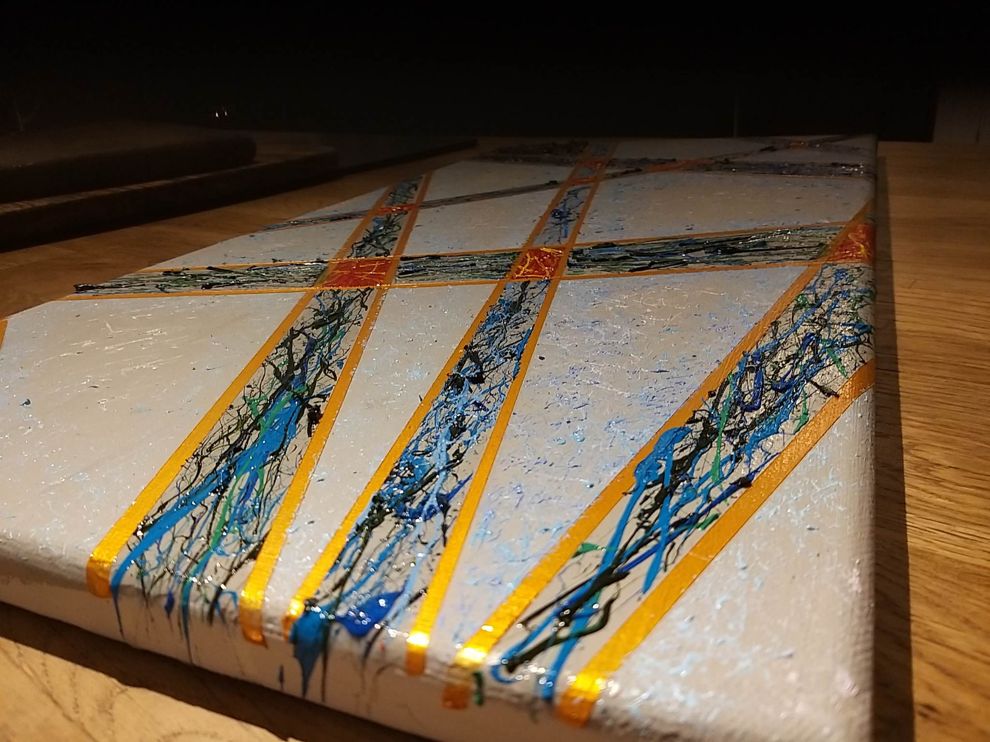

**Figure 8:** angled partial view. Photo by Alan Wheeler. [Link](https://infolit.org.uk/wp-content/uploads/2023/06/346095423_220048734102885_1929451308909361498_n.jpg).

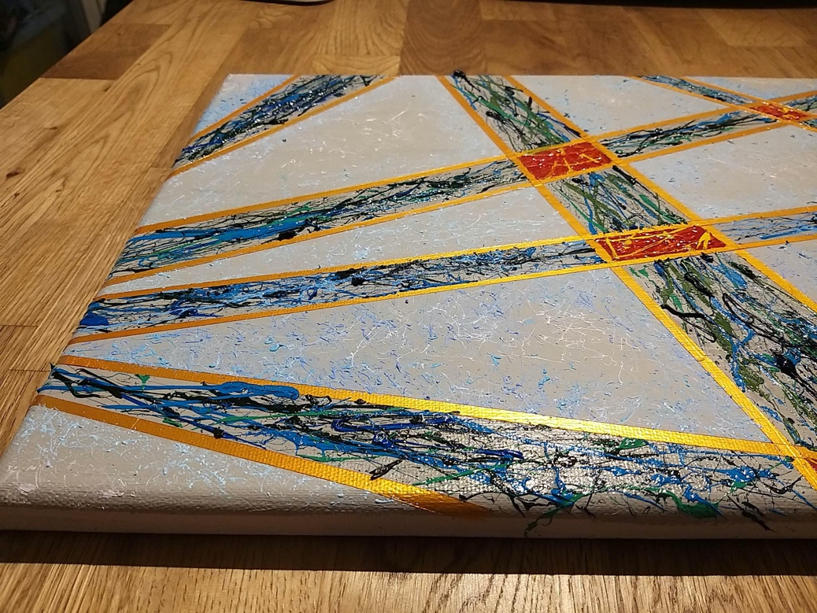

**Photo diary from the 2023 LILAC Conference**

**Figure 9:** Model of the future of academic librarianship made out of Lego at the 2023 LILAC conference. Photo by Lauren Dolman. [Link](https://infolit.org.uk/wp-content/uploads/2023/06/Lego-models.jpg).

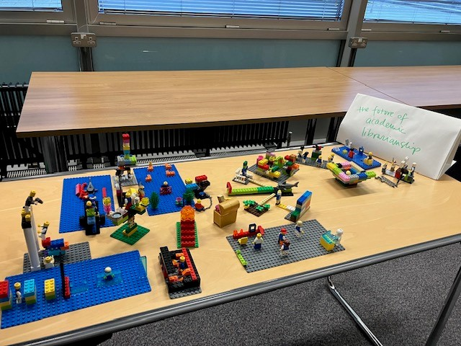

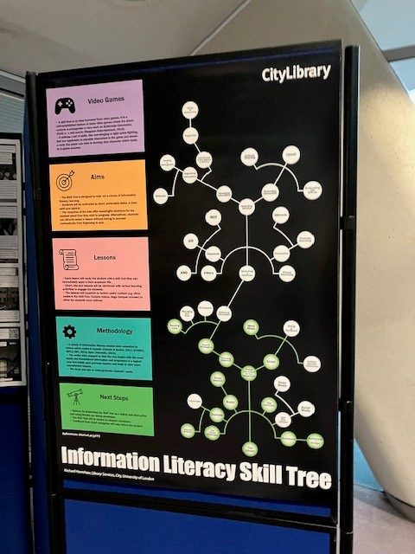

**Figure 10:** Photo of a poster presentation at the 2023 LILAC conference. Photo by Lauren Dolman. [Link](https://infolit.org.uk/wp-content/uploads/2023/06/Poster-presentations-rotated.jpg).

**Figure 11:** Photo of an origami dragon on the bookshelves of the Haddon Library, taken during the 2023 LILAC conference. Photo by Lauren Dolman. [Link](https://infolit.org.uk/wp-content/uploads/2023/06/Critter-in-Haddon-Library-rotated.jpg).

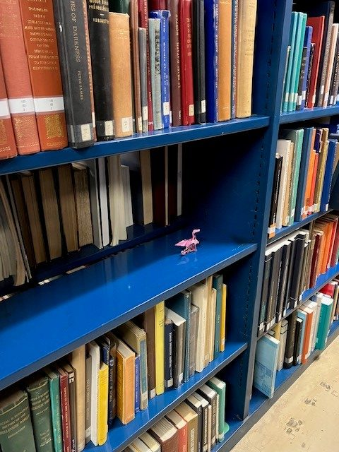

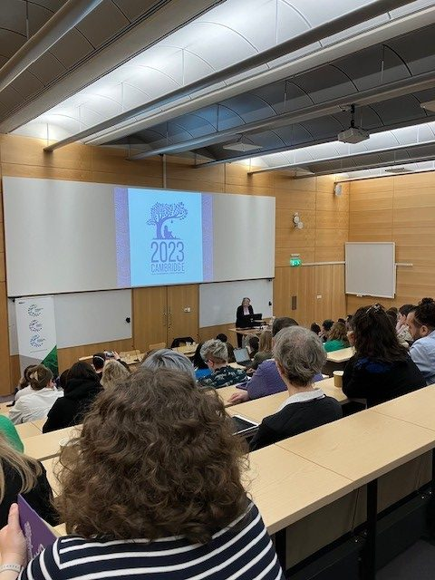

**Figure 12:** Photo of the opening plenary session of the LILAC 2023 conference. Photo by Lauren Dolman. [Link](https://infolit.org.uk/wp-content/uploads/2023/06/Conference-opens_wed-rotated.jpg).

**Figure 13:** Photo from 'Cartooning the Library' workshop at the LILAC 2023 conference. Photo by Lauren Dolman. [Link](https://infolit.org.uk/wp-content/uploads/2023/06/Cartooning_2.jpg).

. [Link](https://infolit.org.uk/wp-content/uploads/2023/06/Conference-opens_wed-rotated.jpg).

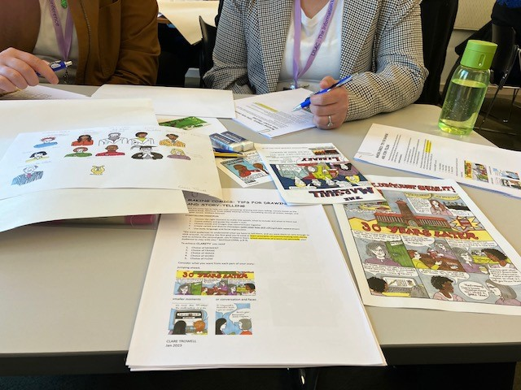

**Figure 14:** Photo of a boat being punted up the River Cam, taken during the LILAC 2023 conference. Photo by Lauren Dolman. [Link](https://infolit.org.uk/wp-content/uploads/2023/06/Cambridge-rotated.jpg).

. [Link](https://infolit.org.uk/wp-content/uploads/2023/06/Cartooning_2.jpg).

. [Link](https://infolit.org.uk/wp-content/uploads/2023/06/Conference-opens_wed-rotated.jpg).

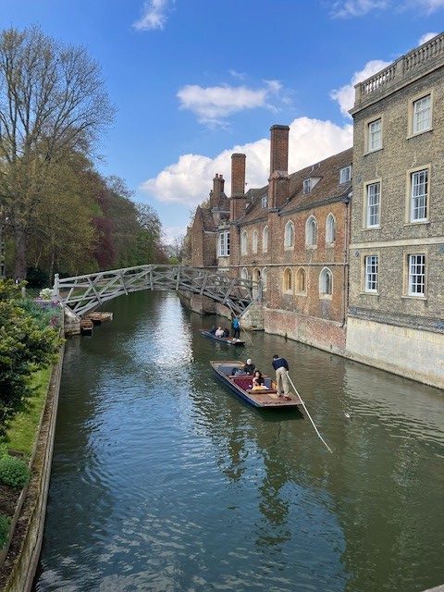

**Appendix 1**

**Transcript of Alan and Lauren discussing their experiences at LILAC 2023.**

**Alan**

Okay. Hello, everybody. My name is Alan Wheeler. I'm one of the librarians who attended LILAC, and my colleague is…

**Lauren**

Lauren Dolman. I also work with Alan—we both work at Middlesex University.

**Alan**

We’ve decided to do a LILAC report, but to do it through audio-visual medium rather than doing a more traditional sort of text report. So me and Lauren have decided to have a conversation covering the three days. Lauren was at all three days. I was only at the middle day, so some of this is going to be me asking her questions and some of it will be, you know, the reverse. Then some of it will be us having a chat, we have we have some things that we want to talk about, but we'll see where it goes because we haven't planned everything out. The first question is very much me saying to Lauren, how was the first day?

**Lauren**

So, it was my first LILAC. I'd been to the online version in the 2021 festival, and I'd really enjoyed that and I'd got a lot out of it, and actually taken some things into my practice, based some sessions around it, and just generally been inspired and kind of innovated and sort of geed-up for the coming academic year. So I was really keen to go along in person and experience a kind of multi-sensory version, rather than just sitting in front of a screen, and I really enjoyed it. I was a bit, I guess, a bit nervous about being there on my own without you, Al, on the first day, and not really necessarily knowing anyone, but once I turned up there were in fact some people who I did my library MA with and some other people who I had just come across their writing or their talking or their emails. So I felt pretty comfortable quite quickly, and just the range of presentations, workshops, networking events felt like a good mix and, you know, ways to engage with it in different ways, however you were comfortable.

**Alan**

It is different. I mean, I understand why we tried doing it all online rather than not doing it at all during the pandemic, but it is fundamentally a different experience doing it in person, right?

**Lauren**

Yeah, absolutely. And, I was thinking, you know, we thought when we saw the programme, oh, there's lots of things going on about audio-visual methods. And so let's kind of home in on those. And then, of course, we're going to present those in an audio-visual way. But actually, being at the conference is a very audio-visual experience, right. You're listening to talks. You're seeing people face to face. You're interacting with them. You're bouncing off people's body language, people's cues, the way you interact at an event or whatever. So the form and the content seem to be nicely streamlined.

**Alan**

Good. What was what was the keynote about on day one?

**Lauren**

So we had the new professionals panel on day one, which I think what I really came away from it with was the kind of sense of freshness of voice among the new professionals who were in different roles. One speaker was at a school library, others were at academic libraries, either in managerial posts or as subject librarians. But, yeah, as I said, they really brought some of the ideas that I think they probably took from their studies and then had applied them.

So there was that kind of inspirational thinking about, well, one of the things I picked up was because even though we're focusing on audio-visual methods, there were links all over the place. And even though this talk wasn't specifically meeting those themes directly, one of the speakers, Naomi Smith, was talking about in the work she does, decolonising and critical race studies, talking about the authority of voice and the authority of text, and how some of her work is about recognising the authority of non-written sources, maybe oral sources, so I thought immediately—ding!—there's a theme there. And that kind of did come across about how much we value different knowledge forms and that seemed like a little bit of a theme that ran through different talks for me and something that I'm really interested in and would be interested to get into in other ways, especially if you're presenting them in different ways too. If you're talking about oral forms, or, you know, if you're looking at visual sources.

**Alan**

This stuff is the sort of thing that we've been talking about and thinking about for a while. And so, the second day I—I actually turned up late on the first day evening—but the second day was when myself and Coco did our Lego Serious Play workshop first thing, so I'm just going to talk a little bit about that.

So, Lego Serious Play is a methodology that I use a lot in my practice. It's a methodology that's been around in different forms now for about 25 years and basically you know the central or principal tenet of it is quite straightforward. You get people to build their ideas using Lego bricks. There's a few rules attached to it and a bit of etiquette as well, and the role of the facilitator has an impact, but at its simplest, it's tapping into creativity that I think all people have, the desire to make things with our hands. So what I do at LILAC with my friend Coco was try to pair Lego Serious Play with the idea of a journal club. So we got people to read a journal article in advance and then discuss that article using the principles of Lego Serious Play. So they built their responses to the article itself, and then we did a discussion on that. And it was—it was interesting.

**Lauren**

Yeah. How did it go?

**Alan**

I think it went well. I mean, it's up to the people themselves, obviously, to really say that, but they were a brilliant group, I have to say, and I was—thank you—if you're listening to this and you were in the group, thank you so much for being just generally a bit amazing, I thought, because, well, there is a kind of perfect Lego Serious Play group, which is just the ideal mix of creativity and spontaneity and openness, and it also really helps if people if people stick to time, and it really helps if they stop building when I tell them to stop building! And this group was brilliant at actually stopping when I asked them to. It sounds silly, but it is actually quite important.

**Lauren**

Following instructions—a very, very valuable quality!

**Alan**

It really does help with a with a Lego Serious Play session, so, yeah. I mean from mine and Coco's perspective, it was great. If you were in the in the workshop and you want to get back to us about that then obviously, you know, please do. But we hope you got something out of it, and you know I'm a big advocate for the methodology.

**Lauren**

I mean, I could see the sort of ideas that you touched upon, and that I know we've talked about before in your in your Lego Series Play practice, kind of reflected in some of the other stuff we went to that day, like, I thought, Laura from Huddersfield’s drawing session, where we were talking about drawing as a way to explore what students are coming to the university during inductions, how they felt, what preconceptions they had. I thought that was a really interesting thing to come out of that session. I was expecting it just to be, well, this is a kind of fun way to engage students and, you know, tell them how late the library is open or whatever. Actually, what she said most surprised her, and what I thought, what I really took away from it, was that it was a way to engage with the “whole student”, in inverted commas, and that kind of holistic and well-being agenda. And ways that libraries can get involved in student belonging, and the whole move towards, how can we help retention and what's our role in that? And actually I thought it was just so fascinating how she was talking about when students come to university we kind of throw all this stuff at them, you know, look at these resources, look at these amazing electronic resources that you didn't have before. And look at this huge library and look at all these books and look at all these people. And actually we're talking on a different track than they were potentially expecting, or maybe hoping for, and we're kind of on two different pathways. And using a method like that, and maybe Lego too, is a way to actually tap into what these students, or whoever your user group are, what they're coming to your session with.

**Alan**

It slows the experience down. There is a natural rhythm to it, which is slower than us telling a group things, and the reflective stuff and the sharing of the reflective stuff is a huge part of that, and I got the distinct impression that was a huge part of the drawing sessions as well.

**Lauren**

Yeah.

**Alan**

Because you're in control of what you decide to share. You share something, but you're very much in in charge of what you decide to share with the group. And I think that's huge.

**Lauren**

Yeah, it's quite powerful.

**Alan**

Yeah, I think that's really important.

**Lauren**

Anything else from that day?

**Alan**

We should mention the night out! I mean, one thing that I want to absolutely shout out is everybody who danced to Dolly Parton’s 9 to 5. Hats off to you, because I think you're marvellous.

**Lauren**

Yeah, real highlight!

**Alan**

That looked like so much fun. But yeah, so, that, and it was a nice meal, and it was really nice to bump into people—shout out to Catherine and Viv especially, who I haven't seen for a million years, and it was lovely because I didn't know they were going to be there, which is always, you know, makes it extra nice, when you don't know people are gonna be places. So, final day?

**Lauren**

Final day—we had some great sessions, some great practical tips from colleagues at Maastricht University who talked about designing materials and gave us some takeaway things. Regina Everett at University of East London gave a really enthusiastic, effervescent, charismatic talk about pivoting through the last three years that we've all had and how we've had to change our practice at the drop of a hat. And that was really nice to be on the other side of that, because it was quite a shared experience, even though we were all siloed, you know, we were all basically at home doing all this. So it was really nice to come together as a group to hear her experience and to find parallels with that, and think about how we've learned from it and the things that we've learned from it and that we've taken from it and that make for a better service and that, now, felt quite positive. So it was really great.

**Alan**

Good. Yeah, I think that was all we were going to say, pretty much. One of the things towards the end of my day of being there was certainly the podcasting thing with Jane Secker and the guys that were part of that, because I've been flirting with the idea of a podcast seemingly for the last ten years and just not done it. And they were very much—when someone asks the question, how do you start?—they were like, you just start. You start and you're terrible at it and you don’t know what you're doing, and then you get better.

**Lauren**

Much as we've done today.

**Alan**

Pretty much like we've done today, and like we tell students quite often when they're starting any assignment or any activity, just be terrible at it at first. But it's still better than not doing it at all.

**Lauren**

Just build, right?

**Alan**

Yeah, just build. Don't think, just build. So I am maybe going to take the podcast idea away, and I hope some other people in the room were as well, because it definitely felt, at the end of that, like I could do it. You just need an angle. You can't do it on just anything. There has to be a hook, and that came through loud and clear. You need something to make the podcast: you need a format. They talked quite a lot about the importance of the format, and certainly most of my favourite podcasts all have a very clear format. They play with it a little bit, but having a good format is a tremendous starting point. So, anything else you want to add to finish off?

**Lauren**

No, just I guess a big thank you to the LILAC Committee for organising it. I thought it was seamlessly run…

**Alan**

It was brilliantly organised.

**Lauren**

…and to all the delegates for being so friendly and making it such a really nice way to spend three days, which will hopefully have ramifications and inspirations for the coming year.

**Alan**

Yeah. Thank you. Yeah, I'd like to echo what Lauren said there. Not that I've been to badly organised conferences in the past, you understand, but when you go to one that's really well organised, you don't even notice what people are doing, you know, when it's running so well, you're not even aware that people are there helping you. That's a great plus. And hopefully we'll do this again sometime and maybe see some of you next year.

**Lauren**

Bye for now.

**Appendix 2**

**Transcript of Alan discussing the painting he produced as a reflection on his Lego Serious Play workshop.**

Hi everyone. So, this little clip I've put together to accompany the painting that I painted to describe my thoughts and my reflection on the Lego Series Play workshop that myself and Coco facilitated at LILAC. I've never done anything like this before, just to be clear. I do paint, but I've never painted, and then described in a conference report, anything like this before. But I had the idea and thought, I'm gonna go with the idea. I'm using this as a different way to provide reflection on something that was certainly an interesting experiment, because we'd never used Lego Serious Play in that particular way before, we'd never used it by combining it with the idea of a journal club.

So all these elements are new, which is what made it exciting and interesting. The painting that you can see images of attached to this audio is me attempting to describe what happened in the actual room and this sort of art that I've done in the past, I've never really—I’ve never described it. In fact, I always let people—there is always a meaning behind it, but I let people bring their meaning to the pictures, which is often more interesting than my original meaning. But this particular painting, with the criss-crosses of lines and the actual colour scheme itself, to me represents what happened in the room.

So, to explain in a little bit more detail what the colours are about and what the actual lines represent. The heavily coloured lines, the actual thin strips which are predominantly blues and greens, to me represent the idea of actual creativity and the ideas and the builds flying around the room.

The elements where it criss-crosses over which have the very highly coloured red, orange, and yellow section, they represent the two ideas interacting or intersecting and becoming something different. Sometimes, the creativity that happens in Lego Series Play workshops—in fact, often—it’s chaotic. Which is one of the reasons why I enjoy doing it so much. It is controlled chaos, but the idea of, you know, two ideas smacking up against each other is often one of the things that I find most interesting about those workshops, and then how people react to those criss-crossings of ideas.

The paler colours which lie outside those kinda represent the ideas that didn't fully form, which is why they're paler and more nebulous and less defined. Because often what happens in Lego workshops is that ideas will come and go, but not become, you know, the main focus of what people are making, so those are the ideas that kind of didn't fully form.

There's one other area that I'd like to draw your attention to. At one point, the idea developed of “the corner of doom”, and the corner of doom represented different troublesome elements that are going on in academic librarianship, and amongst those I remember distinctly are the idea of burnout and lack of finances, so the vaguely triangular section in one corner, which is predominantly dominated by different browns and black, that represents what participants came up with in that moment, which is the corner of doom. I hope that makes sense. I've never really presented a reflection via a painting before, but I really enjoyed doing it, so hopefully I will do something similar again, and thank you to LILAC again for being open to these different ways of presenting reflections and presenting reports because it is a kind of leap of faith doing things this way, so myself and Lauren really appreciate the faith that people will hopefully get something out of this different way of presenting reflection and ideas. Thank you.